Working on Conventions Appropriate for 8th grade Writers

Explanation of symbols on marked papers.

Ideas
- inacc --inaccurate
- ? -- in margin means passage is confusing or unclear, over word or phrase means I don’t understand its meaning.
- awk -- awkward: sentence is, difficult to read and comprehend
Full Sentences
- frag – sentence fragment
- ro -- run-on sentence (2 independent clauses in 1 sentence without punctuation or conjunction)

Spelling
- sp -- spelling error
Capitalization
- -- capitalize
- -- lower case
Paragraphing
- 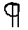 -- insert new paragraph
Verb tense -
- vt? -- verb tense - past tense needed for history
Third person
- 1st? -- first person should not be used in formal writing

General Marks to help you build general skills.
- 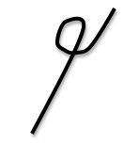 -- strike out
- -- insert period
- 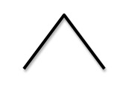 -- general insert
- -- join
- w/c – word choice doesn’t express what you seem to mean
- rep – repetitive

