Fitzgerald
Video Notes – Shhh! We’re Writing the Constitution by Jean Fritz on SchoolTube
https://www.youtube.com/watch?v=BepyT1faFLA
What does it mean to say the states were sovereign? | Each state was its own boss.
Who thought the idea of sovereign states was silly? | George Washington
How did George Washington learn that the states were not united? | His soldiers refused to say a pledge to the United States.
A confederation is like a …… | League of friends
Name three people who were in favor of a strong central government. | George Washington  Alexander Hamilton  John Adams
In 1787,  delegates gathered to improve the Articles.  Name a state that didn’t attend.  Name a person who didn’t attend and give his famous quote. | Rhode Island  Patrick Henry  “I smell a rat!”
Couldn’t start work until 7 states present.  Many delegates were late arriving;  give their excuses. | - weather  - roads  - personal business  - lack of money
How did Ben Franklin get to meetings each day? | In a sedan chair carried by prisoners  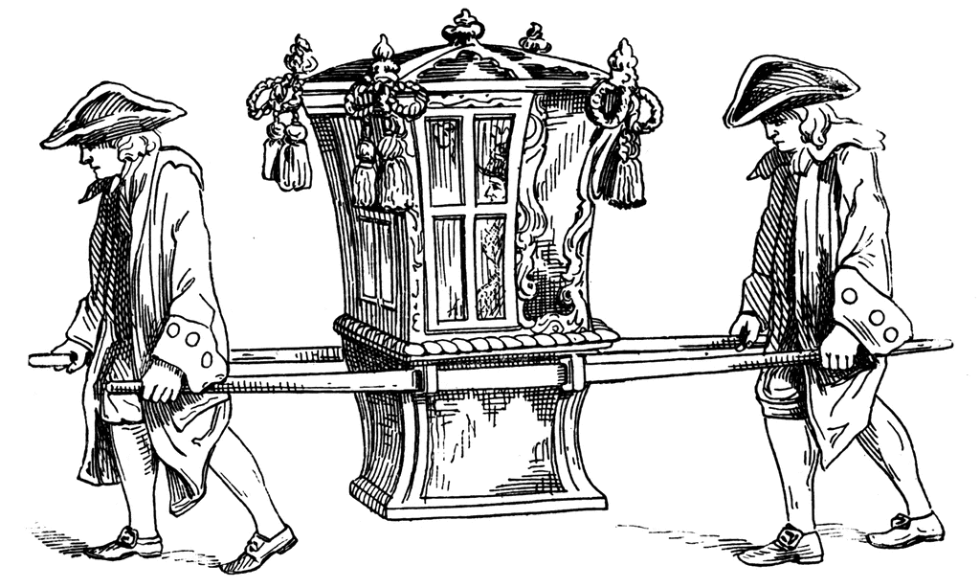
How many delegates attended?  How many were at any given meeting on average? | attended - 55  average at meetings 30
First order of business? | electing George Washington as president of the meeting
They kept meetings secret to avoid what? | people interfering, taking sides
Though all promised not to write letters about or discuss proceedings, who had to be followed to prevent this? | Ben Franklin
What was an infamous rumor about what the convention was doing? | offering a son of King George a crown
They were afraid to use certain words because they upset people.  Instead of Constitution, they used ....  Instead of National, they used .... | Plan  Federal
The Virginia Plan set up three…  The legislature would be called ….  and have two houses called ….  The judicial branch would be headed by the ….  Questions about the executive branch were… | branches  legislative, executive, and judicial  Congress  the House of representatives and the Senate  Supreme Court  - how many?  - King?  - would pay salary?  - how chose?  - Serve for how long?  - can he be impeached (removed from office)?
Decisions about executive branch were …. | - only one  - paid by national government  - serve for 4 years  - can be impeached  - if dies, Vice President wills serve  - Vice President is runner-up in election
A stumbling block would be representation. | large states say by population  small states say equal
Great Compromise | Senate - 2 per state  House of Representatives -  with 1 representative for every 40,000 people  (Today the number of member is frozen at 435. There are about 733,103 Americans/district depending on the state and how the district lines were drawn. Seven states have a single House member. Among these states, Montana has 1,023,579 citizens represented by its single House member (the highest ratio of any state) while Wyoming has 584,153 citizens represented by its single House member (the second lowest ratio of any state, just ahead of Rhode Island.)
Other Conflicts  One –  Two –  Decision? | North v. South  Where government located –  New York?  Philadelphia?  A separate district?  Let new Congress decide!
Concern about foreigners in Congress because of immigration.  Decision? | Had to citizen for  7 years to be in the House  9 years to be in the Senate  ___ years Had to be native born to be President
Number needed to ratify? | 9 of 13 states
Washington called the new Constitution …. | little short of a miracle
Those for the Constitution were called…. | Federalists
Those against the Constitution were called…. | Anti-Federalists
Who wrote a series of newspaper articles to “sell” the ideas of the Constitution? | Alexander Hamilton  James Madison  John Jay
The arguments saying that it protected against abuse of power were….. | each branch checks the powers of the other  every law had to pass both houses  the president can veto a bad law  the Congress can override a veto with a 2/3rds vote  The Supreme Court can decide if a law violates the Constitution  any amendment has to be submitted to the states  people elect all representatives
Patrick Henry upset that words “We the People” wipes out the …..  He and all Antifederalists want a ….. | 13 states  Bill of Rights
Worry about Bill of Rights? | can list all!
First state to ratify? | Delaware
9th state to ratify, making it official? | New Hampshire
Two statesmen out of country for whole process? | John Adams  in Great Britain  Thomas Jefferson  in France  Both were serving as ambassadors

