Fitzgerald
Establishing the New Nation Started by the Constitution – Four Topics
- Development of Political Parties
- Establishing the Power of the Judicial Branch and Maintaining the Federalist Policy of Powerful National Government
- Establishing National Government’s Power against Domestic Challenges to its Authority
- Establishing the Power of the United States in the World – Troubles with Foreign Nations

The Development of Political Parties
Take Notes on | Topics to Know
p. 283  - The Executive Branch | - Washington’s Cabinet – Finding the Best Man for the Job
pp.248-5  - The Nation’s First Economic Crisis  - Hamilton’s Financial Plan  - Paying the Debt  - The National Bank | - Hamilton’s Financial Plan  - Jefferson’s Opposition  - The Necessary and Proper Clause
Read the following and create a chart on the paper provided, noting leaders , positions on key topics, and supporters of each party  pp. 290-293  - Political Parties Emerge  - Republicans against Federalists  - Organizing and Arguing | - Birth of the First Two Parties – Leaders, Positions, and Supporters of Each  Note – Jefferson tries to resign from the cabinet in 1792 over the National Bank and the use of the army against the protesting backcountry farmers in the Whiskey Rebellion, but Washington convinces him not to because he wants send the message that the two sides of an argument can work together. Jefferson does resign in 1793, over the refusal of the Federalist to support France
p. 293  - The Election of 1796 – Paragraph 1  p. 297  - Washington Retires from Public Life | - Washington Steps Down  - Washington’s Farewell
p. 293  - The Election of 1796 – Paragraphs 2-4 | - Adams’ Election 1796 – Peaceful Transition of Power
pp. 299-300  - The Alien and Sedition Acts | How does the party in power deal with attacks by the other party?  - Alien and Sedition Acts
pp. 300-1  - States’ Rights | How can a party with no power fight a party that controls all three branches?  - States’ Rights
pp. 310-12  - Republicans Take Charge  - A bitter Campaign  - Jefferson’s inauguration  - Jefferson Charts a New Course  - New Republican Policies  - Federalist Policies Remain | - Election of Jefferson – Bitter Campaign  - Jefferson’s Inaugural Address  - Jefferson’s Reversal of Federalist Policies  Note – After Jefferson’s election, the Constitution is amended so that the President and Vice President are elected separately. Today the President chooses a Vice President, who is called a “running mate,” with the help of his party. Electors who are to vote for the president who won their state also vote for the vice president he has chosen, so that the pair is elected together.
Fitzgerald
Establishing the New Nation Started by the Constitution – Four Topics
- Development of Political Parties
- Establishing the Power of the Judicial Branch and Maintaining the Federalist Policy of Powerful National Government
- Establishing National Government’s Power against Domestic Challenges to its Authority
- Establishing the Power of the United States in the World – Troubles with Foreign Nations

Establishing the Power of the Judicial Branch and Maintaining the Federalist Policy of Powerful National Government
Take Notes on | Topics to Know
p. 300  - States’ Rights – Paragraphs 1 and 2  p.236  - Notes words in Article III.1 that suggest this power | - Power of Judicial Branch to declare laws unconstitutional not in the Constitution
p.236  Note words in Article III.1 that  - Allow the Federalists to create new courts  - Say how long a judge will serve  - suggest the power to declare laws unconstitutional  Readings Attached  - A Federalist Stronghold: John Marshall’s Supreme Court | - Packing the Courts / Midnight Judges  - Federalists Grab the Judicial Branch to hang onto Power
p.312  - The Supreme Court and Judicial Review | - Establishing the Power of Judicial Review –  - Marbury v. Madison (1803)
p. 343-4  - Three Important Supreme Court Rulings | - Marshall establishes the power of the federal government using Judicial Review – Three Famous Cases  - McCulloch v. Maryland (1819)  - Dartmouth v. Woodward (1819)  - Gibbons v. Ogden (1824)

A Federalist Stronghold: John Marshall's Supreme Court
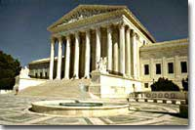
Marbury v. Madison was one of the most important decisions in U.S. judicial history, because it legitimized the ability of the Supreme Court to judge the constitutionality of acts of the president or Congress.
The Democratic-Republican victory in the 1800 election began a long run of Republican political success. In spite of Federalists' departure from most elective offices, they remained a powerful force in American life especially through their leading position among federal judges. In the final months of Adams' administration he enlarged the federal judiciary and appointed many new judges.

In the view of GOUVERNEUR MORRIS, a Federalist senator from New York, this created an independent judiciary necessary "to save the people from their most dangerous enemy, themselves."
In sharp contrast, Democratic-Republicans were appalled by the "MIDNIGHT APPOINTMENTS" that tried to continue Federalist influence despite their election loss. In Jefferson's view, the Federalists "retired into the judiciary as a stronghold . . . and from that battery all the works of Republicanism are to be beaten down and destroyed." As in so many areas, the two political parties fundamentally disagreed.
The most influential of Adams' final judicial appointments in 1801 was naming John Marshall as Chief Justice of the Supreme Court. He held that position until his death in 1835 and shaped the court's decisions and dramatically raised its stature. He also defined the basic relationship of the judiciary to the rest of the federal government. His forceful actions as Chief Justice set the Supreme Court on a course it has continued to follow for the next two centuries. Marshall was guided by a strong commitment to judicial power and by a belief in the supremacy of national over state legislatures. His judicial vision was very much in keeping with the Federalist political program.
http://www.ushistory.org/us/20e.asp

Marshall’s readings of the Constitution brought him into conflict with the Republican-Democrat opponents of the Federalists. Chief among them was President Thomas Jefferson. Although the two men were cousins, Marshall and Jefferson were continually in conflict. Marshall believed that a strong federal government was necessary to ensure that the government would meet the needs of all the people. Jefferson, on the other hand, believed that the power of government should remain largely in the hands of the states.
http://www.johnmarshallfoundation.org/john-marshall/life-legacy/

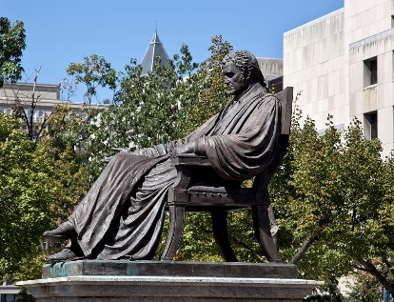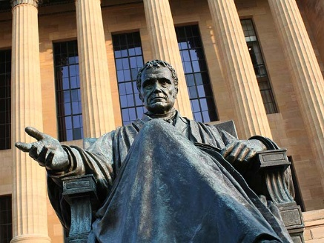

This famous statue of John Marshall sits on the steps of the Supreme Court in Washington, D.C.

