Referring to the maps, explain how the sides had formed in the Civil War.

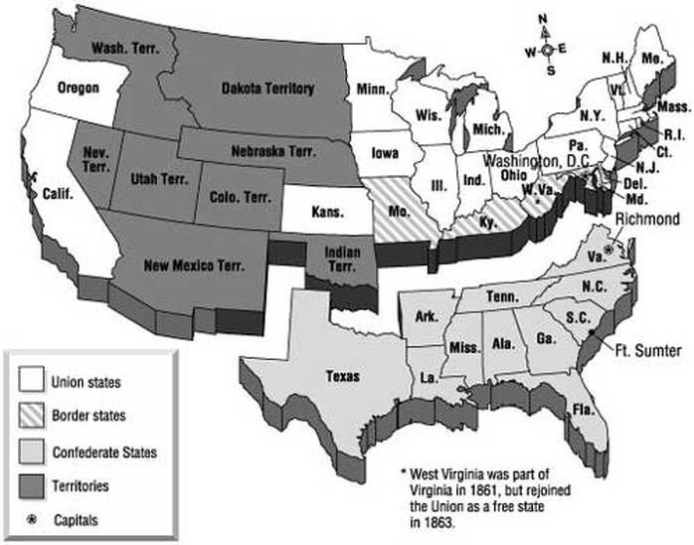 | 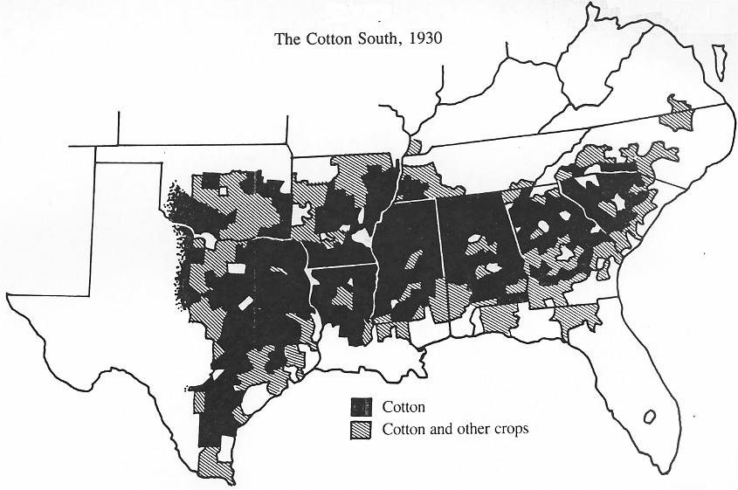
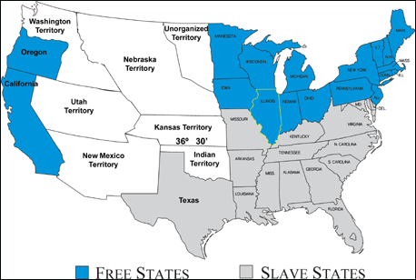 | Details I notice –  Write your answer on the next page and staple it to this sheet.

Prompt
Referring to the maps, explain how the sides had formed in the Civil War.

Structure
- Claim/Topic sentence - responds to prompt - using prompt's wording
  - Sentences of detail
    - reference details observed in document
    - relate ideas in our studies that relate
      - to details in the image
      - the topic in general
- Conclusion -
  - may repeat
  - offer thoughtful comment
    - maybe one generated in class discussion of topic

