Fitzgerald
Topic 9 - Life for People During the War

A Soldier's Life

Raising Civil War Units from Same Geographic Area - The Consequences
- often in the same units as their friends, family and neighbors.
- if ran away during a battle, all of his neighbors, friends and family would hear about it.
- if a unit suffered horrendous casualties during a battle, it could effectively wipe out the male population of a small town.
Camp Life - 3/4ths of the time a soldier is in camp
- 10 hours a day of training
- guard duty
- gathering firewood
- digging latrines
- writing home
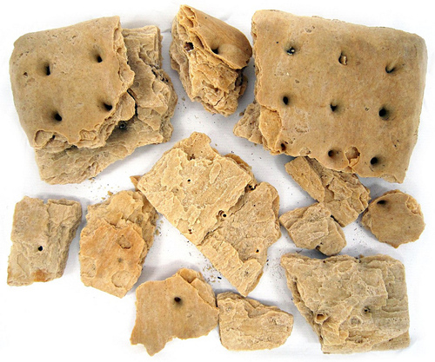
- basic food - light bread, coffee, fresh meat when available, salt meat, beans, rice, onions, Irish and sweet potatoes and hardtack. https://www.youtube.com/watch?v=sf0IOVIB6Bc

- Camps could be miserable
  - wet
  - no clean water - health threat
  - disease - not unusual for 1/2 of men in a regiment to be too sick to fight

Disease - the biggest killers during the war
- reasons - bad hygiene, overcrowded army camps, bad water, bad food, and lack of proper sanitation
    - latrine placed upstream from the water supply - foul water would quickly lead to water
- worst disease was Dysentery, which caused 45,000 Union and 50,000 Confederate deaths
- other disease included: Typhoid, Pneumonia, Measles, Tuberculosis, and Malaria.

Civil War Medicine
- Huge numbers of casualties - caused by
  - Greatly improved weapon technology - including the rifled gun barrels, minie ball, case shots that exploded over infantry, and canisters that made cannons work like shotguns
  - Coupled with old style battle tactics
- Medicine primitive - years behind the military technology
- Sanitation non-existent
    - any type of open wound could easily become infected leading to severe complications even death
- Chloroform was available as an anesthetic
    - Great quantities of it in both the north and the south
- Wounds to the head and truck were not treated
    - Patients were made comfortable until they died
- Wounds to the limbs led to amputation
    - Most recognizable piece of medical equipment - bone saw
    - 75% of surgeries in the field were amputations

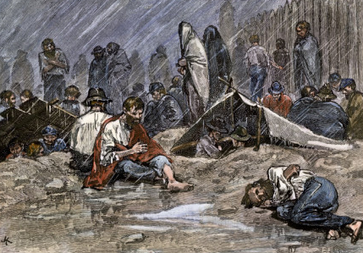
Prison Camps - overcrowded deathtraps
- 1/10 soldiers who died in the war died in the camps
- Two most famous
Elmira, New York - Union Camp
  - built to hold 5,000 - holds 10,000
  - in coldest, snowiest part of Union
  - fed only bread and water - eat rats to survive
Andersonville, Georgia - Confederate Camp
  - built for 10,000 - holds 35,000
  - a fenced open field with no shade
  - 100 die each day of starvation and exposure

The Home Front - It would take decades for many communities to recover, both physically and emotionally
- Family members waited anxiously for word of soldiers
    - wrote frequently to their relatives in the field - cherished the letters they received in return
    - struggled to get accurate, timely information about battles and the fate of their loved ones
    - usually received news of death through a letter sent by an officer, comrade, or relative
- Missed labor of soldiers - women had to do jobs once filled by men
    - working as clerks or in factories, planted and harvested crops and tended livestock
    - on large plantations in the South - relay orders to overseers and slaves
- New jobs opened for women as nurses and teachers
    - men had previously been seen as teachers
- Many families in the Upper South and in Coastal areas of the Confederacy relocated -
    - Went to live with friends or relatives
- Near the fighting - soldiers from both sides stripped the countryside
    - took food, livestock, forage for the few remaining horses, and wood for fires
- People near battles were devastated by the loss of life and the destruction
    - more wounded than local residents could care and had to bury the dead
    - Almost every available nearby building became a temporary hospital
- In the Upper South, in rural and mountainous areas outside of military control - Guerillas attacked civilians with no men home to help protect them
    - Confederate bands targeted Unionists and vice versa
- Soldiers’ aid societies were developed
    - made bandages, socks and other clothing, and regimental flags
    - handed out water, cakes, pies, fruit, and other foods to passing troops
- Women able to act as spies
    - men in positions of authority assumed that women didn't understand such things as war
    - spoke freely of confidential information
- Runaway slaves gave the Union valuable information
    - Confederate troop movement
    - local geography and roads
    - Harriet Tubman - most famous African American informant for Union forces
      - disquised as slave, served as a scout in South Carolina and Florida
- Slaves sabotaged Southern plantations
    - Purposefully performed tasks incorrectly - ex. Planted seeds too deep
    - Broke equipment - claimed did not know how to fix it
- In Confederacy - food shortages - due to blockade and scavenging soldiers
    - Led to bread riots
    - Inflation - high, high prices for things
- When the war ended, welcomed home soldiers
    - Still suffering - debilitating disease - dysentery, malaria, tuberculosis, lungs damaged by pneumonia, amputated limbs, post-traumatic stress disorder
- Estimates between 620,000 and 750,000 men killed - leave widows and orphans
Women in the War - nurses, spies, and soldiers

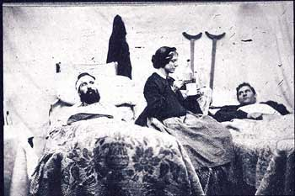
Women Nurses
- Between 2,000 to 5,000 women volunteered as nurses during the Civil War

- Nursing was a gruesome job -
    - cleaned and bandaged wounds, fed soldiers, dispensed medication, assisted surgeons during operations and treatment for things like amputations

- Most famous nurse of the Civil War - Clara Barton
    - worked as a clerk in the U.S. patent office when the Civil War broke out
    - began to show up at local battlefields armed with medical supplies, which she used to nurse sick and wounded soldiers
    - nickname “Angel of the Battlefield”
    - Years later - used this experience inspired Barton to found the American Red Cross
- Union Hospitals organized by Dorothea Dix - the young reformer famous for campaigning for the opening mental hospitals to get the mentally ill out of prison before the war

Women Spies
- It is speculated that hundreds of women served as spies
    - usually gathered valuable military information by flirting with male soldiers at parties, dinners or other social events, especially when men had been drinking
    - also smuggled supplies, ammunition and medicine across enemy lines
- Most famous Confederate spy was Belle Boyd, from Virginia
    - At 17, arrested for shooting a Union soldier who had broken into her family’s
    - investigated and cleared her of all charges but watched closely
    - Young and attractive, used charms to get information officers, which passed along to the Confederacy
    - also worked as a courier between Confederate generals "Stonewall" Jackson and P.G.T. Beauregard - credited with providing the intelligence that helped win many victories
    - 1862 - arrested, sent to prison in Washington, D.C., released a month later and deported to Richmond
    - soon caught behind federal lines and imprisoned for three more months
    - arrested again while trying to smuggle Confederate papers to England
    - fled the country and a few months later married one of the Union naval officers who had detained her

Women Soldiers - Forbidden to join the military - still over 400 women served
- Overwhelmingly working-class, immigrant, poor, urban or subsistence farm girls
- Disguised themselves as men and adopted masculine names
    - Often only discovered while being treated for injuries or illnesses

