Fitzgerald
Anaconda Plan Completed - Siege of Vicksburg  - surround the city, 6 weeks, cut-off food and supplies, bomb each day, live in caves, eat rats, surrender  Sherman’s March –  - Total war against everything that supports enemy, cut across middle of South to sea  - pumps up North winning Lincoln reelection against antiwar McClellan | Topic 8 - Battles of the Second Half of the War  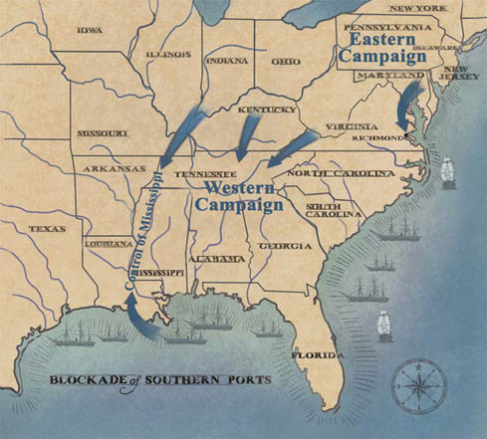 | Gettysburg. - Stop Second Invasion  - Lee again following victories hopes to get North to end war  3 day battle  - 1st day - Union cavalry unseat and hold the incoming Confederates off the high ground, Union takes high ground  - 2nd day - Confederates try to flank the Union lines on the high ground but are held off  - 3rd day - Lee orders a deadly mistake - a charge at the middle of the Union line (Pickett’s Charge) across a mile wide field which failed horribly  - Union does not pursue and finish off retreating Confederate army that had lost 1/3 of its men!  Grant chases Lee around Richmond –  - attacks and attacks again, never retreating - Lee losing irreplaceable men and supplies  Sherman heads North to join Grant

