Fitzgerald

Topic 6 – Union and Confederate Strategies



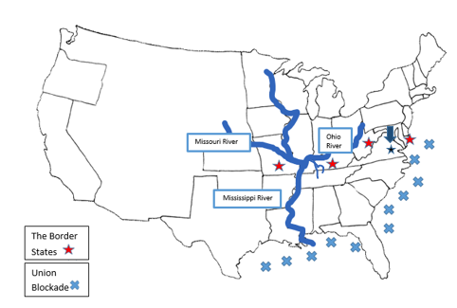

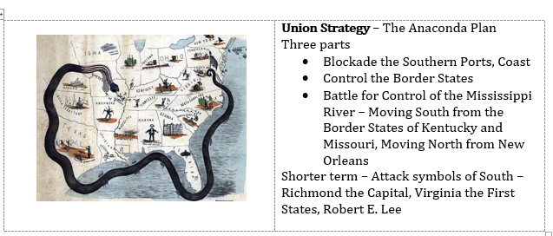

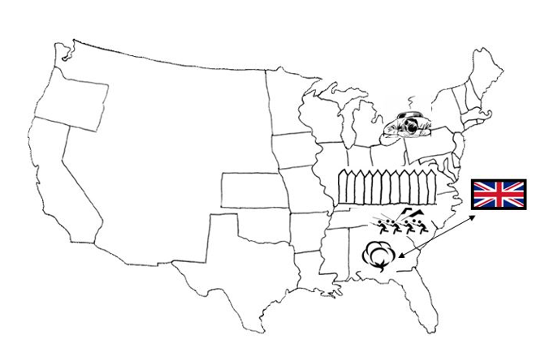

**Confederate Strategy** –

* Fight a defensive War
* Use the power of Cotton to obtain the support of Great Britain (Navy, $, Supplies)