Fitzgerald
Topic 5 Civil War – The Sides

North | South
Union | Confederacy
Yankees | Rebels (Johnny Rebs)
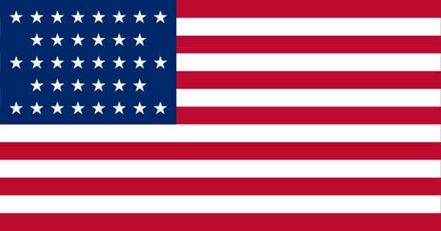 | 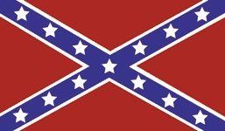
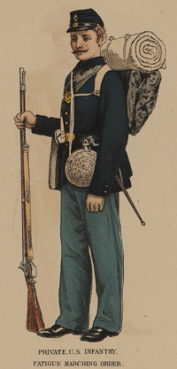 | 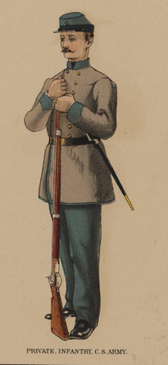
The Blue | The Gray

