Fitzgerald
Topic 5 Civil War – The Sides

Prior to the war, the two sides were known as the North and the South, but once at war, other terminology began to be used. For each word or image below, identify it as either belonging to the North or the South. Circle the word. Then we will check together.

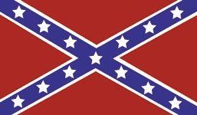 | North or South?
The Blue | North or South?
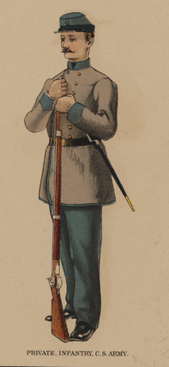 | North or South?
Union | North or South?
The Gray | North or South?
Rebels (Johnny Rebs) | North or South?
Yankees | North or South?
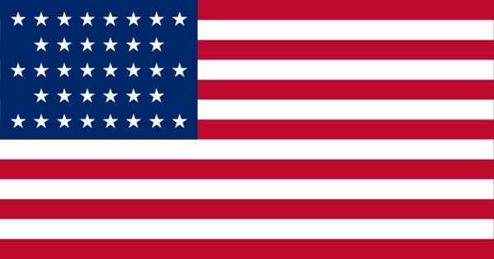 | North or South?
Confederacy | North or South?
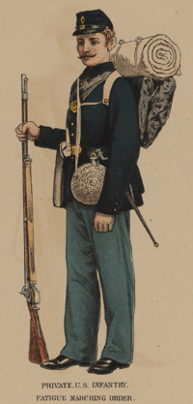 | North or South?

