Fitzgerald
Topic 2 - Civil War - Order of Secession
Slave-holding States - To secede or not to secede? - Three Stages
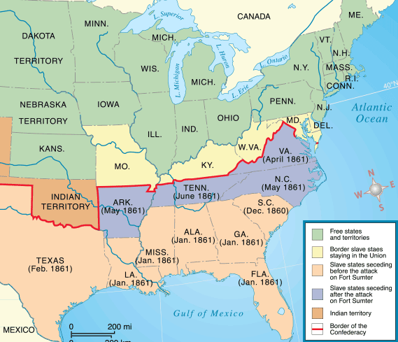
List the states that seceded after the election of Lincoln.
1. | 5.
2. | 6.
3. | 7.
4.
List the states that seceded after shots were fired at Fort Sumter.
1. | 3.
2. | 4.
List the Border States: slave-holding states that stayed in the Union.
1. | 3.
2. | 4.

