Fitzgerald
Topic 1 Civil War - How does the Fighting Start? Dilemma of U.S. Army Forts in South

"Attack on Fort Sumter Marked the Start of the Civil War"
by Carolyn Reeder,The Washington Post, 4/18/2011

Boom! A single cannon shell burst in a flash of light high above Fort Sumter. This was the signal for the Confederate attack on the U.S. fort to begin. It was also the moment our Civil War began — 4:30 a.m. on April 12, 1861. For 34 hours, Confederate cannon fire from the shores of South Carolina’s Charleston Harbor battered the towering walls of the island fortress as fiery shells crashed into the open area in its center. The noise was deafening, and thick smoke made it hard for the defenders of the U.S. fort to see — or breathe. With little ammunition, they fired back just often enough to let the Southerners know they were still fighting.
Who were Sumter’s defenders? Just 82 soldiers — including members of the military band — aided by about 40 workmen employed at the fort. The soldiers knew it was their duty to defend U.S. property that President Abraham Lincoln had vowed to protect. But they were greatly outnumbered. Finally, with fires raging inside, Fort Sumter’s commander surrendered. A great shout went up from the Confederates when they saw a white flag of truce replace the battle-torn American flag that had flown over the fort.
For months, that flag had angered the Southerners. They didn’t want a U.S. fort in Southern territory, but Lincoln, who had taken office the month before, had made it clear he wouldn’t give it up. When he told South Carolina’s governor that he was sending an unarmed supply ship to the men inside Sumter, it was the last straw. Confederate leaders decided to bombard the fort unless the U.S. soldiers left right away. But their orders were to defend the fort, so they did.
The bombardment of Fort Sumter was the first battle of the American Civil War. Force had finally brought an end to the standoff between North and South. Here’s what happened next: In the South, Confederates rejoiced at their victory. People cheered and rang church bells. In the North, a wave of patriotism. Enraged that the U.S. flag had been fired on, people organized parades and public meeting to show support for their government. Lincoln called for volunteers to serve for 90 days and put down the rebellion of the seven deep-South states that had formed the Confederacy. He also called for a blockade of Confederate ports so the South couldn’t import goods — including weapons — or export their cotton and tobacco.

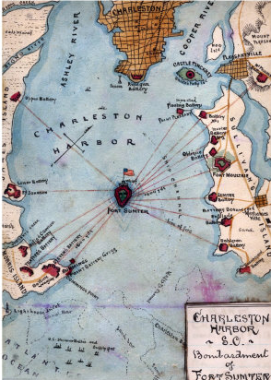 | Brilliant Chess Move by Lincoln -  - If given a choice between two evils, do not choose  - Give the choice to your opponent.  Chose one Fort as an Example -  - Fort Sumter - in the Harbor of Charleston, South Carolina  - South Carolina had always been the first to lead secession  Dilemma - Damned if you do. Damned if you don't. Stuck between a rock and a Hard Place.  - Fort in enemy territory  - If withdraw - look weak  - If fight - look like aggressor - but are claiming the South has started war  Do not Choose. Give the dilemma to the South.  - Write letter saying will resupply fort on a certain day at a certain time  - If allow resupply - look weak  - If fight - look like aggressor - have fired first shot but are claiming just being defensive  Lincoln Wins.  - South fires on Fort Sumter and starts the war.
http://www.history.com/topics/american-civil-war/fort-sumter#

