Fitzgerald
Topic Civil War - Reconstruction

The Country is in a mess as the war ends!
- Lincoln faced the serious possibility of losing reelection.
  - He had to choose a Vice-President who would win votes in the Border States. He chose Andrew Johnson. Johnson was from Tennessee. Johnson, like Lincoln, had grown up in poverty. He did not learn to write until he was 20 years old. He came to political power as a backer of the small farmer. In speeches, he spoke strongly against the elite. slave-owning class ruling the South like European noblemen. He said they had little use for white working men. He painted the South as treasonous for seceding from the Union and had refused to leave the Senate when Tennessee seceded. But when Frederick Douglas was introduced to him by President Lincoln at Lincoln's second inauguration, he gave this impression of the man:
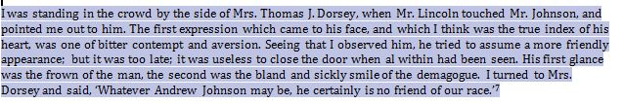
No friend to our race!

  - Sherman's march had energized other Northern voters, but it had also destroyed large parts of the South and the South is angry.

Sherman's March (Start at 25 sec) - http://www.history.com/topics/american-civil-war/shermans-march/videos
Sherman's tactics - http://www.history.com/topics/american-civil-war/shermans-march/videos/shermans-terrifying-tactics?m=528e394da93ae&s=undefined&f=1&free=false
- The Lincoln was assassinated.

https://www.youtube.com/watch?v=hVLM0BSqx5o

So who will guide the country?
- Two groups are left:
  - the Vice-president, now the President, Andrew Johnson
  - Congress, dominated by a group called the Radical Republicans.
- Two questions had to be answered.
- How would the Southern states be brought back into the Union?
- What should be done to help the newly freed slaves?

- The 13 Amendment - ended slavery
  - passed by Congress shortly before the end of the war
  - ratified by 3/4 of the states by December of the 1865

- The Freedman's Bureau
- created to help the newly freed slaves after the 13 Amendment was passed.
  - furnished food and medical aid to the former slaves
  - established schools for the freedmen
    - by 1870, a quarter million black children and adults attended more than 4,000 of these schools in the South
  - tried to make sure that the former slaves received fair wages and freely chose their employers
  - created special courts
  - to settle disputes between black workers and their white employers
  - address cases of threats to the rights of freedmen

To reenter the Union, Johnson only required that
- Southern states ratified the 13th amendment that ended slavery,
- Southerners take a vow of loyalty to the Nation before serving in the national government.

Cruel and severe "Black Code" laws were adopted by southern states - to maintain the social structure even without slavery.
- created a separate set of laws, punishments, and acceptable behaviors for anyone with more than one black great-grandparent.
- required black workers to contract with white farmers by January 1 of each year or face punishment for vagrancy
  - vagrancy means not having a job
  - If a black person was convicted of vagrancy - sentenced to forced labor
    - then his labor was sold to the highest bidder
  - If he left the job, he was breaking his sentence
    - could be rearrested and sentenced to a longer term.

Blacks were usually forced into Sharecropping agreements with White farmers, which trapped them on the land.
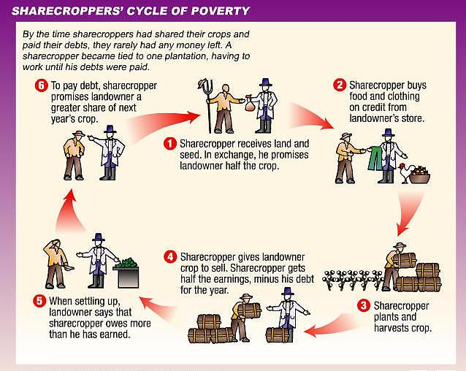

Southern states were also denying blacks the right to vote, saying that the 13th amendment freeing the slaves did not mean they had the right to vote. Many Southern Confederate officers were then reelected to Congress and arrived to take their seats.

So Congress passed the 14th amendment, but most Sothern states refused to ratify it.
The 14th Amendment - provided full citizenship and rights to the recently freed slaves
- all freedmen are citizens
  - have equal rights
  - cannot be deprived of life, liberty, or property without due process of law
  - must be equally protected by laws
- if a state does not comply - their representation Congress will be cut

All persons born or naturalized in the United States . . . are citizens of the United States and of the State wherein they reside. No State shall make or enforce any law which shall abridge the privileges or immunities of citizens of the United States; nor shall any State deprive any person of life, liberty, or property, without due process of law; nor deny to any person within its jurisdiction the equal protection of the laws.

. . . . when the right to vote at any election . . . is denied to any of the male inhabitants of such State, being twenty-one years of age, and citizens of the United States, or in any way abridged, except for participation in rebellion, or other crime, the basis of representation therein shall be reduced in the proportion which the number of such male citizens shall bear to the whole number of male citizens twenty-one years of age in such State.

Radical Republicans in Congress were upset with all of this and refusal to pass the 14th amendment was the last straw. Being the majority, they took Reconstruction into their own hands.
They did three key things.
- They refused to accept the newly elected Southern legislators, saying that the Constitution gave it the right to decide on rules for its own membership.
- Established military rule in the South
- Passes the 14th amendment and later the 15th amendment

Congress the established military rule in the south.
- state boundaries in the South were ignored
- the South was divided into 5 military districts
- Military generals in were in charge of these districts
- New elections were held which allowed the vote to black males - caused
  - Black men to be elected to public office in both the state and national governments
  - election of Ulysses S. Grant as president

The 15th amendment - national and state governments cannot deny a citizen the right to vote , based on "race, color, or previous condition of servitude"

The Ku Klux Klan (the Kan, the KKK), which had been rising in power, at this point became very strong!
- the Klan did all the things the Southern governments had done to the black man that were now forbidden by the 13th, 14th and 125th amendments
- sought to restore white supremacy by threats, violence, and murder
  - burning crosses placed in yard
  - beatings
  - lynchings - the hanging of a person by a mob
- targeted both black men and any who supported them
- worked in secret
  - Klansmen wore cloaks and hoods to hide their identity
  - attacked at night

Reconstruction ended due to a deal made to settle a disputed presidential election
- Grant a terrible president - gave jobs to family and friends - unqualified, accepted bribed
- Presidential Election of 1876 - no clear winner of 50% majority, so the choice fell to Congress
- Deal with cut - Republicans get the presidency if military rule of South over

With no troops, freedmen in the South were without any protection.

