Discuss the topic presented in the image.
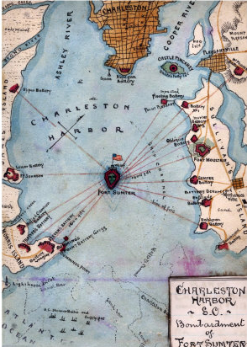 | Things I notice in the image –  - Body of water surrounded on three sides by land  - Label in water – “Charleston Harbor”  - Island in center of harbor  - Label below island – “Fort Sunter”  - American Flag on island  - Label in bottom left corner in water – “Atlantic Ocean”  - Title Box – “Charleston Harbor S.C.”  - Redlines connecting what look like structures along coast to island  - 15 structure  - Labels on structure are difficult to read – One seems to say “Battery”  - Lam  - Land area at top of map a different color (rust-colored, not beige) also contains grid of lines
Structure
- Claim/Topic sentence - responds to prompt - using prompt's wording
  - Sentences of detail
    - reference details observed in document
    - relate ideas in our studies that relate
      - to details in the image
      - the topic in general
- Conclusion -
  - may repeat
  - offer thoughtful comment
    - maybe one generated in class discussion of topic

The image depicts the Confederate attack on Fort Sumter, the first battle of the Civil War. In the center of the image, the little island is labeled Fort Sumter. Fort Sumter was a U.S. fort, as is shown in the image by the Union flag flying over island fort, but since the South had seceded from the Union, it was now in Confederate territory, Charleston, South Carolina. Right above the fort in the image is the label "Charleston Harbor," and these words are also in the title box. This was just one of many forts in the same situation. Lincoln would not give up these forts. He ordered the men in these forts to defend the forts, but not to attack. This caused a stand-off. The stand-off ended, though, when Lincoln informed the Confederates he would resupply Fort Sumter with an unarmed ship. In the image the label "Atlantic Ocean" is in the bottom left corner, showing that the fort would be easily accessible for a supply ship. This caused the Confederates to end the stand-off by attacking, maybe because they would look foolish if they stood by and watched the fort be resupplied. The men in the fort were outnumbered and only shot often enough to make it known that they were still fighting. It did not seem like they were trying to win. They surrendered when fires inside the fort from the bombs made it necessary to, after 34 hours. The image shows 14 red lines coming from positions on the harbor's shore surrounding the fort; these lines probably represent the shot fired on the fort While the South rejoiced at this "win," the North was furious at the U.S. flag being fired upon, which was different than just seceding. This picture was probably draw by a northerner because the fort is in the center with the Union flag dead center, too. Lincoln used the patriotism this caused to request that states send troops to put down a "rebellion' and to order the navy to set up a blockade of Southern ports, like Charleston, so that the South could not export tobacco or cotton or import foreign goods. Thus Lincoln destroyed all economic activity in the South. He probably chose this fort instead of any of the other forts because it was a port, it could easily be resupplied by ship being right at the mouth of the harbor off the Atlantic Ocean, and it was in South Carolina, which had always been the leader of the cotton plantation states and had been the first to secede..

