Discuss the topic presented in the image.
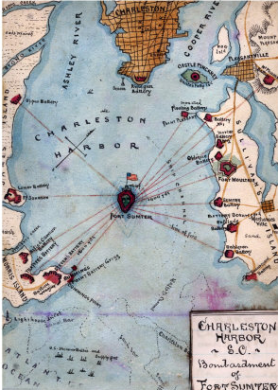 | Things I notice in the image -
Structure
- Claim/Topic sentence - responds to prompt - using prompt's wording
  - Sentences of detail
    - reference details observed in document
    - relate ideas in our studies that relate
      - to details in the image
      - the topic in general
- Conclusion -
  - may repeat
  - offer thoughtful comment
    - maybe one generated in class discussion of topic

The image relate to the Confederate attack on Fort Sumter

