Fitzgerald
Instructions – Making a Timeline
Examine Timelines
- Timelines must be well planned when events overlap so that where each event is placed accurately shows when each event occurs and conveys order of events clearly.
  - The examples show that placing the timeline down the middle and placing events on either side of the line will make this easier.
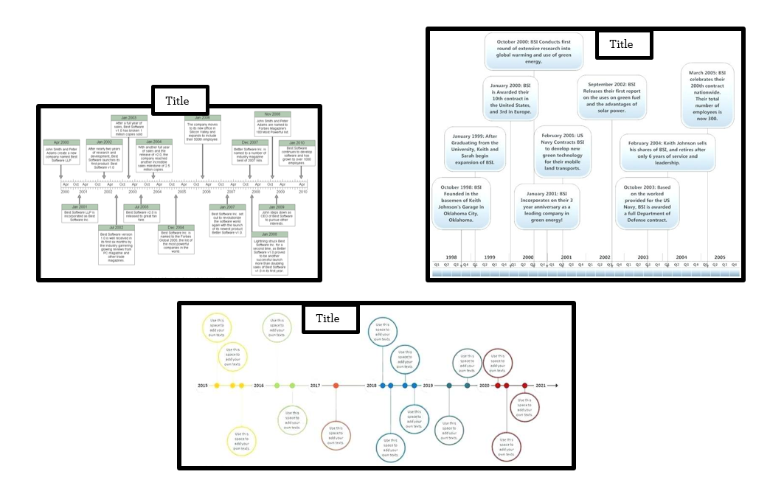
- Draw your timeline down the middle of the paper.
  - Fold the paper neatly in half to easily determine the middle.
  - Draw the line carefully along the middle using the meter stick.
- Choose whose summary of each event the group will use and place the event summaries in order.
  - Each student should identify his or her best summary, which is the one I will grade, and contribute that event and at least three others to the timeline.
  - If a group member does not have four summaries, the other group members need not worry, that will only affect the person himself.
- Choose a logical year to start your timeline and end your time line.
  - Identify your first date and your last date.
  - The first and last events should not be crowded against the edge of the paper.
    - Start at least five years before the first date on a year ending in "0" of "5" and at least five years after the last date in a year ending in "0" or "5," as you will label your intervals every five years.
- Determine the interval for a year.
  - Determine the number of years between the first date and the last date.
  - Measure the length of your line.
  - Divide the length of the line by the number of years.
    - This will be the interval you will mark on the line to indicate one year.
- Label your time line.
  - Place a hash mark along the line every time you measure the interval you determined.
  - Label the first date then every five year interval (counting five hash marks up): 0,5,0,5,0,5,0,5, etc.
- Place your events along the timeline. - Do not tape them down yet!!!
  - Use the space both above and below the timeline, so that you will have room for events in crowded years
  - Balance the number of events above and below the line, alternating them.
  - Plan where you will draw the connecting line between the event and the correct date on the timeline.
    - Make your best effort to make this line as clear as possible, straight from the summary box to the line.
- When all your events are correctly, logically and clearly placed,
  - Tape down each summary box.
  - Draw the straight connecting line to the correct date on the timeline..
- Give the timeline a title that reflects our main idea of examining the events that established the new nation..
  - Clearly worded
  - Creatively worded
- Finishing up
  - Lightly label the initials of the group member who did each summary below the box in small, pencil letters.
  - Each group member should place a star next to the initials below his or her best summary. I will grade the one indicated.

