The French and Indian War (part of The Seven Years’ War)

This conflict that began in North America became part of a battle between the empires of Britain and France.

It started when
French activity in North America expanded south into the Ohio River Valley,
causing conflict with the claims of the British colonies.

A series of battles occurred, with France easily defeating the forces of the British colonies.
This led most Natives to side with France, as they hoped to stop British settlement, which brought farming that ruined their way of life.
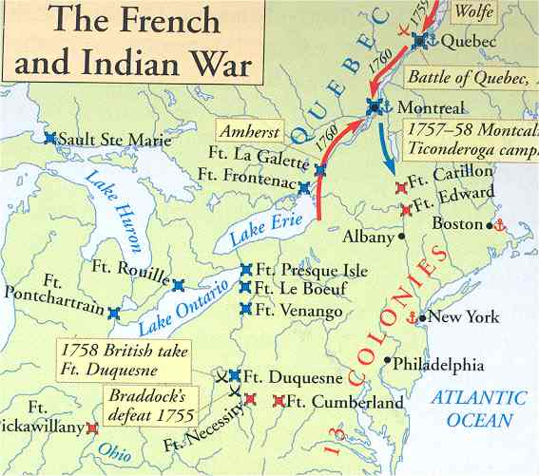

Britain declared war in 1756, and the conflict spread to Europe, the Caribbean, Africa, and Asia, throughout the empires of the two powers. See map below.
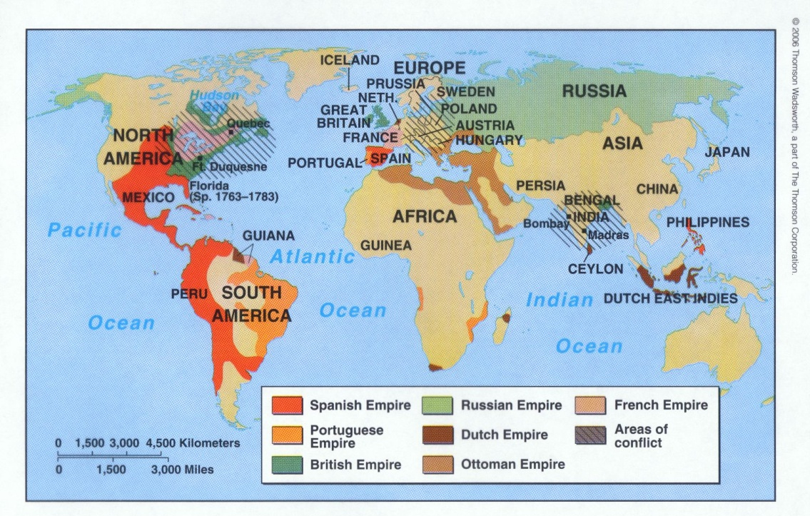
Areas with stripes show conflict.

The new prime minister in Britain saw the battle in North America as key, and borrowed heavily to fund it, sending 20,000 troops.
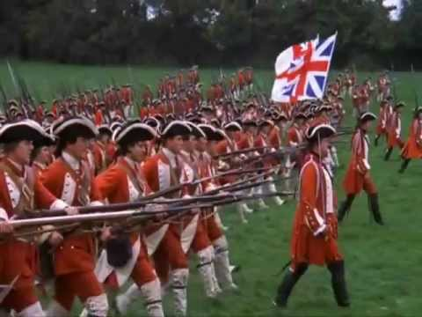
Britain was able to win the war.

Having won, Britain received the territories of
Canada and the land between the Appalachians and the Mississippi River from France and
Florida from Spain. (Notice all the pink!)
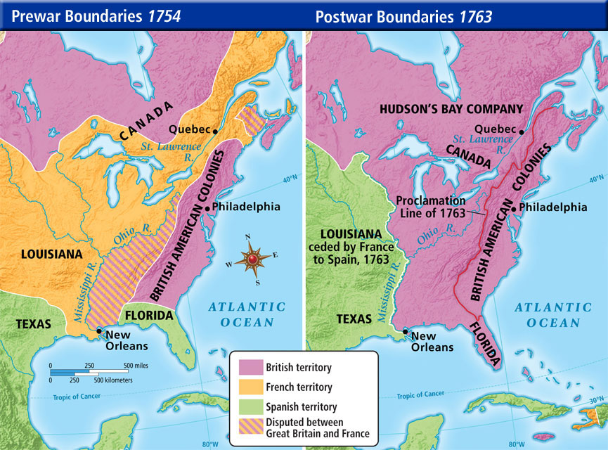

Natives continued to fight British settlement in the land west of the colonies,
especially the Ohio River Valley.

The British had spent MUCH money and Native conflicts were still costing MORE money!

They needed to stop the costs and repay their debts! Sooo . . .

The British outlaw any movement of colonists onto Native land in Ohio and
start taxing the colonies directly.
These actions end any positive relationship the colonies had with Britain.

