Fitzgerald

Strategies of North and South

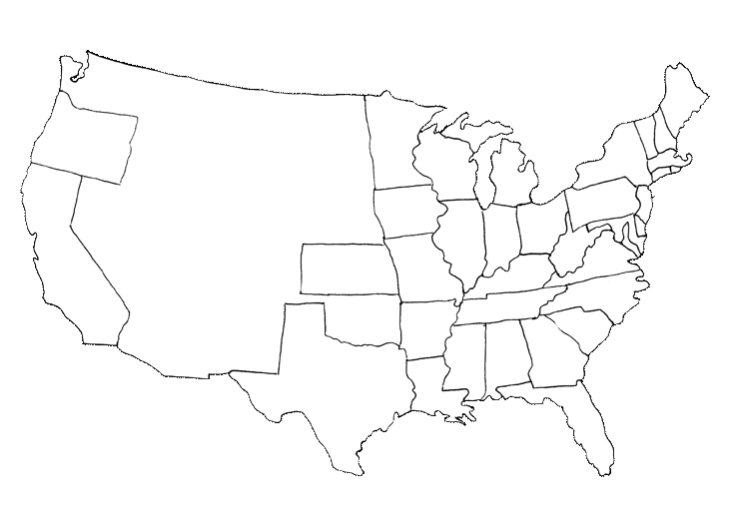

Mississippi River

Ohio River

Union Blockade

The Border States 

Missouri River



**Union Strategy** –

* The Anaconda Plan
  + Developed by General Winfield Scott
  + Three parts
    - Blockade the southern ports, Coast
    - Control the Border States
    - Battle for Control of the Mississippi River – Moving South from the Border States of Kentucky and Missouri, Moving North from New Orleans
    - Shorter term – Attack symbols of South – Richmond the Capital, Virginia the First States, Robert E. Lee

**Confederate Strategy** –

* Fight a defensive War
* Use the power of Cotton to obtain the support of Great Britain (Navy, $, Supplies)