Military Intelligence
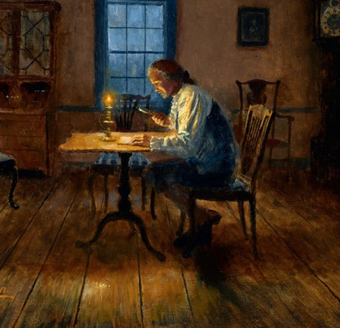
Military intelligence was invaluable to General Washington during the Revolutionary War. Entire spy networks were created to intercept information pertaining to enemy troop movements, supply logistics, and officer’s correspondence, to name a few. Both information and counter-information were crucial in keeping the Americans one step ahead of the British.
A notable example of this occurred in 1775, prior to the British assault on Boston. General Washington discovered a gunpowder shortage in Cambridge, Massachusetts, which rendered the American force too weak to properly defend the region. Using a tactic of false information, Washington ordered all of the gunpowder barrels to be filled with sand and moved outside of Boston. This way, British spies would relay false military intelligence that the rebels were well supplied, making Washington’s position appear stronger than it was. The tactic succeeded, resulting in the British delaying their attack, and allowing Washington crucial time to resupply his troops.

Ciphers and Coded Letters
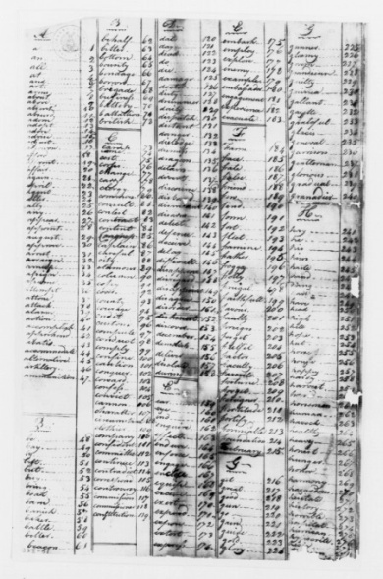
Ciphers and secret codes were used to ensure that the contents of a letter could not be understood if correspondence was captured. In ciphers, letters were used to represent and replace other letters to mask the true message of the missive. The letter’s recipient utilized a key--which referenced corresponding pages and letters from a well-known book, such as Entick's Dictionary--to decode the document’s true message. Some spy groups even created their own pocket guide to serve as a cipher’s key. Similarly, some letters were written in intricate secret codes where numbers and special characters replaced letters, a method most notably practiced by the Culper Spy Ring.

Codes and ciphers allowed information to be masked by an elaborate system of substituted letters, numbers, and symbols. A piece of information would be written out in code, often appearing like gibberish to anyone except its intended recipient. This person possessed a key, or cipher, which translated the code so the true message would be understood.
Benjamin Tallmadge developed the Culper Code Book to encode and translate intelligence gathered by the Culper Spy Ring. This cipher substituted numbers, ranging from 1 to 764, for key words used in correspondence. For instance, 410 stood for “Fort” and 711 was code for “General Washington”. The Culper Code Book proved to be invaluable to the war effort, and was a major factor in the Culper Spy Ring remaining undetected for the duration of the Revolution.

Learn More: The Culper Code Book

Invisible Ink
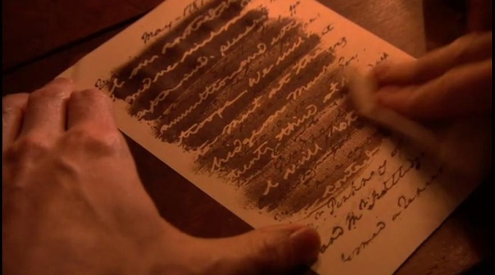
One form of secret writing used by both the British and American armies was invisible ink. During the Revolutionary War invisible ink usually consisted of a mixture of ferrous sulfate and water. The secret writing was placed between the lines of an innocent letter and could be discerned by treating the letter with heat or a chemical substance. The recipient placed the paper over the flame of a candle or treated it with a chemical reagent, such as sodium carbonate, which would reveal the letter’s hidden contents.

James Jay, the brother of John Jay and a physician practicing in England at the time, created a chemical solution out of tannic acid to be used as an invisible ink, and supplied quantities of the stain to the colonists. George Washington himself instructed his agents in the use of what was referred to as the "sympathetic stain," noting that the ink "will not only render. . .communications less exposed to detection, but relieve the fears of such persons as may be entrusted in its conveyance." Washington suggested that reports could be written in the invisible ink "on the blank leaves of a pamphlet. . . a common pocket book, or on the blank leaves at each end of registers, almanacks, or any publication or book of small value.”

Learn More: Decoding John Jay's Cipher

Hidden Letters
British spies placed rolled up letters and small notes into a variety of holsters to hide potentially sensitive information. The hollowed out quills of large feathers that were used as writing utensils, for example, could hide a tightly rolled up letter. Other materials were used to hide messages, ranging from buttons on a textile to hollowed out small, silver balls. One particularly unlucky British spy named Daniel Taylor was caught in New Windsor, New York with a message sent from Henry Clinton to John Burgoyne hidden inside one of these small silver balls. In haste, the spy swallowed the silver ball to avoid detection. However, Patriot soldiers forced the spy to drink a purgative and vomit up the ball. Momentarily undeterred, Taylor grabbed the ball and swallowed it again. Under the threat of being hanged and having the ball cut out of his stomach, Taylor relented. However, Taylor would eventually meet the cruel fate of the gallows, executed on October 16, 1777.

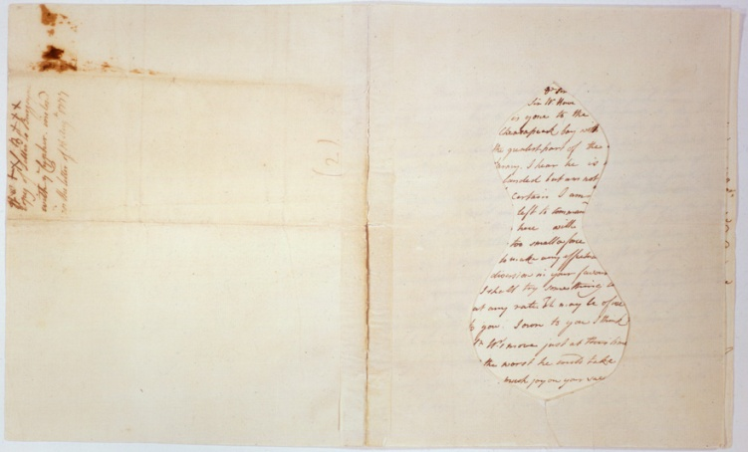
Mask Letters
The true contents of letters were also hidden through the use of mask letters. These documents were intended to be viewed by a recipient who would place a shaped template over the full letter. The true message of the letter would then appear within the boundaries of the “mask.” The letter and the “mask” were usually delivered by separate couriers to ensure that the trick would go undetected.

Dead Drops
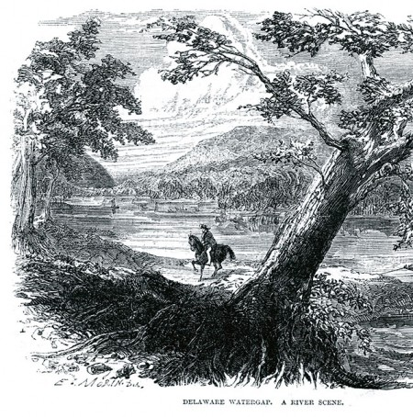
Dead drops are secret locations that allow two individuals to pass messages to one another. They were widely used during the American Revolution, often existing in remote locations so as to not draw the attention of the enemy. They are particularly effective because the agents involved never have to meet in-person.
The Culper Spy Ring utilized dead drops when the new information was ready to be transported. Robert Townsend, aka Samuel Culper Jr., utilized a dead drop when passing information through Setauket. A courier would leave Townsend’s information at a dead drop in a field owned by Abraham Woodhull, who would in turn pass the information along to Caleb Brewster via dead drop. This sophisticated system of espionage allowed the Culper Spy Ring to operate in secret through the entirety of the Revolutionary War.

Identifying Marks and Clothes
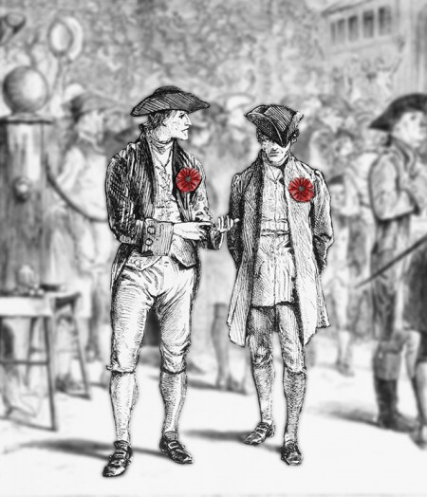
The American Revolution was fought in the open, amongst the people. As such, spies often relied on their ability to blend into normal society in order to operate effectively. Subtle usage of identifying marks and clothing were used to signal fellow agents to one’s true allegiance.
Ann Bates, a British spy posing as a patriot, employed this tactic in 1778. Posing as a refugee, Bates was able to enter General Washington’s encampment at White Plains. She carried a small token that identified her as a British loyalist to an American officer who was also spying for the British. Because she was a woman, she was able to move freely through the camp, taking detailed notes of the military strength therein. The information she gathered was passed onto to British General Henry Clinton, who subsequently reinforced the British presence in Rhode Island. This ultimately resulted in French and American forces withdrawing from Newport.

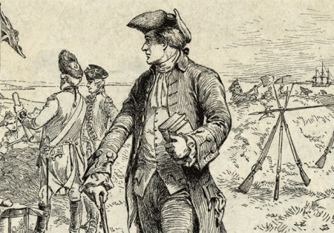
Couriers
Couriers were invaluable to American spy networks during the Revolution. Their job was to transport information between agents within a spy ring. They would carry intelligence back and forth across enemy lines, a task that was extremely perilous. Couriers caught with intelligence faced execution by the British.
Austin Roe was the main courier for the Culper Spy Ring. He was a childhood friend of Abraham Woodhull, Benjamin Tallmadge, and sever other figures of the Culper Spy Ring. He became an active member of the ring in 1777, after which he would routinely carry American intelligence between Setauket and New York City, a journey of 55 miles one-way. Roe presented himself as a merchant, which helped justify his high volume of travel between British military centers. He was able to remain active and undetected for the duration of the revolution, later becoming known as the “Paul Revere of Long Island”.

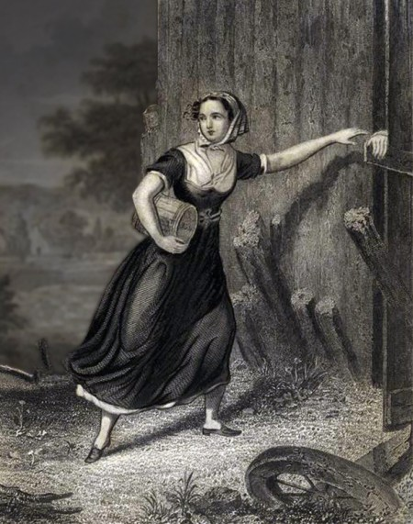
Secret Signals
Secret signals were used throughout the American Revolution to aid communication among American spy networks. They were powerful tools in espionage, because they could be displayed in plain sight. Simple items could be set in specified patterns to alert fellow agents of new intelligence, to designate meeting apices, or convey to simple actions.
Anna Strong joined the Culper Spy Ring after her husband Selah Strong was imprisoned by the British under suspicion of espionage. Within the Culper Spy Ring, Anna Strong utilized secret signals to communicate to her fellow agent Caleb Brewster. She would hang a black petticoat on her clothesline, which sat on a high vantage point overlooking Long Island Sound. Brewster would discreetly enter the waterway, and would be directed to one of several dead drop locations that contained new intelligence to be transported to the American leadership.

