Natives of the Northeast

This region is cold in winter, with deep snows, and often hot in summer. The region contains deciduous and coniferous trees. From these trees, the native people made an enormous variety of tools: houses, containers, canoes, bows and arrows, ritual and subsistence equipment. From some of the trees came foods: nuts and fruits. The forests also were the habitat of much of the game hunted by the native peoples: bear, wolf, fox, moose, deer, along with numerous smaller game animals and birds. From the lakes natives took fish of several kinds while along the ocean shores shellfish in uncountable numbers were regularly harvested. Numerous wild foods were harvested in a seasonal cycle: rice, maple sap, berries, nuts, onions, yellow waterlily roots. Many nations, in addition to acquiring food by hunting, fishing, trapping, and collecting, some also farmed maize (corn), several types of beans and squash, and, in some areas, tobacco.
All natives in this region had a subsistence lifestyle, with three basic subsistence patterns: gathering-hunting, a mixed hunting/farming pattern, and all farming. The balance of the diet came from game, fish, and wild plants, and a highly nutritious combination of three basic crops: maize, beans, and squash. 50% farmed corn. Women were the primary cultivators, but men helped to prepare the fields. Corn, beans and squash were planted together, with the corn was planted along a central mound along with beans that could climb the corn stalk and squash was planted between mound rows. Such planting methods conserved moisture, prevented weed growth, and resulted in a high yield per acre. Gathering was primarily carried out by women and children. Hunting, on the other hand, was always a man's job, and deer were the primary game animals. Several groups used dogs for hunting. People in coastal areas caught eel and other fish, and collected shellfish. Men stalked seals sunning or rocks near shore, and larger fish were speared and netted from boats.
Settlements ranged from small villages of one or two houses to large towns encompassing several acres. Common dwellings were wigwams, oval- circular- or pyramidal-shaped wigwams framed with saplings and covered with overlapping strips of bark, woven mats, or skins. These houses were relatively easy to construct and take down, and could be adapted to all weather conditions. The Iroquois built longhouses (Iroquois). Gathering-hunting groups tended to come together in the winter in one base camp, living in single- or extended-family dwellings, hunting large game and trapping smaller animals.
Some groups built large wooden structures for rituals and council meetings in the center of villages.
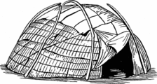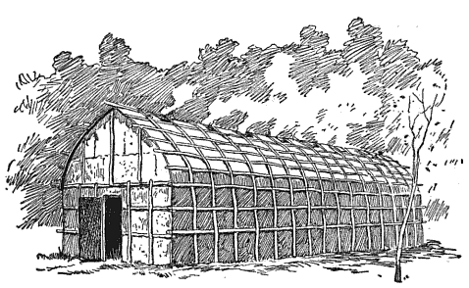
Political Organization varied from the highly structured League of the Iroquois to the much simpler forms of semi-nomadic gatherer-hunters: nuclear families and bands or group of bands led by a leader chosen by the community. In some nations there were councils headed by chiefs. Occasionally, nations also formed alliances, the most famous being the Iroquois Confederacy of 5 and later 6 tribes. This confederacy lasted 100s of years and played a major role in European conflicts including the American Revolution.
Social Organization varied widely. Many of the gathering-hunting groups recognized clans, a group of people all of whom claim descent from a common ancestor. Some groups based clans on descent from a common mother, others from a common father, and still others from both. Clans in northeastern groups were often associated with specific animal totems and membership in a clan was the basis for all social interaction. In many areas hereditary leadership was the norm. Among some groups, there were two such leaders: a civil leader and a war leader. Land was owned in common by the group with members having use rights but not ownership rights.
Two religious practices are commonly associated with this region. Warriors sought guardian spirits and supernatural help, either in dreams or during vision quests. Shamans, or medicine men, were the primary curers, although there also existed among some nations medicine societies.

Natives of the Southeast
The vegetation of the Southeast was dominated by pines, which were maintained by regular burning of the underbrush to provide good browse for the prime game, deer. Oak and other deciduous trees, many bearing edible nuts, cover the uplands. Cypress trees flourish in the many swamps. Tidal marshes are found along the coast. There are three environmental zones: the coastal plains, the foothills (known as the piedmont), and the Appalachian Mountains.
Native were subsistence farmers, growing corn, beans, and squash together. Most of the agricultural labor was provided by women, although men helped clear the fields. Women also were generally responsible for gathering wild plant foods, honey, and other materials. Hunting was a critical source of food and materials with deer being the primary game animal and providing meat, skins, hooves, and bone for many uses. Although a man might hunt deer by himself, deer were also hunted by groups of men using both fire and dogs. Bears were also hunted (both for their meat and for their fat, which was rendered into oil), as were opossums, squirrels, rabbits, turkeys, and waterfowl. Crabs, crawfish, shellfish, and fish were also caught.
Settlement tended to be larger than many in the Northeast. Many groups had at least one permanent town, where the bulk of the people lived. Some of these towns were quite large (covering hundreds of acres and containing thousands of people), laid out with planned streets, residential and public areas, surrounded by a palisade (stockades of upright posts), with moats or earthworks for protection. Sturdy thatched-roofed houses had mud-plastered walls over poles interwoven with reeds or branches. Families of a common mother usually lived next to each other. Following their wedding, a couple generally moved to the wife's village, building a house near the wife's mother and her female relatives.
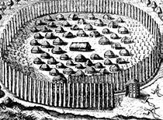
The common form of political organization was a chiefdom with a high levels of military organization. The people were ruled by an elite, some of whom seemed to have been given a god-like status, and the peoples' lives were governed by complex religious beliefs and elaborate rituals. Towns were usually independent, but almost always allied with other nearby towns into confederations. Each town had a council comprised of the most influential household leaders.
Social Organization was based on clans descended from a common female ancestor. Land was owned by the clan. Clans were associated with particular types of leaders, one clan being the one political leader came from, another, war leaders, another religious leaders.
Religious beliefs and practices had the primary goal maintaining harmony. Most towns had an eternal sacred fire burning in a temple, symbolizing continuity and harmony. The major religious observances in the Southeast were for planting and harvest. The Green Corn Ceremony was the major ceremony. This ceremony was held over a 3-day period. On the first day, the men refurbished public buildings and the women cleaned the town. On the second day, outstanding issues, such as disputes, divorces, crimes, and arguments, were settled. On the third day, a feast was held in the morning, and in the afternoon, the sacred fire was renewed.

