Fitzgerald
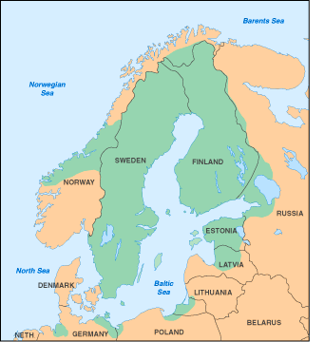
Swedish Colonization in North America in the 17th Century
In the 17th century, Sweden was one of the major military and political combatants in Europe. By mid-century, the kingdom included part of Norway, all of Finland and stretched into Russia. Sweden also controlled of portions of modern Poland, Latvia, Estonia, Lithuania and Germany, and so controlled much of the land around the Baltic Sea.
Perhaps inspired by the riches other Great Powers gathered from their overseas colonies, Sweden too sought to extend its influence to the New World. In 1637, Swedish, Dutch and German stockholders formed the New Sweden Company to trade for furs and tobacco in North America. The company's first expedition sailed from Sweden late in 1637 in two ships under the command of a man who had been the governor of the Dutch colony, New Netherland, centered on Manhattan Island, from 1626 to 1631.
The ships reached Delaware Bay in March 1638, and the settlers began to build a fort at the site of present-day Wilmington, Delaware. They named it Fort Christina, in honor of Sweden's twelve-year-old queen. It was the first permanent European settlement in the Delaware Valley.
During the next seventeen years, eleven vessels and some 600 Swedes and Finns arrived in New Sweden. The colony eventually consisted of farms and small settlements along both banks of the Delaware River into modern Delaware, New Jersey, Pennsylvania and Maryland.
From 1643 to 1653, settlers extended the settlement northward from Fort Christina along both sides of the Delaware River and improved the colony's military and commercial prospects by building Fort Elfsborg on the New Jersey side of the river to stop English and Dutch ships from sailing up the Delaware River into this colony. The settlers also tried to remove the Dutch settlers in New Sweden, angering the governor of the Dutch colony of New Netherlands.
Seven armed Dutch ships and 317 soldiers were sent to the Delaware River. Realizing that resistance would be useless, the vastly outnumbered Swedes surrendered. Swedish rule over New Sweden was at an end, but the Swedish and Finnish presence remained. The Dutch permitted the colonists to continue as a "Swedish Nation" and be governed by a court of their choosing, be free to practice their religion, organize their own militia, retain their land holdings and continue trading with the native people. This independent "Swedish Nation" still existed when the Englishman, William Penn received his charter for Pennsylvania and the three lower counties, present-day Delaware, where the Swedish lived. Swedes and Finns continued to settle in New Jersey, Delaware and Pennsylvania.
from "A Brief History of New Sweden in America" by the Swedish Colonial Society, http://colonialswedes.net/History/History.html

