European Colonization of North America

- Natural resources like gold, silver, furs, and crops attracted European nations.
- Rivalry between European nations was rooted in religious feuds taking place in Europe.
- The Spanish were the first to colonize and focused on Central America, and they were followed by the French, Dutch, and British focused on North America.

European Motivation for Colonizing

It is often said that the three reason European nations sought colonies in North America were God, Gold, and Glory. The word “Gold” represents not just gold but any valuable natural resource, such as furs or crops like sugarcane, indigo, rice, tobacco, and later cotton, that couldn’t be found or grown in Europe. “Glory” just refers to the fact that the nations were battling to be the dominant nation in Europe. “God” refers to a religious dispute between the nations.
Part of the battle for North American colonies between European nations was driven by the fight between Catholic nations and nations that had left the Catholic faith to join the new Protestant branch of Christianity. Since the fall of the Roman Empire there had only been two forms of Christianity: the Catholic faith in western Europe and the Orthodox faith in eastern Europe.
In the 1500s, people started to form new faiths, breaking away from the Catholic faith because they disagreed with, or “protested,” some practices of the Catholic faith. Two common practices they protested were holding the services in Latin and only allowing the Bible to be written in Latin and not allowing priests to marry. The Protestant faiths printed the Bible in the languages of the people and held services in those languages and had ministers who married, not priests. England and the Netherlands had become Protestant nations.
The King of Spain was determined to stop the growth of Protestant Christianity and return these nations to the Catholic faith. The King sent a massive force of over thirty thousand men and 130 ships to invade the Netherlands and England. This naval force was known as the Spanish Armada and was largest naval force ever assembled at that point in history. But the skilled English navy and a bad storm at sea destroyed this fleet in 1588. The defeat of the Spanish Armada was only one part of a larger but undeclared war between Protestantism and Catholicism.

God | Gold | Glory
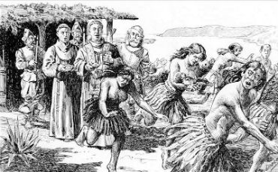 | 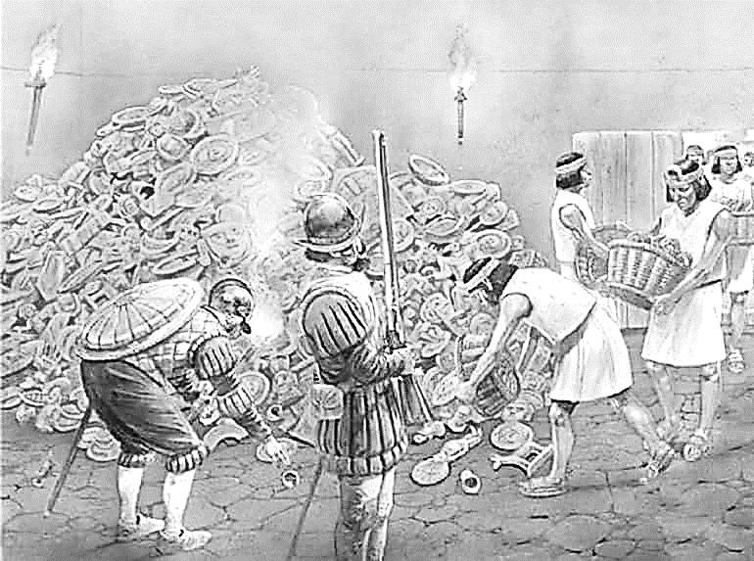 | 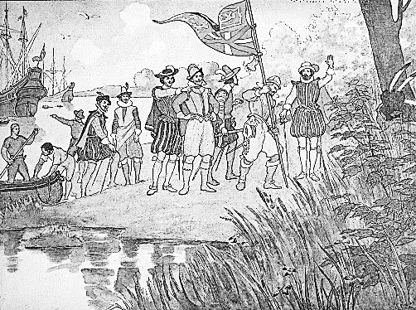

Spanish Colonization

Though Spanish explorers originally were looking for a passage to Asia through the Americas, they quickly learned that there were riches to be found in the Americas themselves. One area of Spanish focus was the Aztec empire. One place that came to the attention of the conquistadors was Tenochtitlan, the capital of the Aztec Empire.
Now, the Aztecs were not well loved in Mexico. The Aztecs ruled harshly over a vast territory, and they forced many smaller tribes to pay them tribute and provide them human captives for sacrifice. So in 1519, when the Spanish conquistador Cortes landed with a group of about 600 men, he was able to gather about 20,000 Native Americans on his way to attack the Aztec capital of Tenochtitlan.
The Aztec empire was powerful, and its ruler greeted the Spanish without fear. Tenochtitlan had about 200,000 to 300,000 inhabitants, larger than any city in Europe! It sat in the middle of a lake with hanging gardens and an aqueduct and had incredible pyramids that were many stories tall. The Spanish had things that the Aztecs had never seen before, like horses, gigantic war dogs which they used to rip apart their enemies, and cannons. Quickly the relationship between the two sides became hostile. Aided by their Native American supporters and the spread of European diseases, the Aztecs Empire fell.
Besides the devastation of the disease, the Spanish turned out to be much crueler masters than the Aztecs. Spain encouraged Spaniards to immigrate by promising them land and the right to enslave the Natives to mine for gold, clear land, and raise crops. The Spanish also forced the Natives to practice Catholicism. The Native population of this region went from about 20 million when the Spanish arrived in 1519 to only about two million by 1600, meaning 90% of the population was lost in 80 years. The Spanish soon began importing slaves from Africa to replace the lost Native workers.
The Spanish established colonies in Florida and Cuba and other Caribbean islands as places to set up forts and harbors for the Spanish navy. Spain needed the navy to protect Spanish ships carrying gold and other valuable cargo. These ships were very vulnerable to attack when they were weaving through the Caribbean islands to enter the open Atlantic and return with the currents to Spain. Pirates occupied small Caribbean islands as bases from which to attack the ships. The pirates used fast, highly maneuverable ships equipped with canons to attack the slow Spanish cargo ships. The cargo ships traveled in groups, seeking safety in numbers, and Spanish naval vessels were stationed in harbors attached to ports along the shores of the Florida peninsula, Cuba, Puerto Rico, and other islands and sent out to protect these “caravans.”

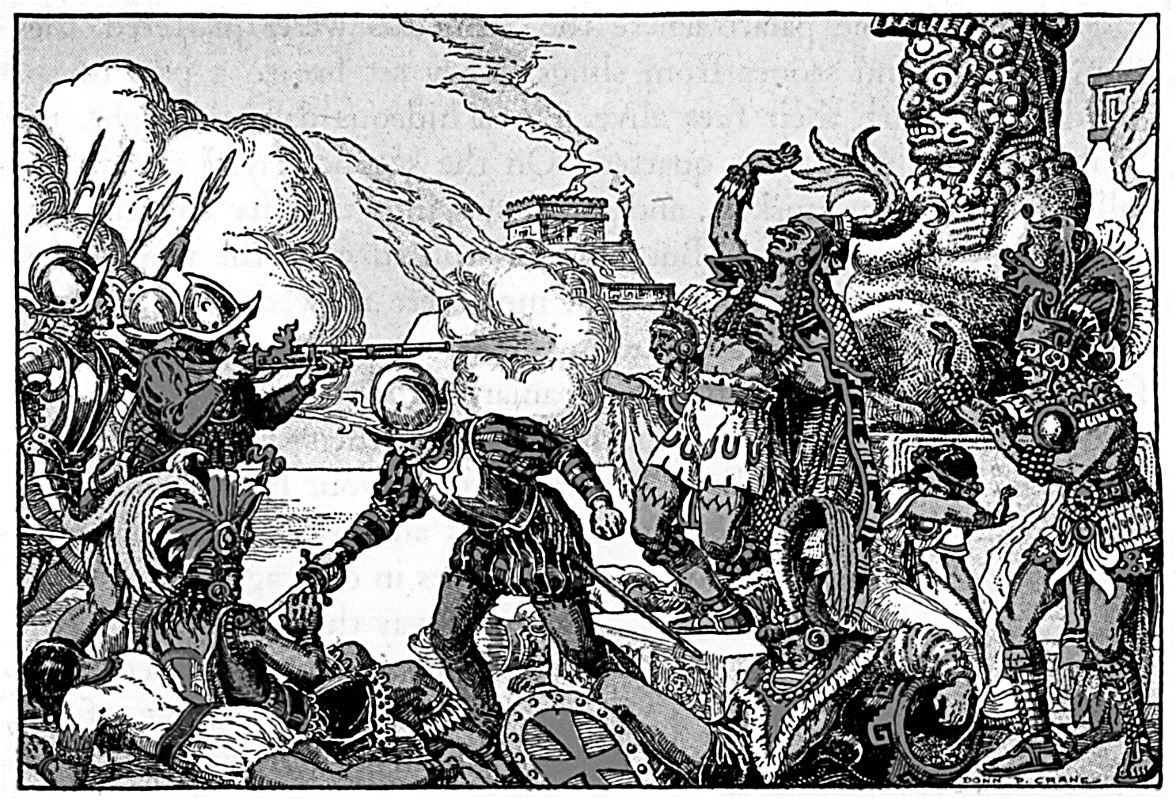

- Link to Khan Academy video discussing Spanish colonization: https://www.khanacademy.org/humanities/us-history/precontact-and-early-colonial-era/spanish-colonization/v/spanish-colonization

French and Dutch Colonization

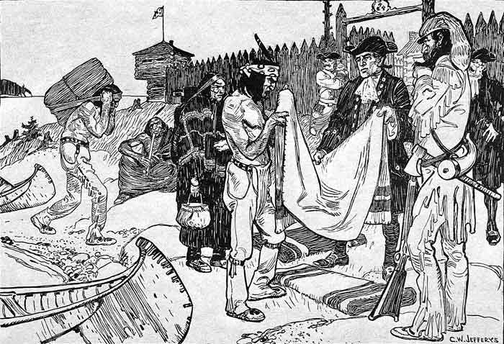
France
Spanish successes in the Caribbean attracted the attention of other European nations. Like Spain, France was a Catholic nation and wanted to expanding Catholicism around the globe. Also like Spain, France was also interested in obtaining natural resources.
In the 1500s, it joined the race to colonize the New World and exploit the resources of the Western Hemisphere. In 1534, France claimed the area around the St. Lawrence River and named it New France. The French built an extensive trading network along the St. Lawrence River that they later extended to the Great Lakes. They relied on Native hunters to harvest furs, especially beaver pelts, and trade the furs for French goods, particularly metal goods, like pots, guns, and bullets.
Following behind French traders were French missionaries. The missionaries sought to convert Native Americans to the Catholic faith. Missionaries like Pere Marquette worked in the Great Lakes and later down the Mississippi River to New Orleans.
France also sought to form colonies in the Caribbean. By 1635, France had colonized two small islands. Like Spain’s Caribbean colonies, the French colonists in the Caribbean started lucrative sugar cane plantations using African slave labor.

The Dutch
After the Spanish invasion failed, the Netherlands quickly sought to become involved in the New World. Powerful Dutch corporations quickly established themselves as leaders of trade. Two well known companies were the Dutch East India Company, which focused on trade with Asia, and the Dutch West India Company, which focused on trade in the Atlantic with Africa, the Caribbean islands, and North America.
The Dutch also explored the Hudson River and established a colony at the mouth of the river as a base for trading with Native Americans for furs. This colony was named New Netherlands and would later become New York.

In Conclusion
Both the French and the Dutch focused on trade, so neither established permanent colonies peopled by immigrants from their nation. French settlements were made up of fur traders, merchants, and missionaries and so had fewer than 5,000 settlers by 1672. Dutch settlements were also small, and only about half of the residents were Dutch, as the Netherlands encouraged settlers from many Protestant nations in Europe to come to their colonies.
Because the goals of both the French and Dutch revolved around the fur trade, the French and Dutch kept good relationships with Native Americans, unlike the Spanish and English. Both the Dutch and the French relied on marriages with Native Americans to help secure their fur trading operations.

- Link to video discussing French and Dutch colonization: https://www.khanacademy.org/humanities/us-history/colonial-america/early-english-settlement/v/french-and-dutch-colonization

British Colonization

Britain was the last major European nation to seek colonies in North America. Three key events were holding Britain back. First, England was busy conquering its neighboring island, Ireland. Second, England was in a warring states period, with forces battling to establish a new ruling dynasty. Third, England was experiences conflict between those who wanted England to become a Protestant nation and those who wanted England to stay Catholic. Those who supported Protestantism won, and this led to England, with the Netherlands, being attacked by the Spanish Armada.
After defeating the Spanish Armada, Britain was ready to compete with Spain, and set out to spread the Protestant faith and seek natural resources by establishing colonies in North America. Britain sought to find gold as Spain had, to establish sugarcane plantations on Caribbean Islands, and wanted in on the fur trade with Native Americans.
Britain followed the Dutch model, and its first colonies were established by corporations, or joint stock companies as they were known then. Instead of the king financing the colonies, people could buy shares in a joint stock company. No single investor had to put up all the money. If the company made a profit, the value of the stock went up and all those who held shares received some of the profit. If the company failed, each investor would only lose the amount he had chosen to invest. The risk was spread between all the investors.
Spanish colonization was led by conquistadors and missionaries, with few Spanish citizens immigrating to become landholders on huge estates granted by the crown. French and Dutch colonization was dominated by men who came as traders. But from the beginning, British citizens immigrated to the colonies.
The first attempt to start a colony attempted failed, in a large part because it was financed by a single person who could not provide all the colony needed and lost all his money when the colony failed. All those who had come mysteriously vanished and were presumed to have died. But the second colony began the tradition of colonies being funded by a joint stock company. The Virginia Company was named after Queen Elizabeth. Queen Elizabeth I was first queen to ever rule England, and she masterfully brought peace to the nation. She never married because if she picked a Protestant the Catholics would be mad and if she picked a Catholic the Protestants would be mad. Her marriage would only return the nation to war, and she would lose power as her husband would rule instead. Being unmarried, Elizabeth the I was called the Virgin Queen. The first colony established by the Virginia Company became known as Virginia. Its first settlement was Jamestown. Here, too, the first settlers to come did not survive, but the colony survived and found a way to profit.
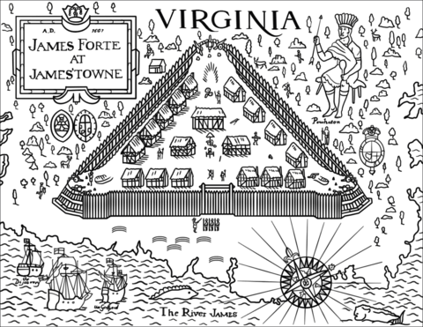

- Link to video discussing British colonization: https://www.khanacademy.org/humanities/us-history/colonial-america/early-english-settlement/v/motivations-for-english-colonization

