Fitzgerald
Reading - Hamilton's Financial Plan, from textbook pp.285-287

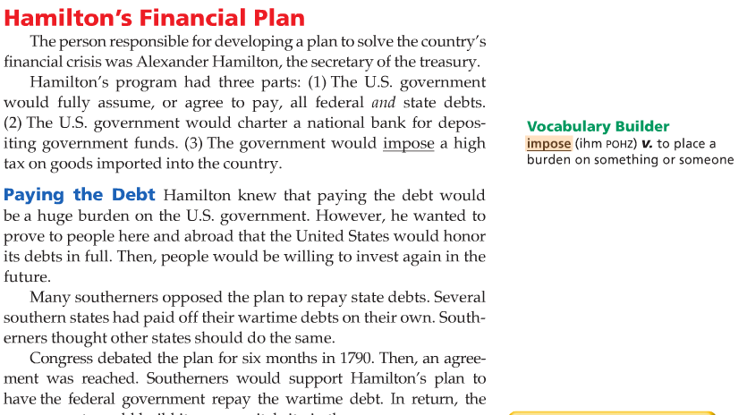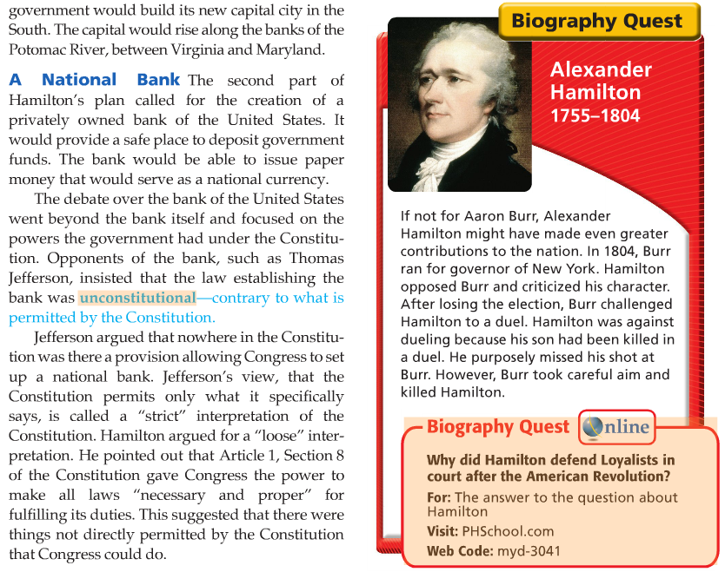

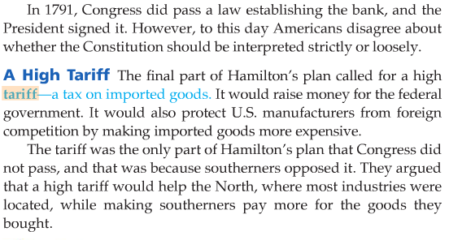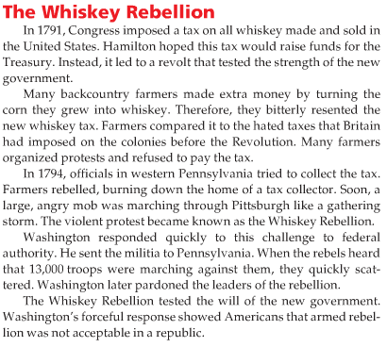
pp. 285-287

General Review
https://www.youtube.com/watch?v=aUPP_xQAg9I
PowerPoint - Specific Review
https://slideplayer.com/slide/7937232/
Raising Money - Bonds
https://www.youtube.com/watch?v=Gw7P82kOOs8
Whiskey Rebellion
https://www.youtube.com/watch?v=DOKtDi4li3k

The Bonds Scam
- Revolutionary War Soldiers had been paid in bonds because the government had had no cash.
  - Bond is a certificate that states that the government owes the holder of the bond a debt, to be repaid in a certain number of years at interest.
- These bonds had not been honored after the war because the economy was bad and the national government had no money still.
  - People had begun to think they would never be honored.
- Wealthy men knew that Hamilton's plan included paying back all Revolutionary War debts like these bonds, but many poor soldiers did not.
  - Some wealthy men went around offering to buy these bonds for less than they were worth from poor people suffering from the bad economy.
    - They knew that the poor people needed the money and so would accept the lower amount.
- Then the wealthy men would get the full amount when the plan was approved by Congress.

