Fitzgerald

https://www.masshist.org/revolution/non_importation.php

Colonial Boycotts - Non-consumption and Non-importation

Colonists were angry that Parliament was passing taxes for them instead of their representatives in their own colonial legislatures. Boycotts of British goods, or non-importation agreements, were organized to put pressure on Parliament to repeal these taxes. Colonists pledged to not buy British goods, store owners pledged to not sell British goods, and merchants pledged to not import British goods. If Britain could sell no goods in the colonies, British businessmen would lose money, and Britain would collect no tax money from the taxes on the goods. Thus Parliament would have to repeal the acts

The message about the boycotts was spread to all. The city council urged citizens to "save your money and save your country!" Newspaper columns appealed directly to women, explaining the benefits — economic, political, and amorous—of boycotting British goods. Colonists who imported, sold, or bought British goods faced threats of violence, and the names of many were printed on the front page of the Boston Chronicle. By vowing to suspend trade with non-participating colonies, Boston merchants spread the word to other colonies, getting merchants in New York, Philadelphia, and other ports to join the boycott.

Patriotic colonists were expected to only purchase goods made in America. As cloth was the most common British good imported, clothing made with homespun cloth became a badge of patriotism, and holding spinning and weaving parties became a way daughters of liberty showed their loyalty to the cause of liberty.

The boycotts were successful, and the taxes were repealed by Parliament, all except the tax on tea, leading to the famous protest known as the Boston Tea Party.

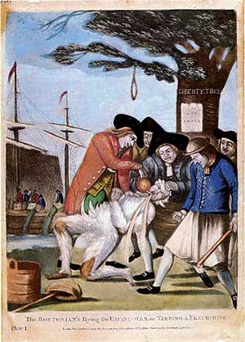
Reading - Tarring and Feathering

Tarring and feathering was a form of mob punishment in which a person is stripped of his clothing, held down, covered with melted tar, then rolled in feathers, and finally tied onto a fence rail or cart, paraded through town, and left at the outskirts of the town, where it was understood he was to leave and never return.

It became more common after the Stamp Act, the set of direct taxes designed to punish colonists for protesting taxes set by Parliament, and it was used to threaten those who collected taxes or violated boycotts . Tax officials also faced their homes being attacked and ransacked by mobs.
The famous cartoon depicting a man being tarred and feathered was published in a British newspaper. It shows a tax collector being tarred, feathered, and forced to drink tea by a group of rebellious Bostonians. The Stamp Act hangs upside down on a tree. The tree also holds a waiting noose. In the background, rebels dump tea into the harbor.

November 1, 1765, the day the Stamp Act was to officially go into effect, there was not a single stamp commissioner left in the colonies to collect the tax.

