Fitzgerald

Reading and Notes -
Plan for Bringing New States into the Union -
Developed by Article of Confederation Congress

Video - https://www.youtube.com/watch?v=A_sfcKxPwYA

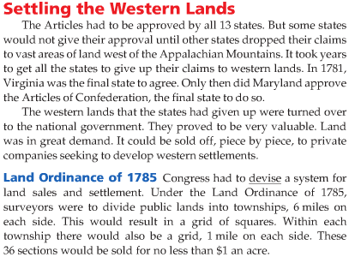
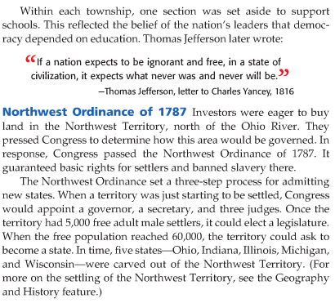

Textbook pp. 206-207

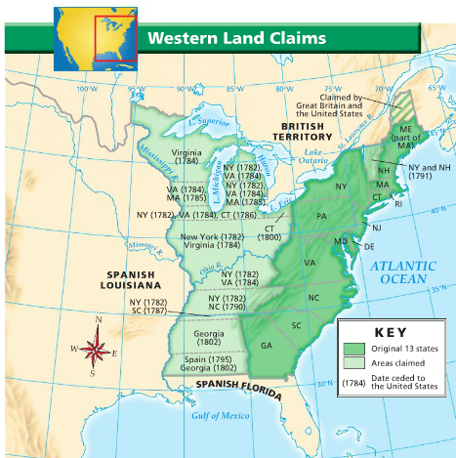
Textbook, p. 207

