Fitzgerald
Primary Source Document - Nativism

Title: Basic Principles of the American Party of Virginia, a branch of the Nativist Know-Nothing Party
Date: 1856
Location: Virginia, the United States
Description: List of thirteen principles with the general purpose "to preserve our political institutions in their original purity and vigor, and keep them unadulterated and unimpaired by foreign influence."
Introduction: Formed in the early 1840s, the Know Nothing movement was a reaction to German and Irish immigration to the United States. members of the party saw these newcomers as a “foreign invasion” that threatened to influence American politics and religion. They sought to limit immigration and citizenship and played on native-born fears of "outsiders." Members of the movement claimed that new Catholic immigrants would seek place America under the control of the Pope, the head of the Catholic faith. The movement was organized through private social and political clubs and political and spread unsubstantiated stories about dangerous immigrants to draw supporters to their cause. Followers of this movement formed the Know Nothing Party, otherwise known as the American Party and the Native American Party. By 1856, it had gained enough support to back a candidate for president who campaigned for shutting down immigration to the United States and stopping the rise of the Catholic faith in America.

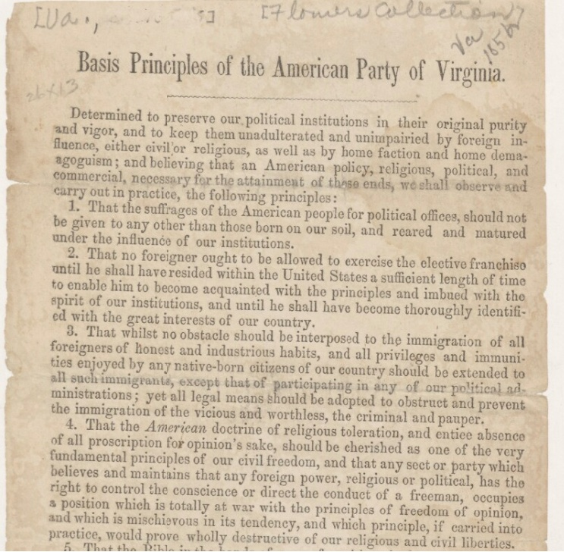

On the following page find a partial transcript of this document, which is held in David M. Rubenstein Rare Book & Manuscript Library at Duke University.

The Basic Principles Of The American Party of Virginia, 1856

Determined to preserve our political institutions in their original purity and vigor, and to keep them unadulterated and unimpaired by foreign influence, either civil or religious . . . ; and believing that an American policy, religious, political, and commercial is necessary for the attainment of these ends, we shall observe and carry into practice the following principles:

1. That the suffrages [votes] of the American people for political offices should not be given to any other than those born on our soil and reared and matured under the influences of its institutions.

2. That no foreigner out to be allowed to exercise the elective franchise [the vote] until he shall have resided in the United States a sufficient length of time to enable him to become acquainted with the principles and imbued with the spirit of our institutions, and until he shall have become thoroughly identified with the great interests of our country.

3. That whilst no obstacle should be interposed to the immigration of all foreigners of honest and industrious habits, and all privileges and immunities enjoyed by any native-born citizens of our country should be extended to all such immigrants, except that of any participating in any political administration. Yet all legal means should be adopted to obstruct and prevent the immigration of all the vicious and worthless, the criminals and the paupers [poor].

4. The American belief in religious toleration . . . should be cherished as one of the very fundamental principles of our civil freedom, and that any sect [religion] which believes that any foreign power, religious or political, has the right to control the conscience or direct the conduct of a free man, occupies a position that is totally at war with the principles of freedom of opinion. . ., and if carried into practice, would prove destructive of our religious and civil liberties.
(Note the link to the fact that the head of the Catholic church is the pope and the center of the Catholic church is in the Vatican City, in Rome, Italy.)

5. That the Bible in the hands of every free citizen is the only permanent basis of all true liberty and genuine equality.
(Note - The practice of reading the Bible daily was Protestant. Catholics still heard the scripture only at Mass and then in Latin, not their native language.)

6. That the intelligence of the people is necessary to the right use and the continuance of our liberties, civil and religious; . . . .
[The Principles go on; there are 13.]
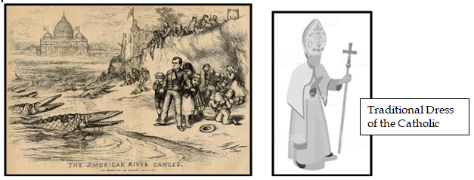
Fitzgerald
Primary Source Document - Nativism - Accommodated

Introduction:
- The Know Nothing movement started in the early 1840s
- called "Know Nothings" because were a secret group
- said immigration was like a foreign invasion - too many immigrants coming
  - hundreds of thousands came
  - mostly Irish due to potato famine
  - they were afraid immigrants would take over
- Especially hated the Irish because they were
  - uneducated
  - poor
  - a different religion
  - the largest group
- They formed a political Party in 1856 to get a president elected
  - called the American Party
  - goals - stop immigration, stop the Catholic religion from growing in America
Title of Document:
- Basic Principles of the American Party of Virginia, branch of the Nativist Know-Nothing Party
Date:
- 1856
Description:
- The Nativists formed a political party called the American Party.
- They were trying to get a Nativist elected to be president.
- This is a list of things the people in the political party called the American Party of Virginia believed.
- Their goal was to keep America "pure." They didn't want immigrants to change America.

On the next page important ideas in this document are typed up for you to read.

This document is in a rare book collection at Duke University.
The Basic Principles Of The American Party of Virginia, 1856 (ACC)

We believe in the following things should be done to keep America the way it is and keep it strong.
We believe we need laws like these to keep foreigners for hurting the American government, America's economy, or America's religion.

1. Only those people who are born and raised on American soil should be able to be elected.

2. immigrants should not be able to vote until they have lived here long enough to understand America's "spirit" and be completely supportive of America's "interests."

3. Honest and hard-working immigrants should be able to come in, but "vicious and worthless" immigrants who are criminals or poor should not be let in.

4. Any religion that is based in a foreign country and tries to control the way people think and act should be treated as something that violates America's belief in freedom of religion and freedom of thought.
(Note -
Most Americans were Protestant.
This refers to the Catholic church.
It is based in Rome, Italy.
The Catholic church service was said in Latin and the Bible was written in Latin not English, so the people relied on priests to interpret the Bible,)

5. Only people who read the Bible themselves understand liberty and equality.
(Note - Then, only Protestants read the Bible every day. The Catholic Bible was written in Latin.)

6. Only intelligent people can protect American rights.

There were 7 more principles .

Document Analysis Question - What ideas from our notes on Nativism do you see in this document? What do you think of those ideas?

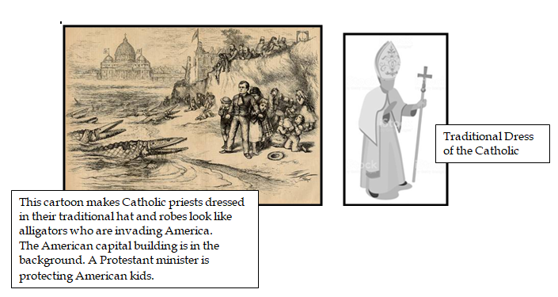

This cartoon makes Catholic priests dressed in their traditional hat and robes look like alligators who are invading America.
The American capital building is in the background. A Protestant minister is protecting American kids.

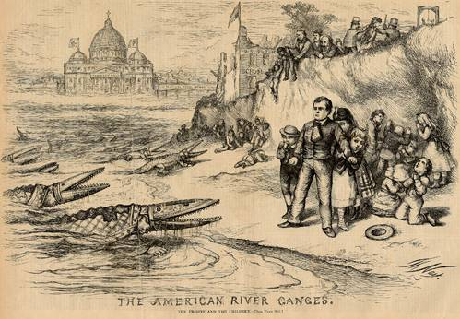
Traditional Dress of the Catholic Pope

Traditional Dress of the Catholic Pope

