This 1848 letter is from Hannah Curtis, an Irish woman, to her brother John, who emigrated from Queen’s County, Ireland to Philadelphia some years earlier. Hannah writes about the impact of the potato famine on her and those around her in their hometown. According to HERB at the City University of New York, a year after this letter was written, Hannah and her husband William moved to the US.

My Dear Brother John,

I had heard a letter come on the morning of this day from John Cullen to his Mother and money in it for her . . . . My uncle William Dunne wrote to me saying he had had a letter from you, I think the latter end of February, saying you would send me one from you in March. I was every day expecting it, but all in vain. My uncle also told me you got a letter . . . . I sent it in the latter end of November and from what I said in it I think you would have no right to forget me when it is in your power [to help.]

I related to you the state of the Country in that letter . . . . only the distress that was amongst the people at that time was nothing to what it is at present,. The people are in a starving state. The poor house is crowded with people, and they are dying as fast as they can, from 10 to 20 a day out of it. There is some kind of a strange fever in it, and it is the opinion of the Doctor it will spread over town and country when the weather grows warm. No person can be sure of their lives. . . . I cannot describe the awful state of Ireland . . . . There is no trade of any kind doing nor no money in the country . . . . Every one that can go to America is going this year as there is no prospect of anything here but poverty and distress. The Reverend Father Healy is after getting I think above 50 letters and money in them all. They were sent to his care by people in America [to give to] their family . . . . Everyone is without money. Dear John, wither regard to the rates [costs] of provision, . . . . butter 1-3s per pound, beef 8 pence a pound, mutton 4 pence a pound, best flour 3s-8, and oatmeal 3s-10 per stone. I need not mention potatoes by any chance as we have none. Now you see how hard it is to live here. As for William's trade, it is very bad. He has only 2 men working for him instead of ten or twelve. No one is buying clothes . . . . as there is so much poverty. There is not room in the church yards for to bury the dead, as they are dying so fast. The coffins are on the surface of the earth as there is no more room for them.

. . . Aunt Betty Carroll and family, Aunt Smith and Aunt Hannah Humphreys and all her family are gone, except John who is in the army. All gone to America. They sailed for America the 19th of this month. Dear John, as I was so sure of your letter when my uncle wrote to me, that we thought we could go when my aunts were going. We sold all our furniture in order to have no delay, and what we got for them is not worth mentioning as everything is sold now for half nothing. All I kept was the bed and bedclothes that we would want to take with us. So now we have nothing but the bare walls of the house. I thought nothing would make you all forget me . . . from the promises my father made me at the boat that you all would send for me in a short time. You need not be saying I would do better at home, as you may know. . . .
If you would only lend us what you could, with the help of God, we would be able to pay you back again perhaps. Many time my father lent money . . . to neighbours and got it again, and I am sure he nor you could not turn it to better use than sending for me now. . . . Everyone is getting money but me. I am quite ashamed of you all, as I think you are behaving so bad. I can say nothing else to you, but if you forgot me on the present occasion, I don’t think you will have me to trouble you long. Don’t attempt to leave me here to fall a victim to the miseries that await.

I send my love with William's to you all a thousand times. . . . I trust with the blessing of the Lord we will all meet and spend happy days together.

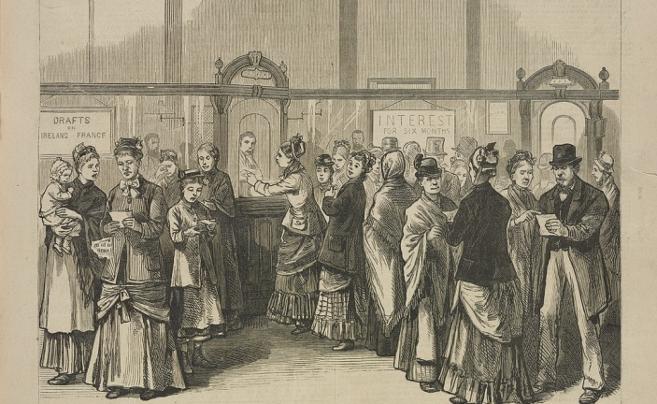

Irish Immigrants withdrawing money back to send back to relatives in Ireland at the Emigrant Savings Bank. Source: Library of Congress

Mary Garvey, writing from Hightstown, New Jersey to her mother in Ireland. October 24, 1850.

My Dear Mother,
I write these few lines to you hoping that you are now and will continue to be in good health when these shall reach you. . . .Dear Mother, I fear that you think that I have forgotten you but this is not the case, for I think of you every day of my life. The cause of my not writing to you sooner was because we have had sickness in the family that I live in for a long time. I have left the place that I was at when I last wrote you and am now living in Hightstown about four miles from where I was before. I feel very uneasy about you all for fear that you may be sick or dead or that you may be suffering. . . . I am going to send home to you four pounds [British currency] , and I will work and earn money enough while God guards my life and strength that I have asked after him. I hope you won't forget to tell my Uncle that I love him as much as I could my own father, and I hope you will give him some of the four pounds, for I don’t want to hear of him or any of his children suffering for anything more than I would myself. I should like to have very much my Uncles two daughters Mary and Bessy out here with me for I know that they could make a very good living in this country.

I should like to know whether this has been a dreadful summer. I am afraid that it has been. I want to know also how my Uncle is getting along with his trade? Is he earning plenty of money to support his family? If he is not, I think he had better come over to this country for here he can make a good living and perhaps get rich. I like being in this country very much, a great deal better than in Ireland . . . .

I should like to have you come over here very much if you think that you would be strong enough to stand the voyage. I hope you will leave that starved country and come over here in the Spring. I hope you will let me know when you are coming about two months before you start, so that I can procure you a good place nearby me. If you need more money to come well you must let me know in the next letter, so that I can send it to you in time. I am happy now, but I should be still more happy if I could see you once more and have you here with me. But I don’t want you to come if you don’t think of yourself strong enough to work. If you don’t think yourself able to come, I want my sister Margaret to come. If Mother is dead, I want the money to go to my sister Margaret, and if she is not, it is for her and she may do what she pleases with it.

I have not seen any of my comrade girls since I left New York. I have been very lonesome since I have seen no one that I knew. . . . I live in Hightstown as I said before with R.M. Smith Esq. It is a large family. He keeps a hotel and quite a large one too. I like it here very much indeed. I get 5 dollars a month which is two more than I got at the other place. There are 6 children and Mr. And Mrs. Smith beside all the boarders and help. The children are two girls and four boys. The babe which is a little girl has been very sick for the last three months so that we have not thought that she could live but she is getting better now. She is very fond of me, and I of her. There is a nice young Irish man in the employ of Mrs. Smith. His name is Noble Colter, and there is an Irish girl living opposite here named Hannah. I am little acquainted with her, but she appears to be very nice.

It will be necessary for you to take some provisions with you that you will not be likely to get on sea. They are some salt, some fresh eggs, and some potatoes. These will be all that you will need for you will get m(tear in the paper) ship of everything else than you can use. I was not sick on sea at all. I thought it was very pleasant until the last week or two when I became tired and began to want to see land. I hope you will fare as well as I did, but I am afraid that you will not as you are more aged. The boys get 10 dollars a month for driving stage in this country. Some of course do not get as much as this but according to their goodness and age. Girls get from 3 to 8 dollars a month according to what they can do. Cooks only get 8 dollars a month. I get good wages for what I do. The different kinds of victuals that we have on the table every day are beef, pork, lamb, chicken, ducks, turkeys, veal, sweet potatoes and Irish potatoes, cabbage, onions, beets, tomatoes, com, beans, peas, cranberries, apples, pies, puddings and many other things to tedious to mention.

Now, dear Mother, I must close for I have written you a long letter and I am afraid that it will tire your patience. My love to you and to all the rest of the family.
Good bye, I remain your ever loving daughter, Mary Garv

https://reimaginingmigration.org

