Fitzgerald
Documents - Interchangeabe Parts

Reenactment - The Gunsmith's Shop
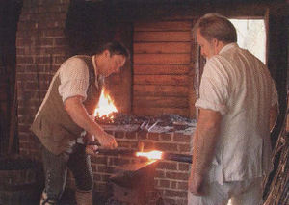 | 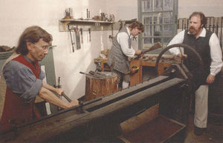
A Master gunsmith forges the barrel of a rifle with help from his Journeyman. | A Master gunsmith cranks while his Journeyman pushes a barrel to a drill bit. Behind them an Apprentice puts a stock on a rifle stocks a rifle.
Master craftsmen taught their Apprentices the craft. A fully trained Apprentice became a Journeyman and worked for 5 to 7 years under a Master before opening his own shop.

Sketch entitled “Yankee Ingenuity”
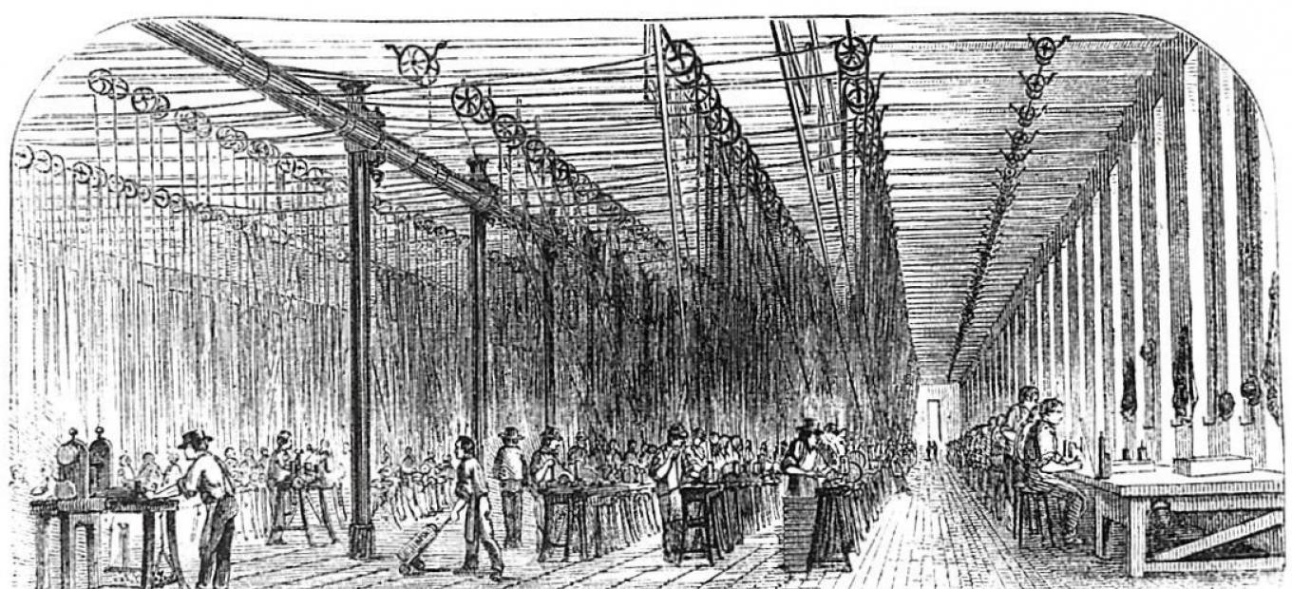
The second floor of Colt’s East Arms Factory, in Hartford, Connecticut, showing dozens of machine tools and operators, powered by overhead pulley, belts, and shafting. From United States Magazine, 1857.
Around 1850, Hartford native Samuel Colt perfected the precision manufacturing process first developed by Eli Whitney that enabled the mass production of thousands of his revolvers with interchangeable parts.

