Fitzgerald Name __________________________________________

Preamble to the Constitution of the United States of America

(Preamble)

We the People

of the United States,

in Order to form
a more perfect Union,

establish Justice,

insure domestic Tranquility,

provide for the common
defense,

promote the general Welfare,

and secure the Blessings of Liberty
to ourselves and our Posterity,

do ordain and establish this Constitution for
the United States of America.

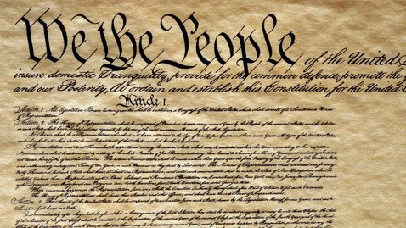

Importance of words shown by their size.

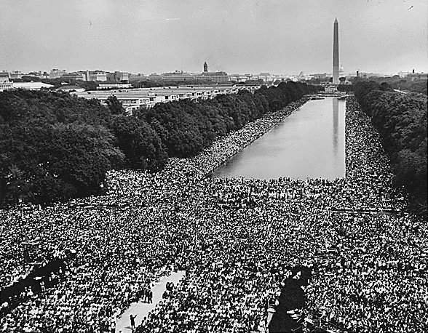
The People Rule!

The image is of the crowd that went to her Dr. King deliver his “I have a Dream “speech
in Washington, D.C., to tell the government what they expect it to do.
Fitzgerald Name __________________________________________
Preamble to the Constitution of the United States of America
(Preamble) | - An introduction  - exact meaning – to walk before  - a quick walk through of key ideas before we begin
We the People | - No King, or royalty or “expert government guy” created this for the people  - The People created this  - The PEOPLE are the source of the power  - Popular Sovereignty – the PEOPLE RULE!  - The president, the Congressmen, the police, the soldiers, they all work for the people.  - The people are the Boss.
(do ordain and establish this Constitution for  the United States of America.) | ordain and establish –  - mean the same thing (same denotation)  - but have different “feelings” (connotations)  Ordain –  - Used to describe orders or rules delivered by God or a king or The Church, religious, royal  Establish –  - very mundane (common, worldly (“mundo” means world), very businesslike
of the United States, | - 9/13?  - In the end, all 13 states did ratify the Constitution
in Order to form  a more perfect Union, | - Order – orderly, organized  - More perfect?  - How can something be better than perfect?  - Didn’t want to say that they had really messed up with the Articles, so it was “perfect.”  - The Constitution is just “more perfect.”
establish Justice, | Think Shays’ Rebellion  Establish justice –  - Make sure things are fair, that rights are not abused but protected  - That we don’t take farms from subsistence farmers and throw them in jail  Insure domestic tranquility  - Create a system that makes things peaceful, not chaotic  - Makes future rebellions unnecessary
insure domestic Tranquility,

provide for the common  defense, | - A national army could defend (notice the term “defense”) the states against invasion,  - as the 13 separate militias of the Articles could not
promote the general Welfare, | - welfare means to “fare” or “do” well  - so making sure all people lead a good life
and secure the Blessings of Liberty  to ourselves and our Posterity, | - making sure this government protects the rights of the people a “bit” longer than the Article did!  - “our posterity” mean those generations who come after us  - In others words not for just 10myears

