Fitzgerald Name ________________________________

Map - Pre-colonial Native American Culture Groups
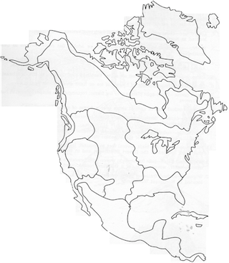

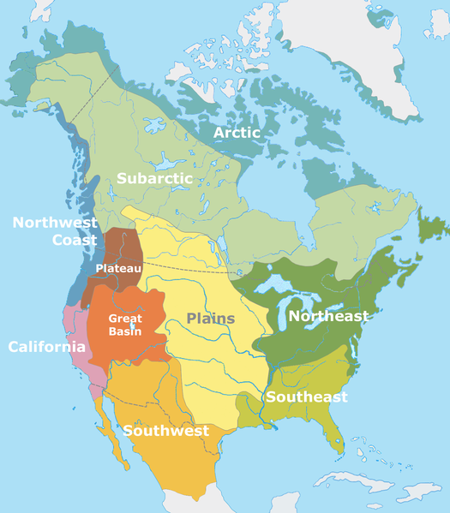

National Geographic Native American Map - Zoomable
https://media.nationalgeographic.org/assets/photos/000/329/32915.jpg
- shows each individual tribe in each culture group

Key Concepts
- ​Native Americans were diverse. There were many different language and culture groups. Experts say there were 150 distinct ethnic groups grouped into 10 culture groups in North America.
- Tribes are often described as either nomadic or settled. Tribes that lived by hunting (or fishing) and gathering were nomadic, meaning they traveled from place to place following their food sources. Tribes that depended mostly on crops that they farmed for their food built more permanent settlements.

Northeast / Great Lakes - Tribes in the Northeast and Great Lakes regions lived by a combination of hunting and gathering and farming. They would "slash and burn" areas of the forest to create fields but later abandon these fields after a few seasons. They grew what is known as the "three sisters," corn, squash, and beans, all together. The bean vines grew up the corn stalks and add nitrogen to the soil. The squash (like pumpkins) grew in vines along the ground beneath them stopping weeds from growing. At the end of the season, every other squash would be smashed to fertilize the soil. Men did most of the hunting and gathering, and women most of the farming.
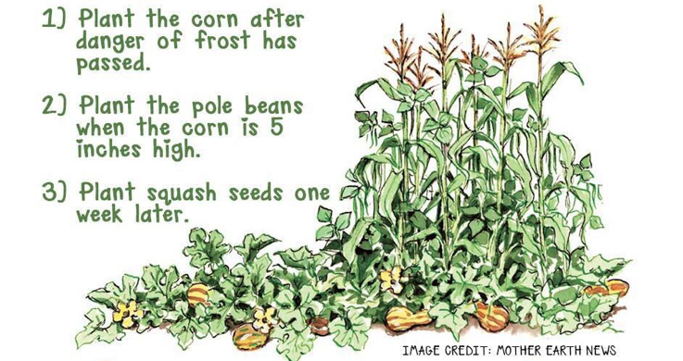  The Three Sisters | The Iroquois Confederation and the Algonquian tribes were the two dominant groups, and they often warred with one another.  The Iroquois, were a confederation of five (later six) distinct tribes who maintained a permanent peace and military alliance with each other. They lived in woodlands centered mostly in what is today the state of New York.  The Algonquian tribes lived along the Atlantic coast in this region.

Southeast - The Southeastern region of the United States has very fertile soil, so Native groups here relied mostly on farming for food. Ruins from along the Mississippi show that large cities formed; one city near St. Louis is thought to have had a population of around 40,000. These cities had organized street systems and often had a large central mound resembling step pyramids.
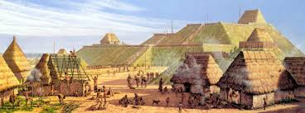

Southwest - Native tribes in the Southwestern United States survived mainly by farming corn. Some tribes constructed cliff dwellings that provided defense against attacks, while other tribes, such as the Hopi, built large apartment complexes out of mud bricks.

Plains - After horses were brought to the plains by Spanish soldiers, most Plains Indians became nomadic bison hunters. The teepee dwelling, which many people wrongly imagine is the type of house all Native Americans live in, was used by many of the nomadic tribes living in this region. Some tribes in the Plains, such as the Wichita, grew crops in settled communities, and then traded their produce with nomadic hunting tribes, like the Sioux.
The Great Basin - The Great Basin was a barren wasteland of deserts, salt flats and brackish lakes (lakes with salty water). Its people foraged for roots, seeds and nuts and hunted snakes, lizards and small mammals. They were nomadic, constantly on the move. There were no permanent settlements or large communities. They lived in wikiups made of willow poles, leaves, and brush, that were quickly setup and taken down

California - This region had more people than any other region because its climate is so temperate. It is estimated that the population was about 300,000 around 1550. It was also the most diverse. There were about 100 tribal groups and over 200 different dialects (language groups). The numbers grew when the Spanish pushed Natives in the Southwest off their land.
Despite this great diversity, many native Californians lived very similar lives. They didn't farm. They lived in small, family based tribelets as hunter-gathers because food was plentiful. The groups had a well established trade system and lived peacefully together.

The Northwest - The Northwest Coast has a mild climate and many natural resources. The ocean and the region’s rivers provided almost everything its people needed—salmon, especially, but also whales, sea otters, seals and fish and shellfish of all kinds. The people were hunter-gatherers , but with so much food provided by the environment, they could build permanent villages that housed hundreds of people each. These villages had the most rigid social class system of any of the Native groups.

The Plateau - This area is focused on the Columbia and Fraser river basins and is surrounded by five other regions. It was in what is today Idaho, Montana and eastern Oregon and Washington. Most of its people lived in small, peaceful villages along streams and rivers and survived by fishing for salmon and trout, hunting, and gathering wild berries, roots and nuts.

https://www.history.com/topics/native-american-history/native-american-cultures

