Fitzgerald

Clip from John Adams https://www.youtube.com/watch?v=notJuFGXQ9w

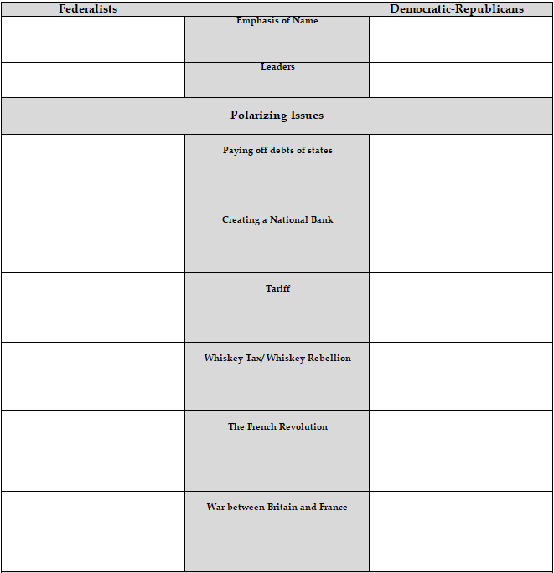

(continued on next page)

