Fitzgerald
Page ____ of ______
Unit - Literary Analysis |  | Name
Topic -  Plot Analysis Notes  from Glossary of Literary and non-Fiction Terms pp. R102-R112 |  | Date
Questions | Notes |  | Additions made in Class
Define plot  List the five stages of a plot. | Plot - definition  - Series of events  - That center on conflict  A plot has five stages  - Exposition  - Rising Action  - Climax  - Falling Action  - Resolution |  | 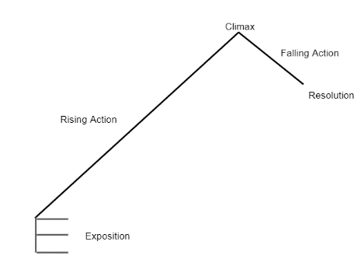
Define conflict.  List and explain the three categories of conflict. | Conflict - definition  - A struggle between opposing forces  Three Categories of Conflict  External conflict  - Character struggles against a force outside himself or herself  - Examples  - Nature  - Physical Object  - Another character  Internal conflict  - Occurs within the character’s mind  Cultural conflict  - Arises because of differing values, beliefs, circumstances between two groups |  | Another way of organizing conflicts -  Universal Conflicts  Character v.  - Character  - Self  - Natre  - Society  - Technology  - High Spiritual Power  - Etc.
Define exposition.  What three things must be introduced in the exposition. | Exposition - 1st stage of the plot  - Provides importan background information  - Introduces (JUST A HINT)  - Setting  - Main character  - Conflict |  | In the first paragraph  (Sometimes a bit in the second paragraph)
Define rising action. | Rising Action - 2nd stage of the plot  - Develops the conflict  - Events occur that increase the conflict (or increase the readers’ understanding of the conflict)  - Events build toward climax |  | Short Story –  - One step per paragraph or dialogue (rarely two)  Novel –  - One, sometimes two, steps per chapter
Define climax. | Climax- 3rd stage of the plot  - Occurs near the end of the story  - Conflict is resolved ended  - Outcome becomes clear |  | Short Story –  - Last Page  Novel –  - End of the next to last chapter  - Beginning of the last chapter  Climax is a single sentence  - Before the climax there is tension  - After the climax there is no tension
Define falling action. | Falling Action - 4th stage of the plot  - Story begins to draw to a close  - Shows results of the decision or action tat happened in the climax  - Tension eases |  | Commonly 3 - 5 steps
Define resolution.  Describe the resolution of a movie and explain how that resolution emphasizes the theme of the movie. | Resolution - 5th stage of the plot  - where the story ends  - a final picture left in the readers' minds in the last paragraph  - like the freeze frame at the end of a movie  - should emphasize the theme of the story  Below, describe the resolution, or freeze frame, at the end of a movie you are familiar with that emphasizes the theme of the movie.  Example given in class by Ben P.  - Movie – Forrest Gump  - Description of resolution (freeze frame at the end o the movie) –  Forrest is a single dad , as jenny has died, putting his son on the bus to school and he drops the Curious George book he had had when he was a child that he is now reading to his son and a feather floats down from an empty sky as it had earlier in the film.  - Explanation of how that freeze frame emphasizes the theme of the movie –  The theme seems to be that Forrest is a great dad just as he has always been a great person because he is like Curious George: he approaches everything in life with a positive attitude as an adventure, as life is a blessing. The feather represents the angel(s) in heaven who look over Forrest, his mother and now Jenny.
Define theme. | Theme  - The message  - about life or human nature  - Must often be inferred, as never really stated in the story |  | NOT A MORAL!!!  Often difficult to put into words

