Fitzgerald
Assignment – Notes on the Pilgrims and the Puritans

Procedure
- Set goals for improvement
  - Examine the feedback you got on note form and identification of main idea.
    - Look over the notes handed back to you that you did with your partner on the Native Culture group.
    - Look over the Roanoke Reading Main Idea Identification exercise.
  - Examine the grading sheet for the notes to focus on the goals.
- Take two pieces of note paper, as you will need one for notes on the Pilgrims and one for notes on the Puritans.
- You will have the hour to work on your notes.
  - I will come around to see how you are doing.
  - You may ask me any questions.
- Notes are due tomorrow at the beginning of the hour.
  - You will be able to use them for a graded activity.
  - I will collect the notes to grade when the activity is over.

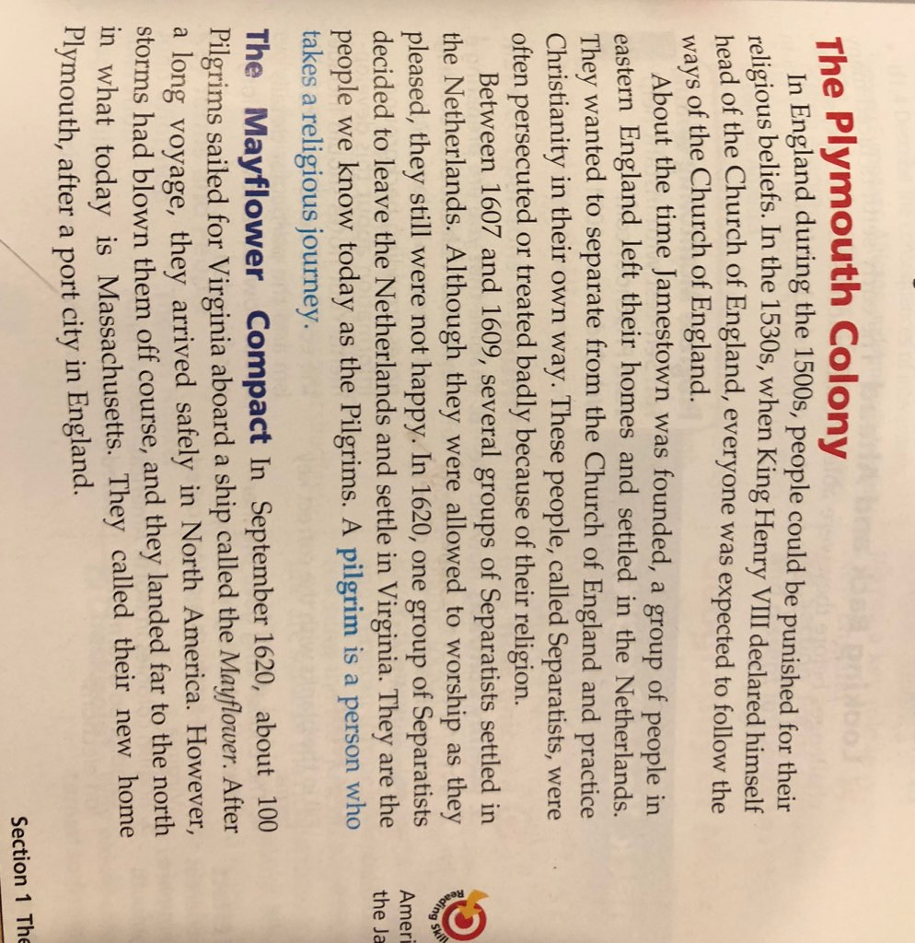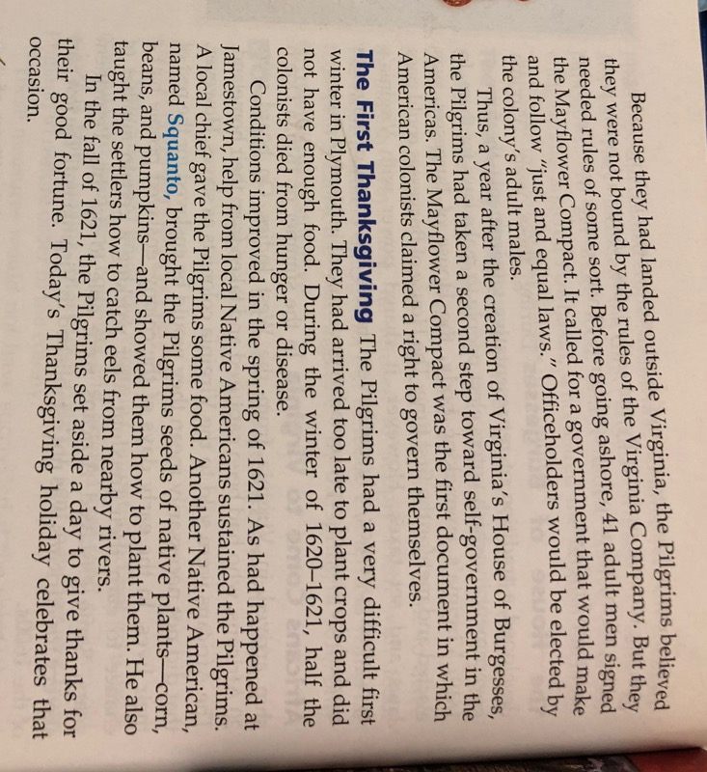 | Pilgrims – 9 paragraphs, pages 69-70,  Headings:  - The Plymouth Colony  - 3 paragraphs  - The Mayflower Compact  - 3 paragraphs  - The First Thanksgiving  - 3 paragraphs

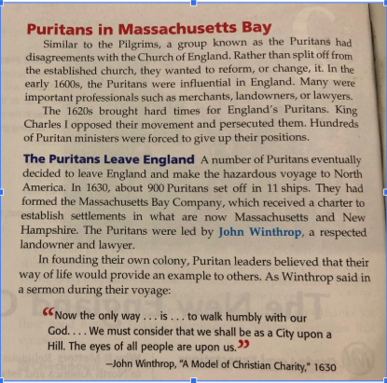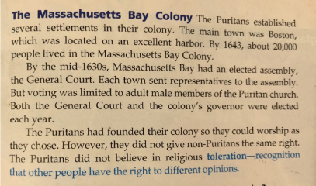 | Puritans – 7 paragraphs, pages 72-73  Headings:  - Puritans in Massachusetts Bay  - 2 paragraphs  - Puritans Leave England  - 2 paragraphs  - The Massachusetts Bay Company  - 3 paragraphs

