Physical Map of North America - Day 6 Places to Label

Day 6
- Pacific Ocean

- Puget Sound

- Cascades
  - Columbia River

Pacific Ocean
Puget Sound
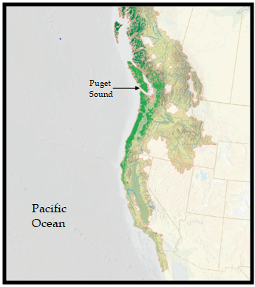
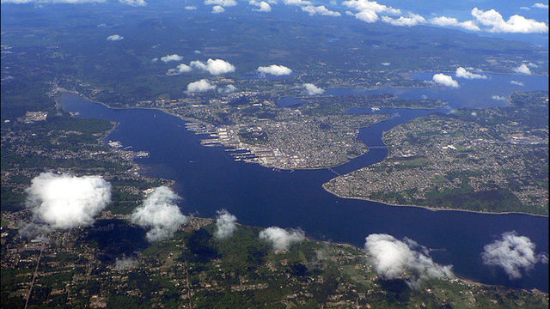
Seattle in Puget Sound
Puget Sound
Puget Sound

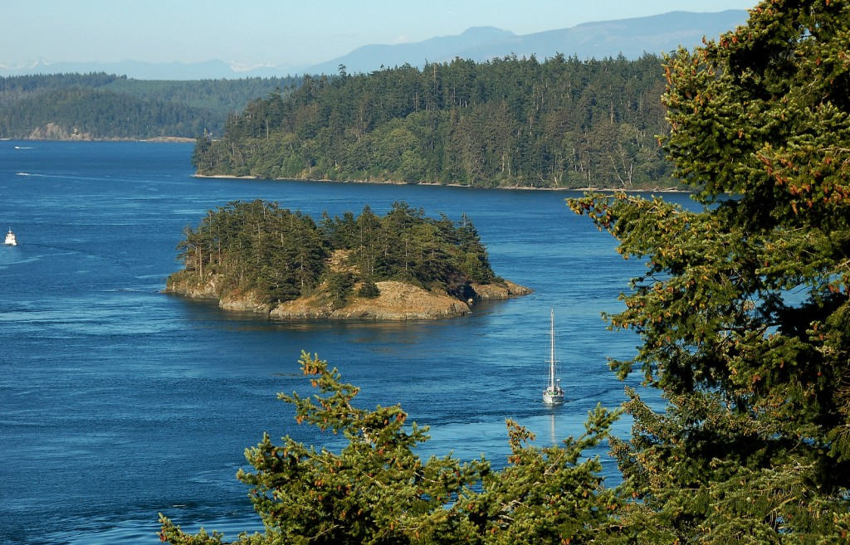

Deception Pass State Park
in Puget Sound

The Cascade Mountains
The Cascade Mountains are part of the Pacific Ocean's Ring of fire but include both non- volcanic mountains in the High Cascades and volcanic mountains. All of the volcanic eruption in the "lower 48 states," meaning not including Alaska and Hawaii, have occurred in the Cascades, the most recent being the major eruption of Mount St. Helens in 1980.

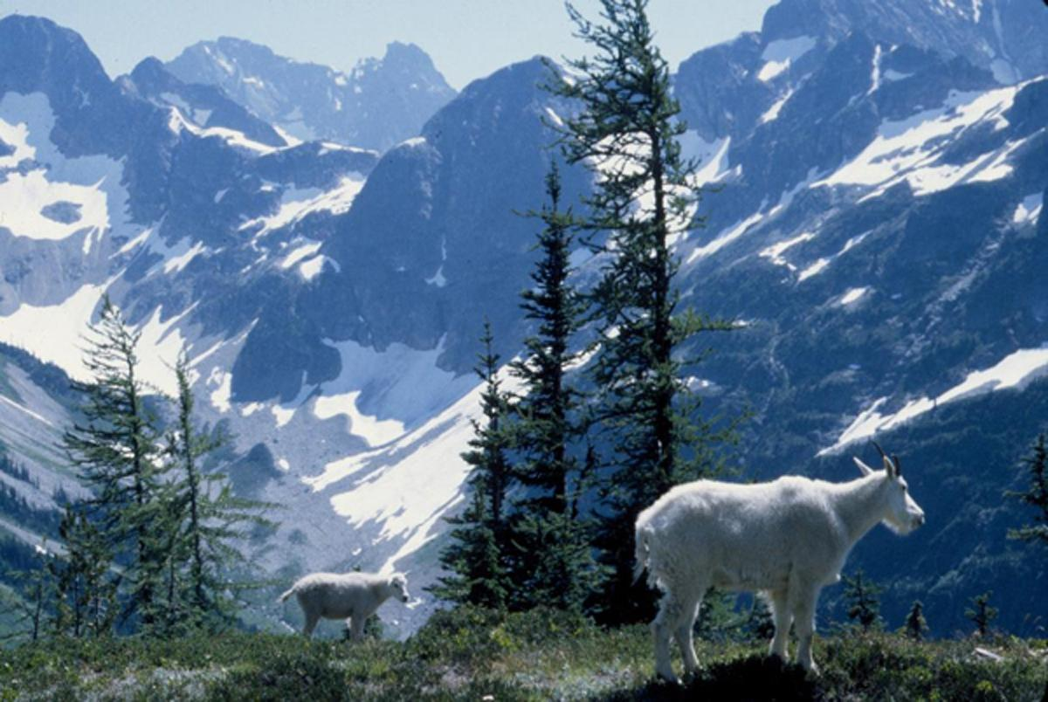
Northern Cascades

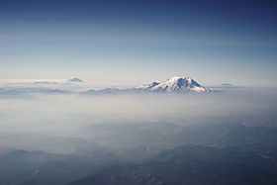
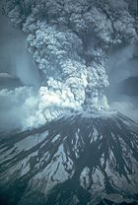
Mount Rainer, the highest peak, is 14,411 feet high, almost three miles!
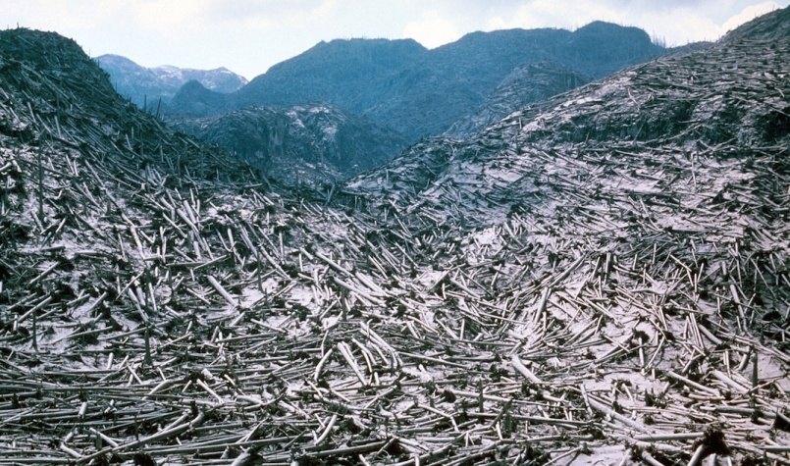

Mt. St. Helen's eruption and the destruction left behind

The Columbia River
The Columbia River is 1,243 miles. It is fed by six tributary river. More water flows into the Pacific Ocean from the Columbia River than from any other river in North or South America.
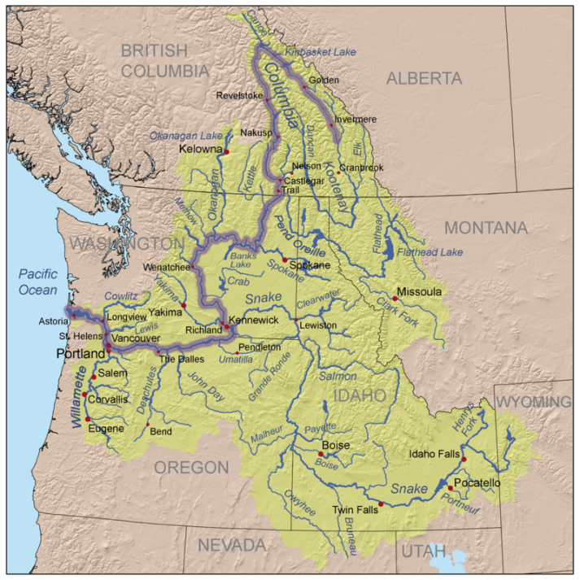

Columbia River with
Tributaries and
Drainage Basin

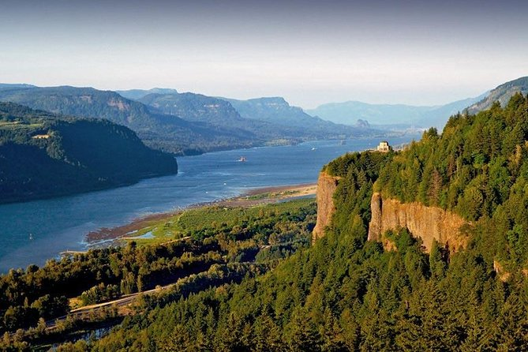

Columbia River Gorge - as it
cuts through the Cascades

