Physical Map of North America - Day 5 Places to Label

- The Great Plains
- Rocky Mountains / Rockies
  - Colorado River
    - The Grand Canyon
- Sierra Nevadas
- The Great Basin
  - The Great Salt Lake
- Mojave Desert

The Great Plains
- a grassland
- the largest biome in North America
- extreme weather prevents the growth of large plants but is perfectly suited to the native grasses
- Native animal species include bison, prairie dogs, and grasshoppers
- at first used mostly for herding cattle, later used for growing grain, grain grown in this region today feeds a large part of the world

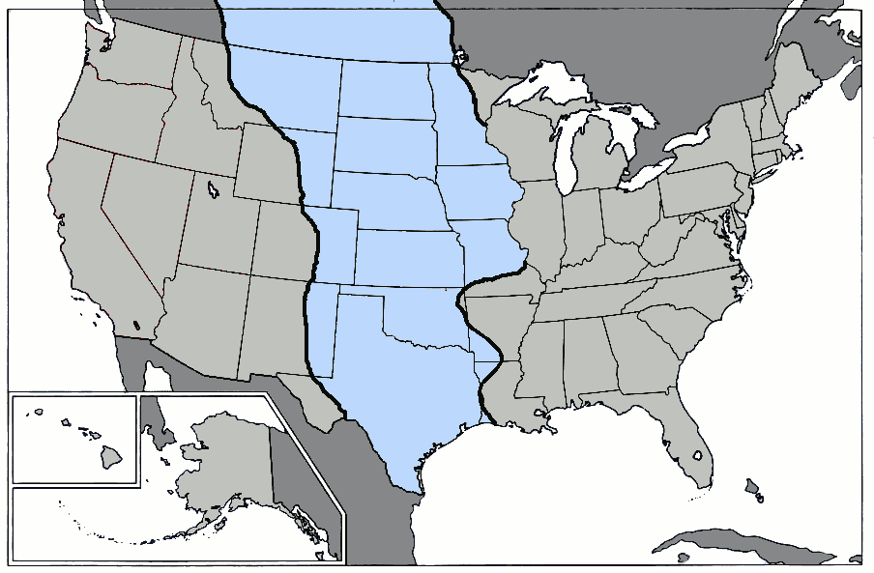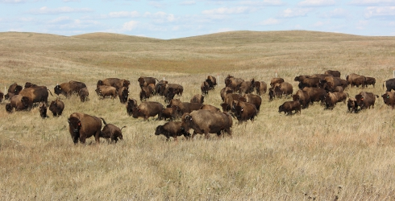

The Rocky Mountains
The Rocky Mountains run 3,000 miles from in what is now Canada and the United States. They are divided into a series of parallel, massive mountain ranges formed when two tectonic plates converged. Due to difficult terrain and other natural conditions the Rocky Mountains were one of the final places explored by European settlers.
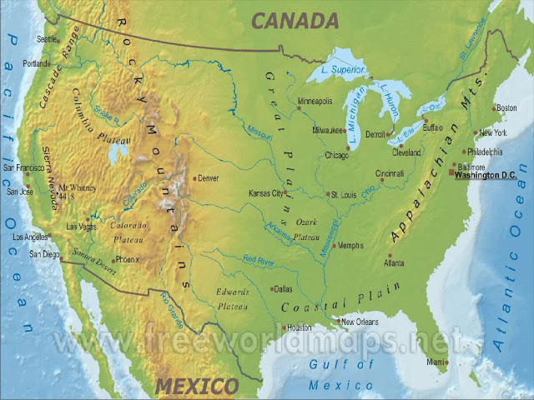
Emerald Lake in Rocky Mountain National Park, Colorado
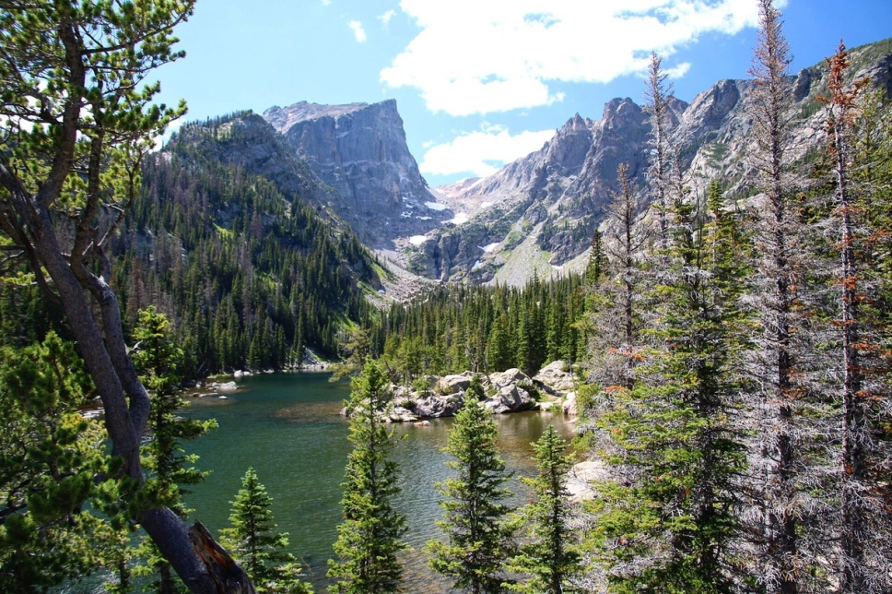
Among the mammals who inhabit this dangerous terrain include grizzly bears, black bears, mountain goats, bighorn sheep, elk, mule deer, bison, wolves, marmot, prairie dogs, pika, rabbits, otters, beavers, and rattlesnakes.
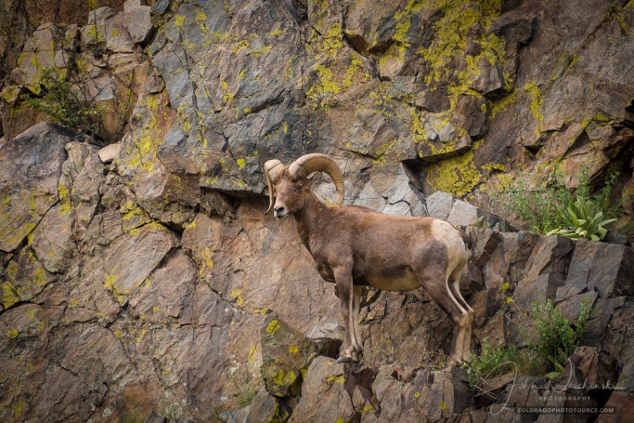
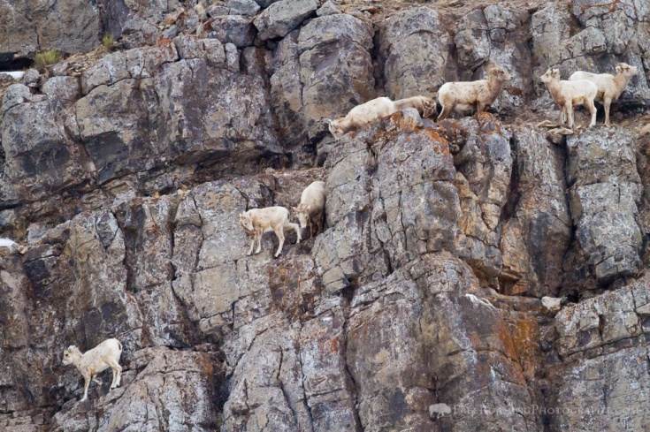

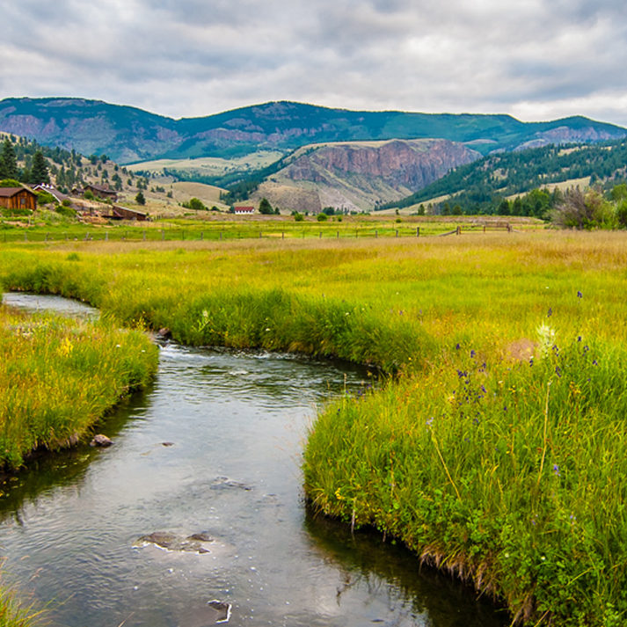
Colorado River
The Colorado River flows through and arid region and is known for its dramatic canyons, whitewater rapids, and eleven U.S. National Parks,
Upper Colorado River

The Grand Canyon -
- considered one of the world's most spectacular canyons
- carved into sedimentary rock by the Colorado River
- average depth - about 1 mile
- length - 277 miles
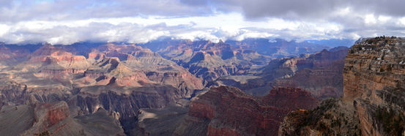

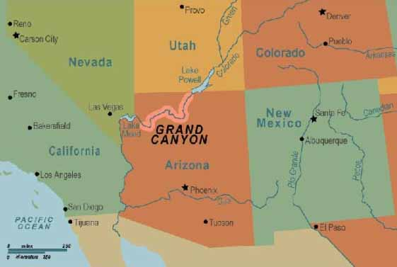
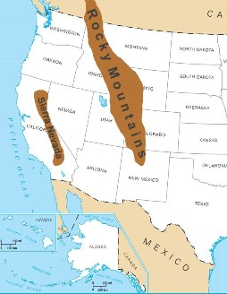

The Sierra Nevada -
- length 400 miles
- mostly in what is now California, home of the California Gold Rush
- Formed by seduction of the oceanic plate under the continental plate
- earthquakes still occur
- uplift still occurring

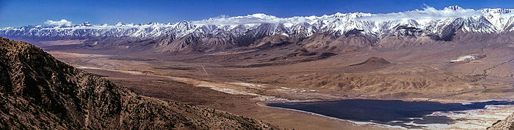
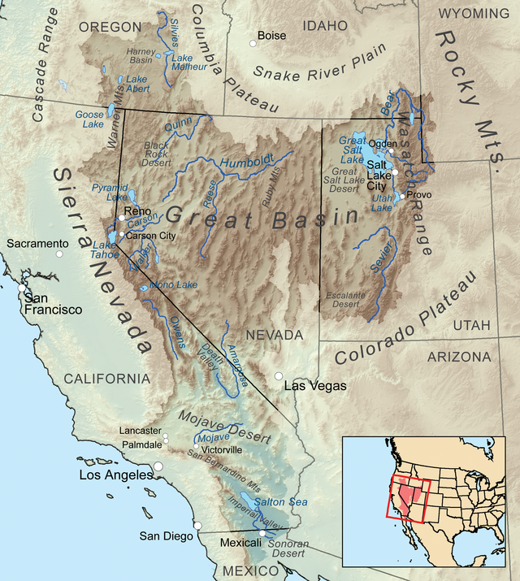

The Great Basin - 200,000 square mile area
- precipitation in the region does not flow to ocean
  - evaporates
  - sinks underground or
  - flows into lakes, which are mostly salt lakes

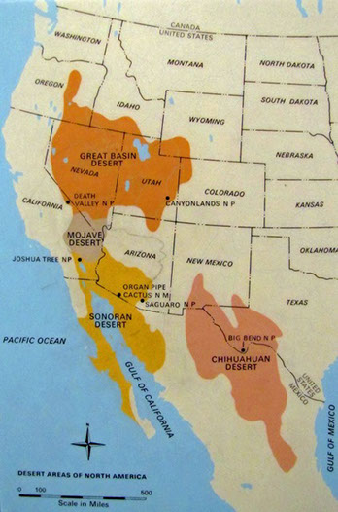

Mojave Desert -
- located in the rain shadow of the Sierra Nevada Mountains
- mountains block precipitation that develops over the Pacific Ocean from reaching these areas

The Great Salt Lake
- largest salt lake of many in the Great Basin
- salty because the creeks that flow into them have eroded salty deposits and drop these in the lake
- water evaporates, leaving the salt

The Great Salt Lake
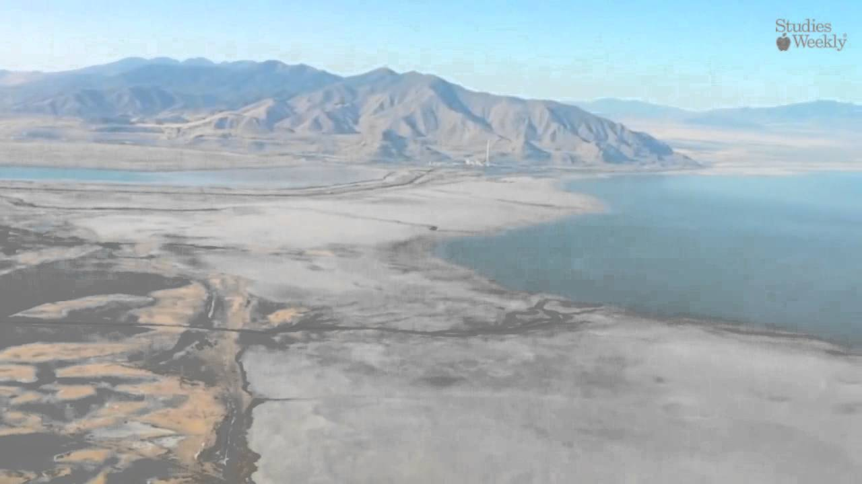

The Mojave
