Physical Map of North America - Day 4 Places to Label
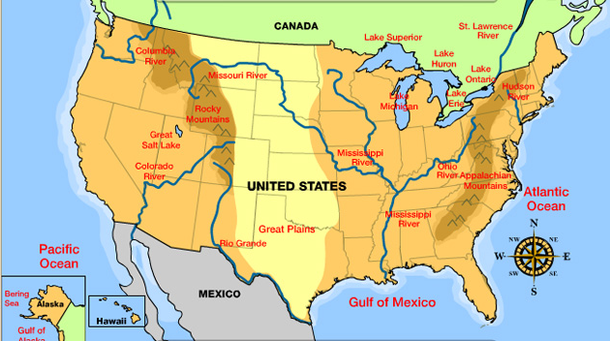
- Ohio River
- Missouri River
- Mississippi River
- Gulf of Mexico
- Rio Grande

The Ohio River

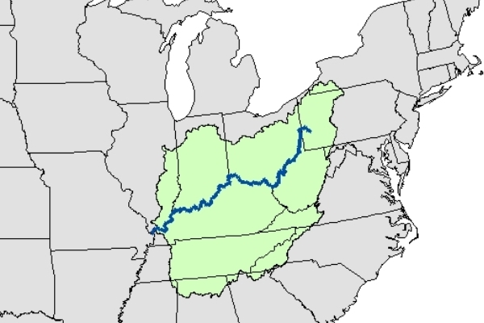

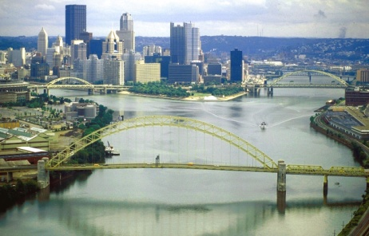
The Allegheny River, left, and Monongahela River join to form the Ohio River at Pittsburgh, Pennsylvania.

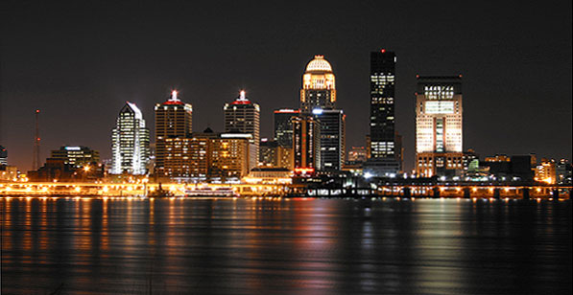
Louisville, Kentucky, is on the Ohio River where it meets the Mississippi River.

The Missouri River
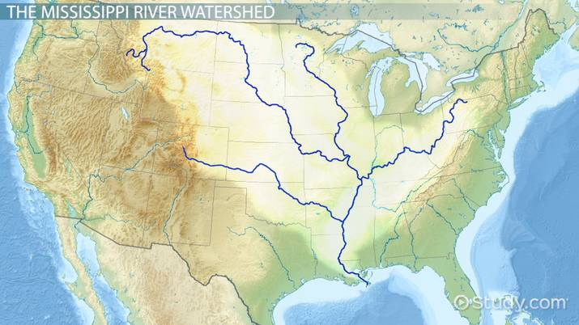
Missouri River

The Missouri River drains one-sixth of the United States and flows 2,341 miles from its headwaters in the Rocky Mountains to where it flows into the Mississippi River, making it the longest river in the United States.
The Missouri is a broad, shallow river. There is a great variety of terrain along the river.

The Upper Missouri
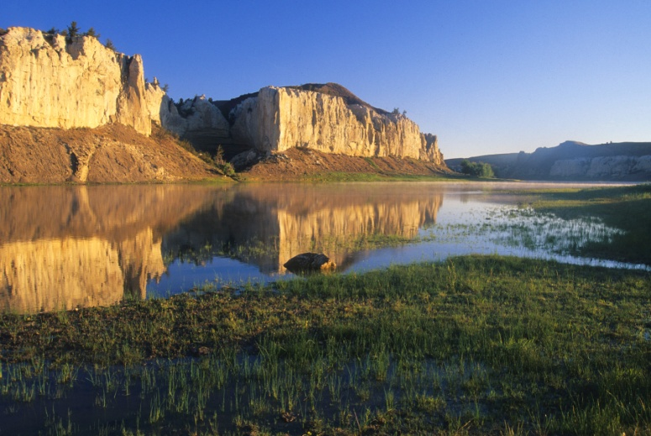
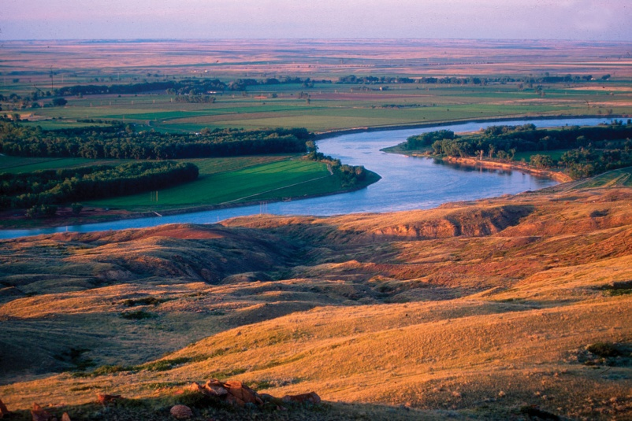Where the Missouri meets the Mississippi In the Great Plains
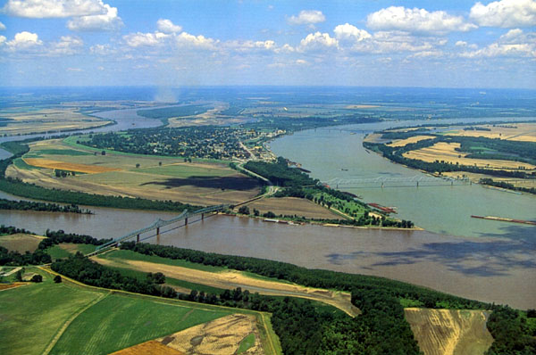

The Mississippi River
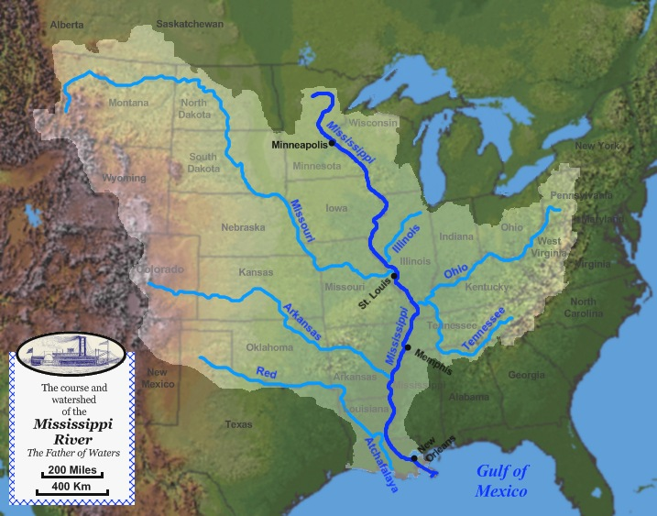

The Headwaters (Start) of the Mississippi
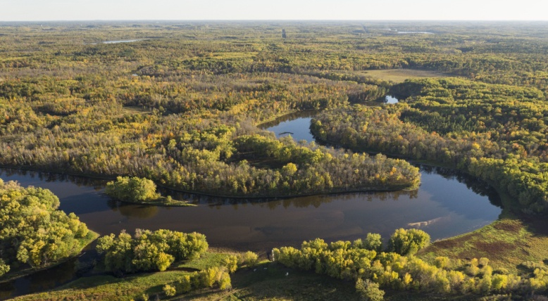

Upper Mississippi River in Minnesota
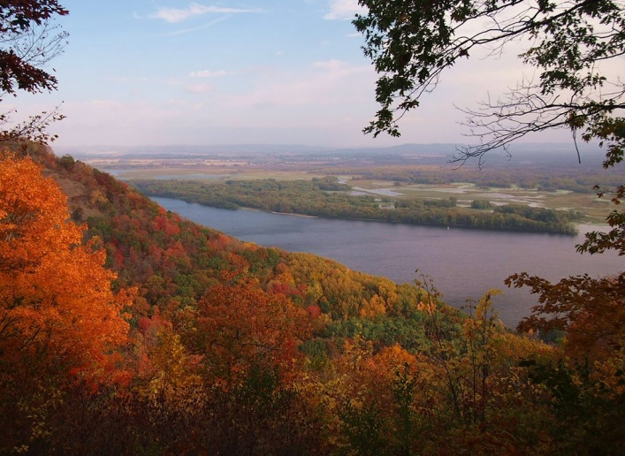

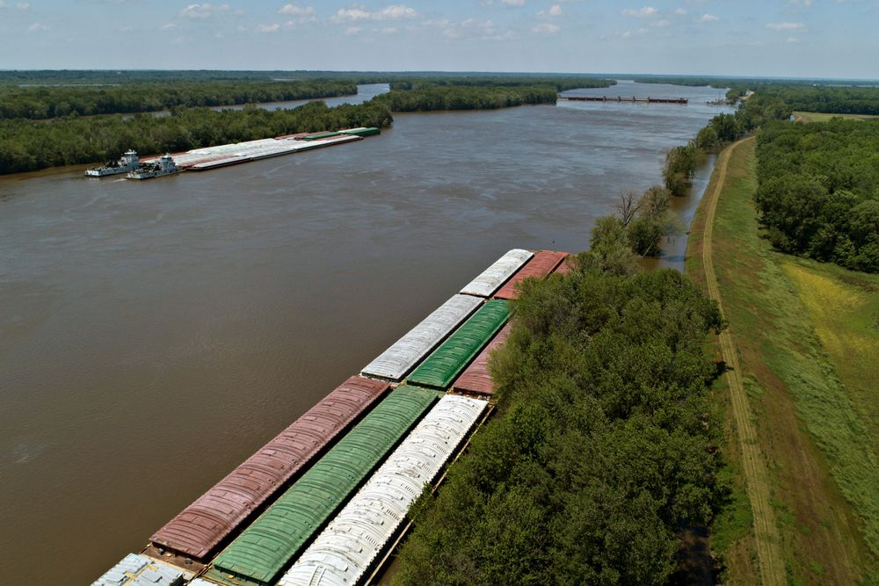
Today the lower Mississippi is so controlled by dams and levees to keep it open for shipping hat is often looks like a canal.

Rio Grande ("Rio" mean river in Spanish.)

The Rio Grande starts in the Rocky Mountains in what is today Colorado flows to the Gulf of Mexico forming along the way part of the Mexico-United States border.

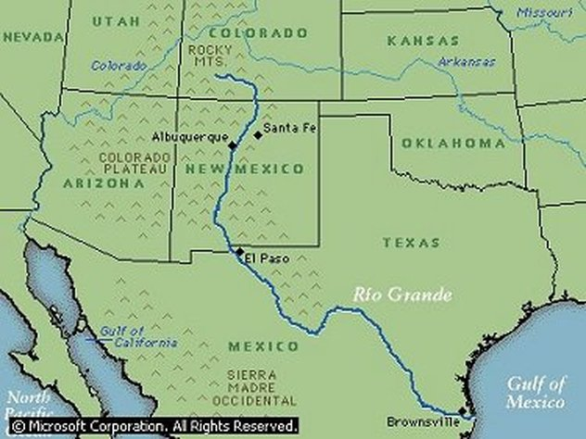

The Rio Grande in New Mexico
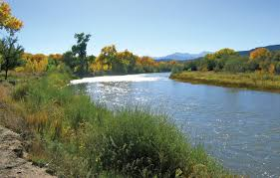
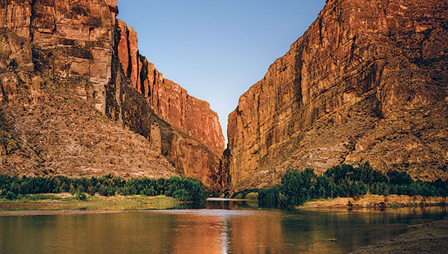
In Big Bend National Park

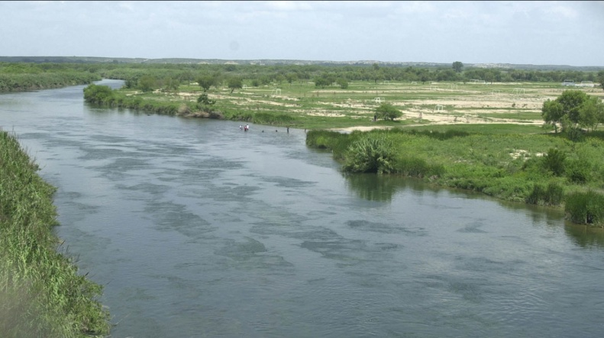
Along the border with Mexico

