Physical Map of North America - Day 3 Places to Label

The Great Lakes - contain 21% of the world's fresh water – See map, pp. A4-A5
Lake Superior, Lake Michigan, Lake Huron, Lake Erie, Lake Ontario

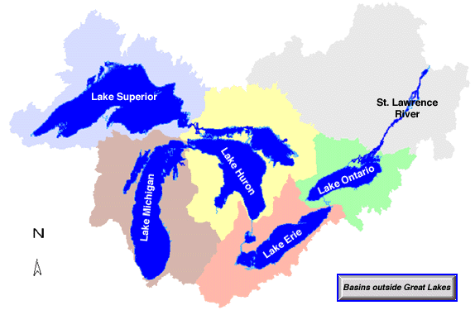

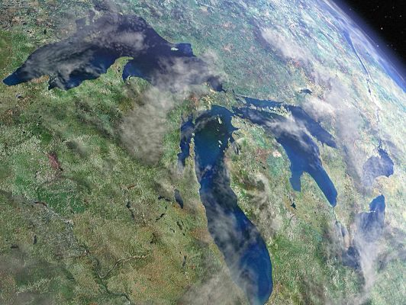
Satellite View
Lake Michigan
Lake Superior
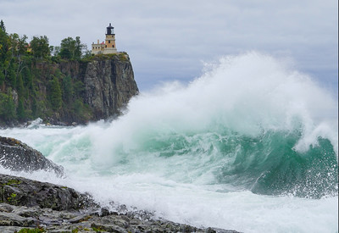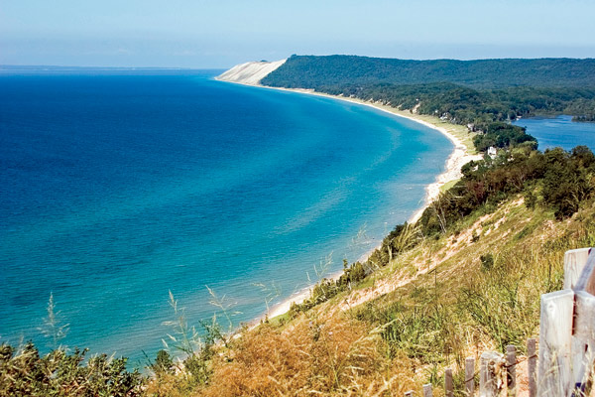

Niagara Falls - on the Niagara River between Lake Erie and Lake Ontario as the Great Lakes drain to the ocean
- actually three different falls: Horseshoe Falls, American Falls and Bridal Veil Falls.
- Horseshoe Falls - 2,600 feet wide, 173 foot drop, and 90% of water volume

