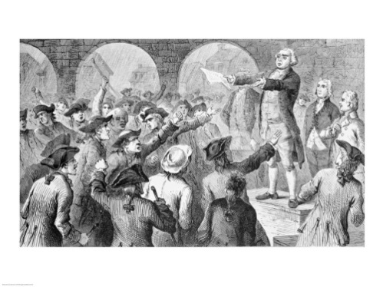
American History - Fitzgerald
5 October 2015

Dear Parents,
We are starting our new unit, the Road to Revolution, addressing the question of whether the colonists were justified in declaring independence. We are working with students to get them used to studying their material as they go, not waiting for the end to cram. This unit is designed to support that goal.

Your student will be viewing, reading about, discussing, and taking notes on causes of the war in class.
- At home each night he or she is to find an image to help capture the key idea of each cause, using Google images.
- They are then to make a flashcard with the title and the image on the front and the notes on the back using Google image or create a Google slide presentation. A model of the Google slide presentation and a Google Docs table for making the flashcards is on my website. They will be asked to share these with me through Google so I can monitor that progress. They will be getting progress check grades along the way. A list of all topics with notes taken so far will always be on the website.
- They are then to use those flashcards daily to review the growing set of causes they should be able to relate.

In the end, they will be asked to present all the causes to you from memory, using the card as a spur.
You will be sent a grading sheet to grade this presentation. This grade will be recorded, and the presentation will serve as a review for their test. We ask that you also take a picture and send it in of the family during the presentation, as we will make a display of all of us and our families.

The test is a document-based test, in which students will be presented with documents concerning the causes and asked to answer questions about these documents given their new earned knowledge and then to write an essay using evidence from these documents that answers our focus question, "Were the colonists justified in declaring independence?"

So, if you could sign this letter this evening, I will then have a record that you are aware of our work. You may also note and questions or comments. I have attached an extra copy for your to keep at home as a reference.
Thank you!
Sincerely, Virginia Fitzgerald
Review of Parent Support
- sign and return the slip at the bottom to let me know you received and read this letter,
- watch for that daily work toward finding images and creating the quizzing card,
- maybe ask your student to present the cards they have so far referring to the topics completed list on my website,
- schedule time at the end for them to present, (They can present as many times as they need to solidify the knowledge, so you should be able to give them and A!)
- and get a picture taken and printed for our display.

Parent Signature __________________________________________________________
Comments or Questions -

