Fitzgerald

Oregon Trail Primary Sources – 3-2-1
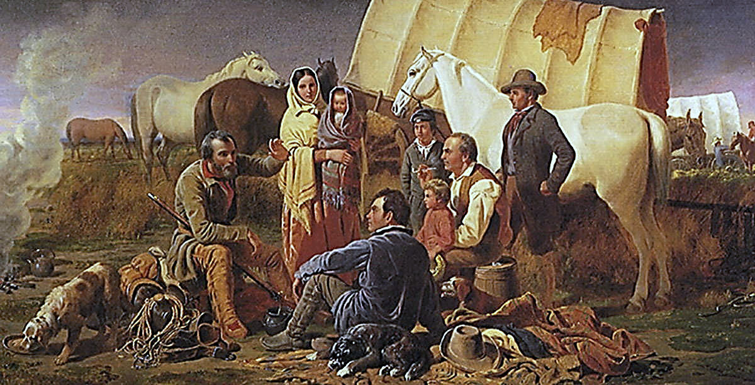
Instructions
- Read the article “Oregon Fever.”

- In the primary source from Harriet Scott on the second page of the article (page 11), find
    - 3 words,
    - 2 phrases (a group of words that does not have a subject or verb), and
    - 1 complete sentence
that capture big, important concepts about the journey on the Oregon Trail.

- Arrange your chosen ideas creatively on the white paper you have been given.
  - You may use colored pencils or any other materials.
  - Do not title the page, it should speak for itself.

- These will be displayed, so create something you will be proud of when others see it.

- Have one group member write the names of the members of your group at the bottom of the page in pencil in small, neat writing.

You can record ideas here before doing your poster.

