Fitzgerald
Order of Secession –
- Lower South (Cotton Growing) – After Lincoln’s Election : SC, MS, FL, AL, GO, LA, TX
- Upper South (Less dependent on slavery economically) After war starts : VA, AK, NC, TN
- Border States - Slave States that Do Not Secede
  - WV – Northern counties along the Ohio River, very mountainous, always considered Backcountry, not part of the wealthy Virginia planter culture KY – Will not send troops, but will not secede – The South invades to get control of Ohio River, Actively join Union as so upset with invasion of South
  - ML – Lincoln suspends writ of Habeas Corpus and arrests Confederate sympathizers to keep Maryland in the Union, as losing Maryland would mean the loss of Washington, D,C.
  - MO – Fighting breaks out between two sides and Federal government assists the pro-Unionists, Military government established, never gets chance to secede

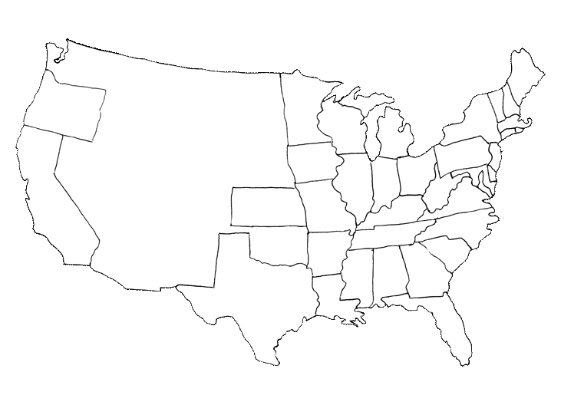
B
B
B
B

– The Lower South – cotton-growing, secede when Lincoln elected secede
The first states to secede
– The Upper South – economy does not depend on slavery, secede when war starts
B - Border States – Union must keep as strategically important, see reasons listed above

