- Review of Situation in the House of Representatives
- Missouri Compromise 1820, p. 404- 405 "Extension of Slavery"
- Republic of Texas 1836, p. 456
- Annexing Texas and Oregon 1845, p. 456-7
- War with Mexico, p. 457 "The Mexican-American War and Opposition to the War"
- The Wilmot Proviso 1848, p. 482
- Kansas-Nebraska Act 1854, pp. 489-90
- Popular Sovereignty, p. 489
- Bleeding Kansas, pp. 490-1 "Bleeding Kansas" and "Growing Violence"
- Bloodshed in the Senate, p. 491
- Election of Lincoln, pp. 499-500 "Election of 1860"
Headings/Questions | Main Ideas and Details | Additions and Corrections
Review of Situation in the House of Representatives  Describe the balance of power in the House of representatives. | Representation in the House of Representative - based on population  - New England and Middle Colonies - majority  - New England - densely populated with towns and small subsistence farms  - Middle Colonies - cities  - South - always minority  - rural - large plantations  - 1/3 of population slaves - even 3/5ths clause doesn't solve this problem
Missouri Compromise 1820, p. 404- 405 "Extension of Slavery"
Slave and Free States  Why had northerners prevented the admission of Missouri as a state? | 1818 - 11 free and 11 slave states  - Balances those that permit slavery v those that prohibit slavery  - But Missouri seeking statehood since 1817  Northerners upset at Missouri's request to be a free state  - Upset balance in Senate  - Each state - 2 votes  - So South would be more powerful than North  Proposal made  - Admit Missouri as slave  - But once admitted - no more slaves allowed instate  Bill not passed  - Pass House, fail Senate  - South feels slavery itself threatened | Inaccurate - North more powerful in House  If Senate balanced - South can block it there
Continue - Missouri Compromise 1820, p. 404- 405 "Extension of Slavery"
The Missouri Compromise  Describe the compromise proposed to bring Missouri into the Union.  Who proposed this compromise? | Maine applies for statehood  - Maine prohibits slavery  - Admit both - maintain balance in Senate  Compromise proposed  - By Henry Clay  - 4 parts  - 2 parts for North  - Maine admitted - free  - Draw line - at southern border of Missouri  - All remaining land in Louisiana territory north of that line - free  - 2 parts for South  - Missouri admitted - slave  - Gave right to slave owners - pursue runaway slaves into North
A Continuing Problem  Are both the South and the North pleased with the Missouri Compromise?  How did Jefferson express that he was worried by the Missouri Compromise? | Revealed - sectional differences divide states  - South not happy -  - Congress made a law about slavery  - North not happy -  - Congress had allowed slavery to expand  Jefferson alarmed - issue raised will tear nation apart  - "a firebell in the night" - awoke him, filled with terror  - "[W]e have a wolf by the ears, and we can neither hold him, nor safely let him go."
Republic of Texas 1836, p. 456  What prevents Texas from being annexed as a state after it wins its independence from Spain? | Public opinion was divided about annexing Texas after it became independent  - South - support  - as it is a slave state  - North - against  - but do want to expand slavery into West  Two presidents refused to annex  - Jackson and Van Buren  - Fear adding slave state  - Spark huge fight  - Split Union
Annexing Texas and Oregon 1845, p. 456-7
Election of 1844 | Tyler wanted to annex Texas but not re-nominated  - Whig party wanted to ignore issue  - Nominate Henry Clay instead -  - "The Compromiser"  Polk ran for Democrats, supporting expansion, and won  - Polk wants to annex both Texas and Oregon  - Oregon claimed by both U.S. and Britain  - Polk campaigns on taking all of Oregon or going to war | Slogan - "54*40' of Fight!"
Annexation  What allowed Texas to be annexed? | Tyler asks Congress to annex Texas right before Polk takes office  - Congress votes to admit  - Texans quickly vote to be annexed  Polk immediately negotiates treaty to divide Oregon with Britain  - Extend 49*N border to Ocean  - Land will become Oregon, Washington and part of Idaho | Texas became a slave state. Balanced by Oregon , a free state.
Tension with Mexico | Tension with Mexico increased  - Never agreed Texas independent  - Dispute over boundary  - U.S. say Rio Grande -  - Mexico say Rio Nueces - farther North  U.S. ever really controlled area south of Rio Nueces to Rio Grande  - But gave U.S. more land  - Polk pressures Mexico to accept
War with Mexico, p.457
The Mexican-American War  What led to Congress declaring war against Mexico? | Polk offers Mexico money  - Knows Mexico needs cash  - Offer - land to Rio Grande and California, and New Mexico  - Mexico refused - outraged  Polk provokes Mexican attack to get reason to declare war  - Sends Zachary Taylor onto disputed land between the rivers, south of Rio Nueces  - Mexico sees this as act of war  - Send troops to ambush a patrol  - Polk asks Congress to declare war,  - claims Mexico shed "American blood on American soil"
Opposition to the War  How did many Northerners feel about the War with Mexico? | War popular with most  - Supported by South and West  - Willing to go to war to gain land, expand  North claim trying to expand slavery  - Lincoln is a representative in the House speaks against war  - Says the land was not "American soil"  - Says Polk invaded
The Wilmot Proviso 1848, p. 482  What was the purpose of the Wilmot Proviso? | The Missouri Compromise did not apply to the land gained from Mexico  - Would it mean new slave states  - North wanted to stop slavery from spreading  Representative Wilmot, from Pennsylvania, proposes banning slavery on any land acquired by war with Mexico  - In 1846, as soon as war declared  - Stop South from gaining power  Bill does not pass  - Passes House - North majority  - Not Senate - balanced  - 15 free, 15 slave states  - Upset South - Northern attack on slavery | Forces Southerners to admit the war’s goal was to obtain slave land.
Kansas-Nebraska Act 1854, pp. 489-90  Who was proposing Kansas -Nebraska Act and popular sovereignty and why?  Define popular sovereignty.  How do Southerners react to popular sovereignty?  How do Northerners react to popular sovereignty? | K-N Act moves nation closer to war  - Proposed by representative from Illinois  - Stephen Douglas  - Wants a railroad to be built from Illinois to Pacific coast  - Eager to develop land in West to get this going  K-N Act proposes adding two new territories  - Southerners object  - Area is closed by Missouri Compromise to slavery - North of line  - Would mean many new free states  K-N Act also proposes popular sovereignty decide whether territory becomes slave state or free state  - To win southern support  - Would erase Missouri Compromise line  Southerners support K-N Act  - Thought people from Missouri would go into Kansas  - Swing vote - make Kansas a slave state  Northerners outraged K-N Act  - Douglass betrayed them  - Reopened territories to slavery  - One Northern senator says it is almost enough to make him an abolitionist
Popular Sovereignty, p. 489 | - Definition - the people rule  - Each territory decides for itself if it is free or slave  - Congress makes no laws that affect the decision
Bleeding Kansas, pp. 490-1
"Bleeding Kansas"  Describe the chaos caused by popular sovereignty in Kansas's elections. | Kansas's citizens will decide if free or slave  - Pro- and anti- slave settlers both flood into state  - Both seek to be majority when it is time to vote  - 1000s of people illegally vote in election for legislature that will write the constitution  - from Missouri, a slave state,  - directly east of Kansas  - Kansas only had 3000 registered voters  - 8000 voted!  - Only 3 of 39 representatives elected are anti-slavery  - Anti-slavery settlers hold a second election!
"Growing Violence"  Describe the violence in Kansas.  How do Southerners react to it?  How do Northerners react to it? | Violence breaks out as two governments claim right to rule territory  - Proslavery sheriff shot when tries to arrest anti-slavery settlers  - Returns with 800 proslavery men to attack  John Brown, an anti-slavery settler, retaliates  - Attack a proslavery settlement  - Murder 5 proslavery men and boys  Widespread fighting begins - "Bleeding Kansas"  - Bands of fighters from both sides roam the countryside  - Terrorize opposition
Bloodshed in the Senate, p. 491  Describe the violence in the Senate.  How do Southerners react to it?  How do Northerners react to it? | Senator from Massachusetts gives speech against proslavery legislature in Kansas  - Attacked Southern legislators who support it  - Singled out a leader, Senator Butler of South Carolina  Senator Butler's nephew, a representative in the House, marched in the Senate a few days later  - Beats Sumner with a cane  - Leaves him on the floor, bloody, unconscious  - Never completely recovers  Southerners support the beating  - Send him canes to show support  - Northerners see as symbol - brutal nature of slaveholders
Election of Lincoln,  pp. 499-500 "Election of 1860"  Who were the four candidates of the Election of 1860 and what did each stand for?  Who wins and why? | Republican candidate - Abraham Lincoln  - Popular in North  - had criticized slavery in debates for senator of Illinois with Douglass  Democrats split  - Northern Democratic candidate - Stephen Douglass  - Popular sovereignty  - Southern Democratic candidate - John Breckenridge, KY  - Seek spread of slavery into territories  Constitutional Union candidate - John Bell  - Seek to heal split in South  - Support slavery but stay in Union  Douglas pleads with Southern voters to stay in Union if Lincoln wins  - Pelted with eggs, rotten fruit  Election shows great division  - Lincoln won in every free state  - Breckenridge won in all but 4 Southern states  - Only upper South (where cotton is not only crop) voted for compromise candidates  - Missouri - Douglas  - Tennessee, Kentucky, Virginia - Bell | Lincoln wins election without one Southern vote, only has 40% of popular vote, but North holds 59% of electoral college votes

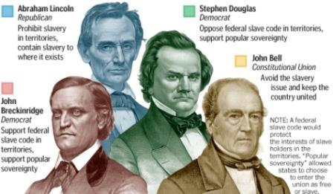
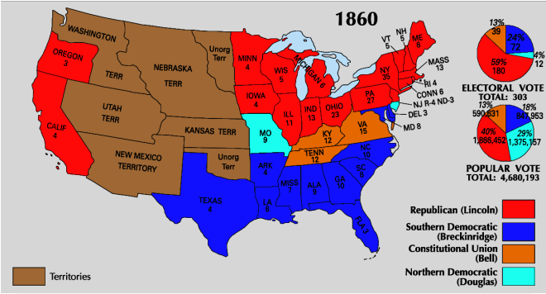

 | Republican |  | Abraham Lincoln |  |  | Hannibal Hamlin |  |  |  | 180 | 59.4% |  | 1,865,908 |  | 39.9%
 | Southern Democratic |  | John Breckenridge |  |  | Joseph Lane |  |  |  | 72 | 23.8% |  | 848,019 |  | 18.1%
 | Constitutional Union |  | John Bell |  |  | Edward Everett |  |  |  | 39 | 12.9% |  | 590,901 |  | 12.6%
 | Democratic |  | Stephen Douglas |  |  | Herschel Johnson |  |  |  | 12 | 4.0% |  | 1,380,202 |  | 29.5%
STATE | TOTAL VOTE | Republican |  |  | Democratic |  |  |  | Southern Democratic |  |  | Constitutional Union
 |  | ABRAHAM LINCOLN |  |  | STEPHEN A. DOUGLAS |  |  |  | JOHN C. BRECKINRIDGE |  |  | JOHN BELL
 |  | Votes | % | EV | Votes |  | % | EV | Votes | % | EV | Votes |  | % | EV
Alabama | 90,122 | -- | 0.0 |  | 13,618 |  | 15.1 |  | 48,669 | 54.0 | 9 | 27,835 |  | 30.9
Arkansas | 54,152 | -- | 0.0 |  | 5,357 |  | 9.9 |  | 28,732 | 53.1 | 4 | 20,063 |  | 37.0
California | 119,827 | 38,733 | 32.3 | 4 | 37,999 |  | 31.7 |  | 33,969 | 28.3 |  | 9,111 |  | 7.6
Connecticut | 74,819 | 43,488 | 58.1 | 6 | 15,431 |  | 20.6 |  | 14,372 | 19.2 |  | 1,528 |  | 2.0
Delaware | 16,115 | 3,822 | 23.7 |  | 1,066 |  | 6.6 |  | 7,339 | 45.5 | 3 | 3,888 |  | 24.1
Florida | 13,301 | -- | 0.0 |  | 223 |  | 1.7 |  | 8,277 | 62.2 | 3 | 4,801 |  | 36.1
Georgia | 106,717 | -- | 0.0 |  | 11,581 |  | 10.9 |  | 52,176 | 48.9 | 10 | 42,960 |  | 40.3
Illinois | 339,666 | 172,171 | 50.7 | 11 | 160,215 |  | 47.2 |  | 2,331 | 0.7 |  | 4,914 |  | 1.4
Indiana | 272,143 | 139,033 | 51.1 | 13 | 115,509 |  | 42.4 |  | 12,295 | 4.5 |  | 5,306 |  | 1.9
Iowa | 128,739 | 70,302 | 54.6 | 4 | 55,639 |  | 43.2 |  | 1,035 | 0.8 |  | 1,763 |  | 1.4
Kentucky | 146,216 | 1,364 | 0.9 |  | 25,651 |  | 17.5 |  | 53,143 | 36.3 |  | 66,058 |  | 45.2 | 12
Louisiana | 50,510 | -- | 0.0 |  | 7,625 |  | 15.1 |  | 22,681 | 44.9 | 6 | 20,204 |  | 40.0
Maine | 100,918 | 62,811 | 62.2 | 8 | 29,693 |  | 29.4 |  | 6,368 | 6.3 |  | 2,046 |  | 2.0
Maryland | 92,502 | 2,294 | 2.5 |  | 5,966 |  | 6.4 |  | 42,482 | 45.9 | 8 | 41,760 |  | 45.1
Massachusetts | 169,876 | 106,684 | 62.8 | 13 | 34,370 |  | 20.2 |  | 6,163 | 3.6 |  | 22,331 |  | 13.1
Michigan | 154,758 | 88,481 | 57.2 | 6 | 65,057 |  | 42.0 |  | 805 | 0.5 |  | 415 |  | 0.3
Minnesota | 34,804 | 22,069 | 63.4 | 4 | 11,920 |  | 34.2 |  | 748 | 2.1 |  | 50 |  | 0.1
Mississippi | 69,095 | -- | 0.0 |  | 3,282 |  | 4.7 |  | 40,768 | 59.0 | 7 | 25,045 |  | 36.2
Missouri | 165,563 | 17,028 | 10.3 |  | 58,801 |  | 35.5 | 9 | 31,362 | 18.9 |  | 58,372 |  | 35.3
New Hampshire | 65,943 | 37,519 | 56.9 | 5 | 25,887 |  | 39.3 |  | 2,125 | 3.2 |  | 412 |  | 0.6
New Jersey | 121,215 | 58,346 | 48.1 | 4 | 62,869 |  | 51.9 | 3 | -- | 0.0 |  | -- |  | 0.0
New York | 675,156 | 362,646 | 53.7 | 35 | 312,510 |  | 46.3 |  | -- | 0.0 |  | -- |  | 0.0
North Carolina | 96,712 | -- | 0.0 |  | 2,737 |  | 2.8 |  | 48,846 | 50.5 | 10 | 45,129 |  | 46.7
Ohio | 442,866 | 231,709 | 52.3 | 23 | 187,421 |  | 42.3 |  | 11,406 | 2.6 |  | 12,194 |  | 2.8
Oregon | 14,758 | 5,329 | 36.1 | 3 | 4,136 |  | 28.0 |  | 5,075 | 34.4 |  | 218 |  | 1.5
Pennsylvania | 476,442 | 268,030 | 56.3 | 27 | 16,765 |  | 3.5 |  | 178,871 | 37.5 |  | 12,776 |  | 2.7
Rhode Island | 19,951 | 12,244 | 61.4 | 4 | 7,707 |  | 38.6 |  | -- | 0.0 |  | -- |  | 0.0
South Carolina | 8 electors chosen by state legislature and awarded to John Breckinridge
Tennessee | 146,106 | -- | 0.0 |  | 11,281 |  | 7.7 |  | 65,097 | 44.6 |  | 69,728 |  | 47.7 | 12
Texas | 62,855 | -- | 0.0 |  | 18 |  | 0 |  | 47,454 | 75.5 | 4 | 15,383 |  | 24.5
Vermont | 44,644 | 33,808 | 75.7 | 5 | 8,649 |  | 19.4 |  | 218 | 0.5 |  | 1,969 |  | 4.4
Virginia | 166,891 | 1,887 | 1.1 |  | 16,198 |  | 9.7 |  | 74,325 | 44.5 |  | 74,481 |  | 44.6 | 15
Wisconsin | 152,179 | 86,110 | 56.6 | 5 | 65,021 |  | 42.7 |  | 887 | 0.6 |  | 161 |  | 0.1
Totals | 4,685,561 | 1,865,908 | 39.9 | 180 | 1,380,202 |  | 29.5 | 12 | 848,019 | 18.1 | 72 | 590,901 |  | 12.6 | 39

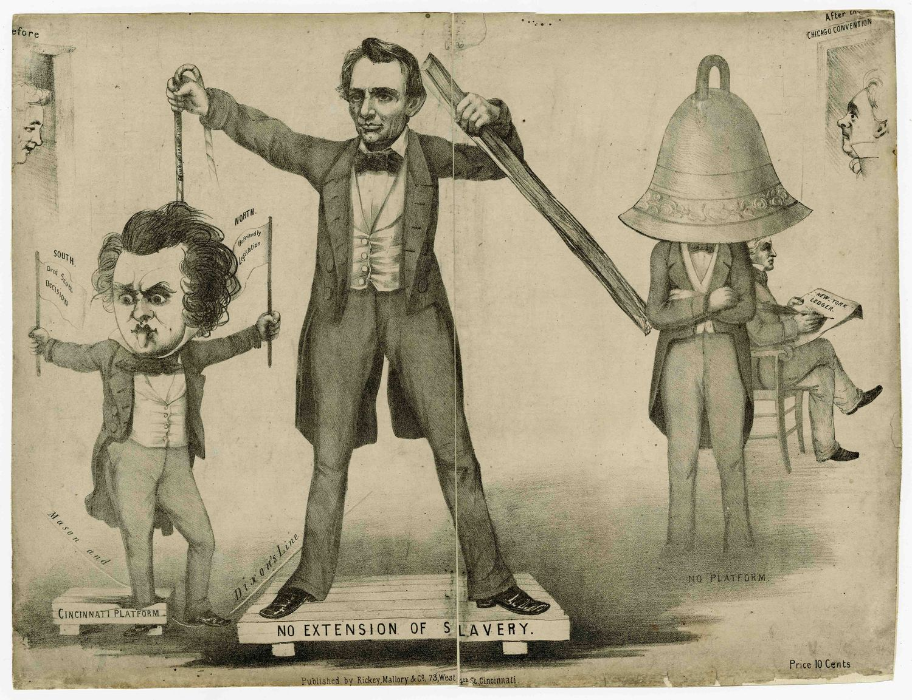
http://www.indiana.edu/~liblilly/digital/exhibitions/exhibits/show/america-in-caricature/item/55
Stephen Douglas
- Divided
  - One foot through the Cincinnati platform, the other foot on the Mason-Dixon line
  - Waves two flags:
    - South - Dred Scott decision - slaves are property,
    - North - Unfriendly legislation
Lincoln
- Stands on a no extension of slavery platform
- Holds rope around Douglas's neck
- Rope says - squatter sovereignty
- Brandishes a rail with his left.
John Bell
- stands on the ground without a platform
- has a bell over his head
Breckinridge
- seated behind him writing New York Ledger
- head also under the bell

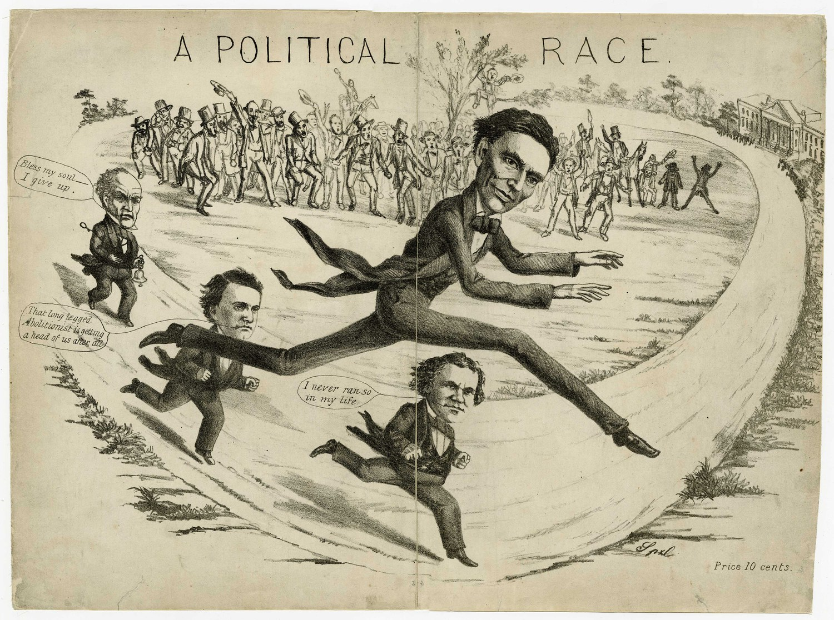
John Bell: Bless my soul I give up.
John C. Breckinridge: That long legged Abolitionist is getting ahead of us after all.
Stephen Douglas: I never run so in my life.

