Fitzgerald

Regions of the Colonies
New England and Life in New England
Questions | Notes  - Main Idea  - Detail  - Sub-detail  - Detail | Additions  Corrections
Describe the role of religion in New England.  Describe the role of the town.  Explain who Roger Williams was and describe the founding of Rhode Island.  Describe the founding of Connecticut.  List the four New England colonies. | Religion very important in the Massachusetts Bay Colony  - Settled by Puritans  - People obeyed the rules of the Bible  - Religions shaped the government  - All settlers had to attend church  Towns more self-governed than in other colonies  - Town meets held once a year  - Men with property could vote  - Made laws for the town  Roger Williams – a dissenter  - Did not agree with belief the Puritan Church  - Did not think the church could control a person’s actions  - Believed in religious freedom  - Banished  Williams starts Rhode island - 1836  - Government separate from church  - Joined by Anne Hutchinson - also banished  - Led meeting in which men and women discussed religion together  Thomas Hooker starts Connecticut  - Reason leaves Massachusetts – so men who are not part of church can vote  - New Hampshire also settled | - Held in the church  - Chose a representative from the town to the state legislature  - Whole family attended  - Pop. of town limited, forcing young and new-comers to start new towns  - To dissent – to disagree  - To banish – to kick out  - William’s beliefs – Natives should be treated as equals, women should be able to be ministers, cannot force church attendance  - Started the Baptist Church  - Purchased land from Natives  - Had female ministers  New England  Massachusetts  Rhode Island  Connecticut  New Hampshire
Describe native American relations in New England. | Fought with Natives for land  - Native did not believe land could be owned  - Fought and killed most of the Pequot  - Fought and defeated the Wampanoags  - war called “King Phillip’s War”  - but leader was actually named Metacom  - enslaved some, forced others to leave  - few Natives remained
Describe the economic activity in New England. | Economic Activity in new England  - Subsistence farming  - Shipbuilding  - Rocky coast – good harbors  - Forests – lumber for ships  - Fishing – cod  - Whaling  - Merchants – shipped goods – imported and exported large commodities  - Part of the triangular trade routes  - Europe  - Africa –  - 100, 000s of slaves taken to Caribbean and Americas  - Caribbean (West Indies) | Ships needed  White pine – masts  Oak – hulls  Whales provide -  Whale oil – from blubber - lamps, fine lubricants, for head oil – candles, from bowels – perfume base
Describe life in New England.  Describe the impact of religion in New England. | Life in New England  - Small houses with one main room  - Cooked in a large, open fireplace  - Made all they ate and worn by hand  - and most of what they used  - men/boys – work farm, care for animals, fixed buildings  - women/girls – cook, preserve food, make, mend, and wash clothes, make soap and candles  Impact of religion on life of New Englanders –  - Taught children to read  - So they could read the Bible  - Some towns had schools  - Great Awakening  - By early 1700s – impact had weakened  - New ministers arise –  - start a drive to return to religion  - start new churches with new ways

Town Structure of New England
Each town had only one church on the town square
Town meeting held in church
All attend meeting (women, kids, too) – though only men can vote
Discuss problems, make laws
Send a representative to the Colonial Legislature
Legislature elects governor
Town has a set size – must start a new town when that size reached

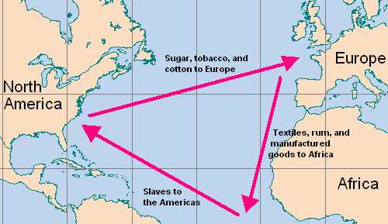
Triangular Trade

Whaling

A Sperm Whale
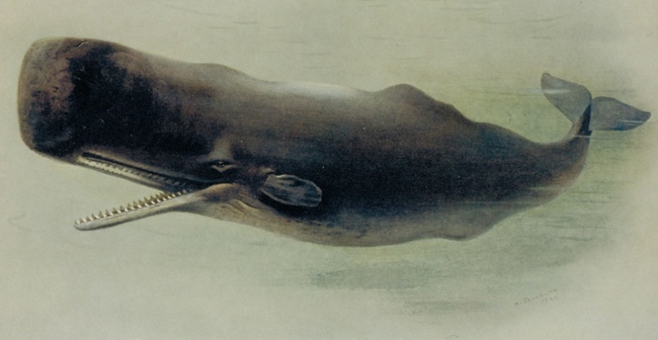

A toothed whale – This whale eats squid.

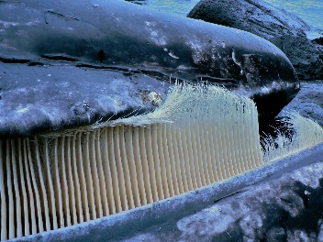

Picture of baleen (versus teeth) – This whale filters plankton through the baleen for food.

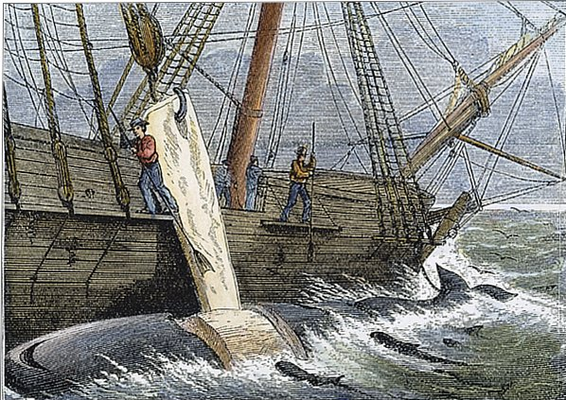

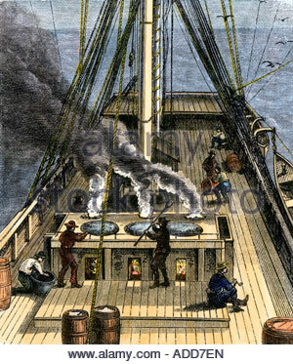

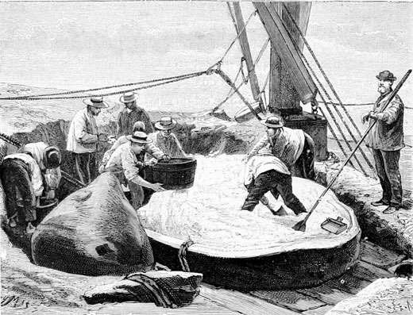
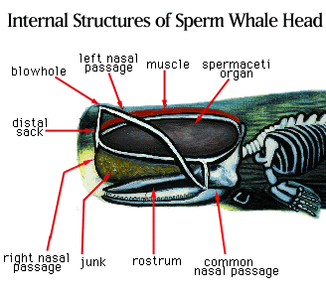

Spermaceti –
- a white waxy substance found in the head of a sperm whale –
  - helps whale sense its surroundings in the dark using acoustics and helps them know which way is up as the substance is lighter than water and wants to float up
- whalers are seen in the second picture dipping out the spermaceti from a whale skull they have butchered
- used in candles and ointments.

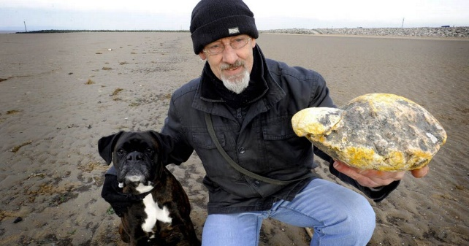

Dog walker finds lump of whale vomit ambergris on beach that's worth £100,000 - Mirror Online

Ambergris -
Sperm whales eat large quantities of cephalopods such as squid and cuttlefish. In most cases the indigestible elements of their prey, such as the beaks and pens, are vomited out before digestion. But in rare circumstances these parts move into the whale's intestines and bind together. They slowly become a solid mass of ambergris, growing inside the whale over many years. There are conflicting opinions as to how ambergris emerges from the whale. Some believe that the whale regurgitates the mass, earning it its well-known nickname 'whale vomit'. Others believe it passes with fecal matter or ruptures the whale’s bowel.

