Fitzgerald/Edwards

Unit - Establishing Our Place in the World
Timeline Topic - The French Revolution – pp. 295 “The French Revolution” – First and Second Paragraphs
French Revolution
http://www.history.com/topics/french-revolution/videos/the-french-revolution?m=528e394da93ae&s=undefined&f=1&free=false
Robespierre and Reign of Terror
http://www.history.com/topics/french-revolution/videos/robespierre-and-the-reign-of-terror?m=528e394da93ae&s=undefined&f=1&free=false
Heading  Questions | Paragraph Main Ideas  Bulleted Details | Additions and Corrections
pp. 295  “The French Revolution”  How did Americans feel about the French Revolutions at first?  What caused Americans to change their mind about the French Revolution? | French citizens rebelled against their monarchy  - Started the French Revolution in 1789  - Follow America's lead  - Most Americans supported at first  But soon supporting the revolution becomes less clear  - Revolution became very violent  - Reign of Terror in 1793  - Revolutionaries execute 17,000 people  - Including king and queen  - Federalists say - blood thirsty monsters  - Democratic Republicans - to be expected because oppressed people trying to win freedom | Also kill -  - all nobility  - all those who worked for the monarchy or nobility  - all who spoke against the violence

Unit - Establishing Our Place in the World
Timeline Topic - War between Great Britain and France – Neutrality, Seizing of Ships, Impressment - pp. 295-96 “The French Revolution” Third through 6th Paragraphs

Heading  Questions | Paragraph Main Ideas  Bulleted Details | Additions and Corrections
pp. 295-96 “The French Revolution”  What stand does Washington take on the war between Britain and France?  Is the United States really neutral?  How do Britain and France react to this "neutrality"?  What problem does the U.S. have only with Britain?  Why can't the U.S. fight with Britain? | By early 1793 France and Great Britain were at war  - Washington declares neutrality  - Neutral - not favoring either side  United States trades with both sides  - Each believed this trade will help their enemy  - Both begin stopping U.S. ships and seizing cargo  Britain also impresses sailors on U.S. Ships  - Impressment -seizing sailors and forcing them to join British navy  - Some sailors are British - had fled British navy  - Many are American  Hamilton urges Washington to stay friends with Britain for trade  - 75% of American exports sold in Britain  - 90% of imports come from Great Britain | British did focus on those of British heritage

Unit - Establishing Our Place in the World
Timeline Topic - The Jay Treaty with Britain concerning respect for American Sovereignty – p. 296 “The French Revolution” – 7th Paragraph through end

Heading  Questions | Paragraph Main Ideas  Bulleted Details | Additions and Corrections
p. 296 “The French Revolution”  With what nation does the U.S. sign the Jay Treaty?  What does Britain agree to do?  What does Britain refuse to do? | Washington tries to repair relations with Britain  - Sends John Jay  - Try to resolve most serious problems  Jay Treaty - 1795  - U.S. agreed to  - Pay debts owed to British merchants  - Britain agreed to - 3 things  - Pay for ships seized  - Withdraw troops from Northwest Territories  - Stop aiding Native Americans fighting settlement in Northwest Territories  - Britain refused to - 2 things  - Recognize right of U.S. to trade with France  - Stop impressment of U.S. sailors  Reactions to treaty in U.S.  - Republicans claim Jay Treaty gave away too much, got little  - Federalists glad for peace  - Federalists control Senate - approve treaty

Unit - Establishing Our Place in the World
Timeline Topic - The Pinckney Treaty with Spain concerning New Orleans – p. 314 “The Nation Looks West”

Heading  Questions | Paragraph Main Ideas  Bulleted Details | Additions and Corrections
p. 314 “The Nation Looks West”  Why is New Orleans so important to the U.S.?  With what nation does the U.S. sign the Pinckney Treaty?  What does the treaty guarantee? | Western settlement speeds up with Revolution  - By 1800 - 1 million settlers  - West of Appalachians  - East of Mississippi  Settlers are mostly farmers who rely on Mississippi  - Few roads, so use river to ship crops  - At New Orleans change ships to continue in ocean to eastern markets in U.S.  Got Pinckney Treaty with Spain, who controlled New Orleans  - 1795  - had threatened to close New Orleans several times  - guaranteed right to use river and port of new Orleans to transfer to ocean ships

Unit - Establishing Our Place in the World
Timeline Topic - The XYZ Affair – p.298 “Troubles with France," “The XYZ Affair"

Heading  Questions | Paragraph Main Ideas  Bulleted Details | Additions and Corrections
p.298 “Troubles with France”  Why is France upset with the U.S.?  W  hat does France do because they are upset? | Adams faces a crisis with France  - France angered about nuetrality  - Had expected U.S. support  - They had helped us in our war  - Thought we would return the support  Jay Treaty increased tension  - Treaty put U.S. on Britain's side  - Refuse to meet with U.S. diplomats  - Continue to attack U.S. ships
p.298  “The XYZ Affair"  What causes the XYZ Affair?  How does the U.S. react?  Practice interpreting political cartoons with the cartoon below on the XYZ Affair. | Adams sent a new mission to France  - 1787  - French demanded a bribe of $250,000  - Demand a loan of several million  Americans refuse to pay  - Say "not a sixpence"  - Becomes slogan "Millions for defense, not one six pence for tribute!"  Bribe Attempt a sensation in U.S.  - Known as XYZ Affair  - As nameless French agents who demanded bribe just called X, Y, and Z | Tribute - yearly money paid by nations in Roman Empire to Rome, for privilege of ruling themselves while protected by of Roman Empire  See political cartoon, p. 299

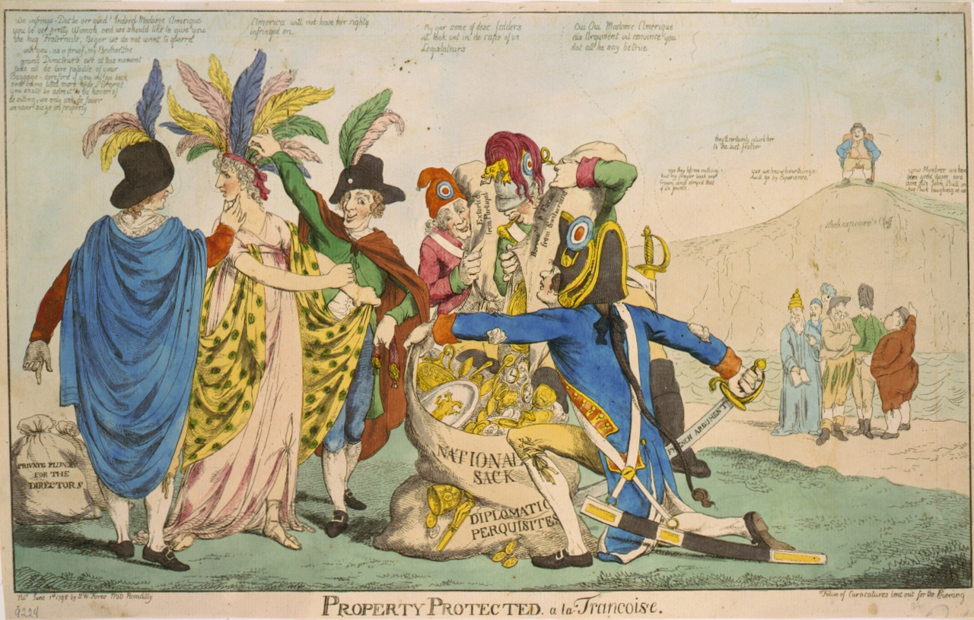

A British political cartoon depicting the affair: The United States is represented by the woman, who is being plundered by five Frenchmen. The figures grouped off to the right are other European countries; John Bull, representing Great Britain, sits laughing on a hill.

Unit - Establishing Our Place in the World
Timeline Topic - France – War or Negotiation? – p. 299 “War Fever”

Heading  Questions | Paragraph Main Ideas  Bulleted Details | Additions and Corrections
p. 299  “War Fever”  How does Adams satisfy the Federalists who ar calling for war with France?  What does Adams also do, though? | XYZ Affair causes war fever  - Federalists demand war  - Urge Adams to ask Congress for war  Adams instead uses support to increases size of army and navy  - Increases power of national government  - Makes navy a separate department  - Fights undeclared naval war with France 1798-1800  Adams opposed full-scale war  - Continues to negotiate  - France now led by Napoleon  - Busy with war with much of Europe  - Agrees to stop seizing ships in 1800  Agreement angers pro-British Federalists  - Especially Hamilton  - Adams weakened politically  Adams proud of avoiding war  - Tells friends he wants it on his tombstone  - "Here lies John Adams, who took upon himself the responsibility of peace with France in the year 1800."

Unit - Establishing Our Place in the World
Timeline Topic - Jefferson’s Embargo – pp. 324-25 “Jefferson Responds with an Embargo”

Heading  Questions | Paragraph Main Ideas  Bulleted Details | Additions and Corrections
pp. 324-25 “Jefferson Responds with an Embargo”  What does Jefferson decide to do when Britain and France are still attacking in 1807?  Describe the effects of the embargo.  Intended effect?  Unintended?  Practice interpreting political cartoons with the cartoon below. | Congresses passes Embargo Act of 1807  - Jefferson tries a peaceful method to get France and Britain to respect U.S. neutrality  - Embargo - a government order that forbids foreign trade  - U.S. ships were forbidden to sail to any foreign port  - Thinks this will force both countries to stop attacking U.S. ships  Instead hurts U.S.  - Exports fell from $109 million to $25 million  - Prices of U.S. crops fell  - Hurts farmers and plantation owners  - 10,000 of Americans lose jobs  Many outraged  - Especially in New England - most merchants involved in foreign trade  - Many smuggle - illegally ship anyway  Congress repeals Embargo Act 1809  - Reopened trade with nations other than Britain and France  - Would reopen that trade when respected rights as neutral nation | - War between Britain and France is continuing and worsened by 1805, Jefferson's second term  - Both again seizing ships  - if too many crops at home, more supply than demand  Job Loss  - if farmers hurt, no longer buy goods or services, causes other to lose jobs  - all in shipping or ship-building industry lose jobs

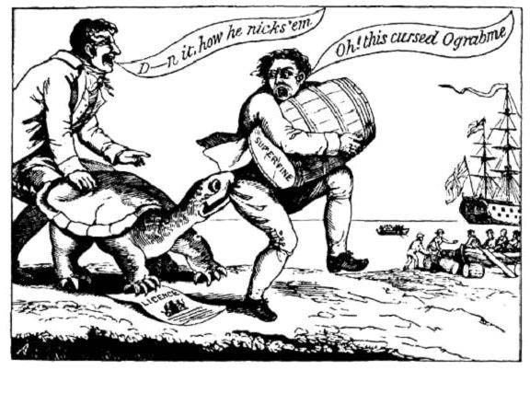

A political cartoon showing merchants dodging the "Ograbme", which is "Embargo" spelled backwards.

New England press also played with letters to form
- Dambargo
- Mob-Rage
- Go-bar-'em

Unit - Establishing Our Place in the World

Timeline Topic – The Louisiana Purchase – pp. 315-316 from end of “Nation Looks West” to “Jefferson’s Dilemma”

Heading  Questions | Paragraph Main Ideas  Bulleted Details | Additions and Corrections
End of “The Nation Looks West”  How does the U.S. feel about the transfer of Louisiana to France? | Crisis developed  - America shipped goods through New Orleans  - Spain had given New Orleans and all of Louisiana to France  Would Napoleon block westward expansion of U.S.?  - Napoleon had set out to conquer Europe  - Jefferson worried
Buying Louisiana | U.S. position in Louisiana had been threatened before  - Spain had stopped American ships from using New Orleans before  - Westerners had demanded war  What would happen when France takes over?  - Situation explosive  - Jefferson worried
A Surprise Offer  What happens after Jefferson approaches France about buying Louisiana?  What are the effects of the Lousiana Purchase? | Jefferson decided to try to buy New Orleans from the French  - Sent Monroe and Livingston  - Instructed to buy New Orleans and West Florida  France offered to sell not only New Orleans but all of Louisiana  - Needed money for war with Britain  - Having lost Haiti to a revolution, France had no base to defend New Orleans in a war with U.S.  Monroe and Living accept without Jefferson’s advice  - Too long to ask Jefferson  - Pay $15 million – 4 cents and acre  An amazing bargain  - Doubled the size of the United States  - Gave them control of the Mississippi and New Orleans  - Millions of acres of farmland and other resources
Jefferson’s Dilemma  Why did Jefferson worry about the Louisiana Purchase? | Jefferson had a dilemma  - Constitution nowhere states the president has the power to buy land from a foreign nation  But  - Louisiana would drastically change the nation  Jefferson decided he does have the power  - Constitution allowed president to make treaties  - Paying money for land could be part of a treaty | Dilemma – def.  Damned if you do, and damned if you don’t.  Used loose construction, which he did not believe in

See next page for summary and image suggestions developed by classes.
Summary –
A crisis developed when Spain gave New Orleans and all Louisiana to France. Napoleon was conquering Europe, and the U.S. was afraid he would block U.S. expansion west by stopping U.S. from using the port of New Orleans. So Jefferson offered to buy New Orleans and West Florida, but Napoleon offered instead to sell all of Louisiana because he needed money for the war with Britain and could not defend New Orleans in a war because he had lost Haiti as a base due to a revolution. The U.S. bought Louisiana for $15 million, 4 cents an acre, which was an amazing bargain as it doubled the size of the U.S., gave the U.S. control of Mississippi, millions of acres of farmland, and many other resources. Jefferson had the dilemma that Constitution did not give the president the power to buy land from a foreign nation, but he used the necessary and proper clause saying it was part of the power to make a treaty.

Image suggestions –
Map of U.S. with Mississippi and New Orleans (to show issue that led to purchase)
Spanish Flag with arrow to French Flag (to show fear of what France would now do)
French Flag with arrow to U.S. Flag (to show sale of land to U.S.)
$15,000,000 and equal sign to square with 4 cents in it (to show bargain)
+1 on one side of Mississippi and +1 on the other side of the Mississippi (to show doubled size)

Fitzgerald/Edwards
Chapter – Establishing Our place in the World
Sections – Native Americans in the Northwest Territories – Little Turtle and the Battle of Fallen Timbers – pp. 394-95 “Conflicts in the Northwest Territories,” “A Struggle Over Land,” and "A Series of Battles"

Conflicts in the Northwest Territories  What are the Northwest Territories?  With whom was the U.S. in conflict in the Northwest Territories and why? | British hoped to limit American settlement in the Northwest Territory  - Treaty of Paris the United States given territory from Appalachian Mountains to Mississippi River  - British still had forts in the region  - British promised to withdraw within “reasonable time”  - British supplying Native Americans with guns and ammunition  Native Americans in the Northwest Territory wanted to keep their lands  - 1780s  - Attacked many American settlements  - Native American groups joined together to oppose settlement | Northwest territories – MI, OH, ID, IL, WI  Still hunting for Beaver – very valuable  (See pictures below)  Worried about threat to Canada
A Struggle Over Land  What did the U.S. try first to settle their dispute with the Natives?  Did this work? | American leaders believed country’s future depended on settling western lands  - Fed. Gov’t tried to force Native Americans in territories to sell land  - By 1790 U.S. succeeded in buying Native American lands in Kentucky and part of Tennessee  - North of Ohio River Native Americans refused to sell
Series of Battles  What did the U.S. do when their first attempt to settle the dispute with Natives did not work? | 1790 Washington sent a small force to end Native American attacks on settlers  - Warriors led by Little Turtle of Miami Nation and Blue Jacket of Shawnees  - U.S. soldiers defeated by Natives  Next year Little Turtle won bigger victory  - 900 soldiers killed or wounded  - Worst defeat army would ever suffer to Native Americans  Battle of Fallen Timbers  - Americans led by General Anthony Wayne  - Battle at place where fallen trees covered ground  - Natives thought Wayne and soldiers would struggle on terrain  - August 1794 major victory for Wayne and Americans  Native Americans give up most of their land from Ohio River in the south to Lake Erie in the North  - Battle of Fallen Timbers broke Native American hold on Northwest  - 1795 Treaty of Greenville  - Today most of the state of Ohio

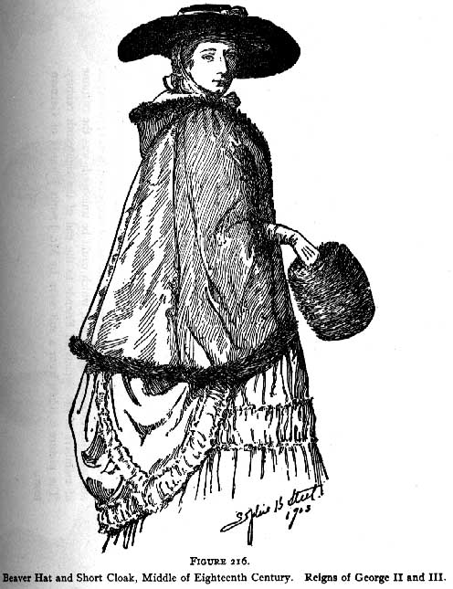
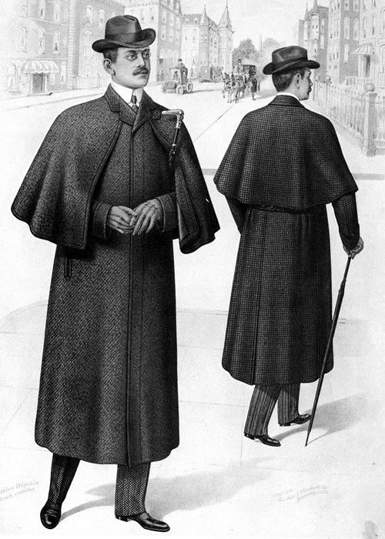

Fitzgerald/Edwards
Chapter – Establishing Our place in the World
Sections – Native Americans in the Northwest Territories – Tecumseh – pp.325-26 “ Tecumseh and the Prophet,” “New leaders take Charge,” “Harrison’s Victory”

Tecumseh and the Prophet  What impact does settlement following Little Turtle's defeat have on Natives? | Americans continued push into new areas  - After Battle of Fallen Timbers tens of thousands of settlers moved westward  - Ohio became a state in 1803  - Settlement in the territory of Indiana and lands farther west  Settlement impact on Native Americans  - Disease killed thousands of Native Americans  - Measles, smallpox, influenza  - Settlers took large parts of Native American hunting grounds  - Animals Native Americans depended on driven away  - Population decrease  - Power of traditional leaders declined
New leaders take Charge  What does Tecumseh try to get Natives to do again? | Tecumseh and Tenskwatawa (THE PROPHET)  - Shawnee brothers  - Urged Native American resistance  - Called on Native Americans to preserve traditional ways  Tecumseh  - Organized western tribes into a league  - Wanted to restore Indian lands  - Traveled widely spreading his message | Attacked when Tecumseh was away
Harrison’s Victory  How does the U.S. react? | American officials deeply concerned by Tecumseh  - Governor of Indiana Territory William Henry Harrison acted  - marched a thousand soldiers against Shawnee villages on Tippecanoe River  - defeated Native Americans  Battle of Tippecanoe marked high point of Native American opposition to settlement  - Alliances decline after the battle  - Tecumseh and warriors continued their struggle for next several years

War of 1812 - Identify the following on our chart.

Name four causes of the war. | - Impressment  - Seizing of ships  - Arming Native Americans  - Westerners interested in possibly seizing Canada
Who supports the war? | Democratic Republicans -  - settlers in west want Native support stopped,  - want Canada
Who is against the war? | Federalists -  - merchants in East worried about trade with Britain
What are the conditions as the first half of the War begins? with Britain? with U.S.? | - Britain - fighting Napoleon so can send no troops  - U.S. - few ships or soldiers due to Jefferson's cuts so unprepared
What does Britain set up right away? | - A blockade of U.S. ports stopping all trade
Where does the war start? Why? | - Near Detroit and Lake Erie  - Westerners focused on Natives and Canada were the ones who called for war
How does the U.S. do in the first half of the war? | - U.S. wins many battles against British and Natives
What changes to mark the beginning of the second half of the war? | - Britain defeats France and can send troop
What two places do the British strike in the second half of the war? why did they choose these targets? | - Washington, D.C. because it is our capital and burning it symbolizes their power  - New Orleans - because they knew we were concerned about it and needed it for western trade
Who won the war? | - No one - the treaty just set everything back to before the war  - Impressment stopped because Britain was no longer at war on the sea
Name three effects of the war. | - Patriotism - U.S. is pumped and all start referring to themselves as Americans  - New leaders - William Henry Harrison and Andrew Jackson  - U.S. Manufacturing had grown when competition from Britain cut off by war

