Fitzgerald/Edwards
Establishing Our Government - Notes on All Topics

Chapter – Establishing the National Government
Section - Hamilton’s Financial Plan
Heading  Questions | Main Idea of Each paragraph  Detail  Detail | Additions and Corrections
Hamilton’s Financial Plan | Developing a plan to solve the nation’s financial crisis  - Alexander Hamilton  - Secretary of the Treasury  Three Part program  U.S. gov’t assume all federal and state debts  - Charter a national bank  - High tax on imports
Paying the Debt | Prove that the U.S. would honor its debts  - Paying all debts a huge burden  - But – people would be willing to invest again  Southerners oppose  - Paid their war debts on own  - Thought other states should, too  Agreement reached  - Debated for six months  - New capital would be built in South  - Between Virginia and Maryland
The National Bank | Create a privately owned bank  - Safe place to deposit gov’t funds  - Could issue paper money for national currency  Debate went beyond bank  - Focuses on powers of national government in Constitution  - Opponents insist it is unconstitutional  Two sides of the debate  - “Strict” interpretation of Constitution  - Constitutional only permits what it specifically says  - Jefferson argues this  - “Loose” interpretation of Constitution  - Also has powers that are “necessary and Proper” for fulfilling other powers  - Article I Sec 8.18  - Hamilton argues this
The Tariff | Final part of plan called for high tariff  - Tax on imported goods  - Raise money for the national government  - Protect U.S. manufacturers from foreign competition  - Raised price of foreign goods  Only part of plan that did not pass  - Southerners opposed it  - Helped the North where there were new industries  - Made Southerners pay more for goods they bought | ADD – Southerners exported tobacco and cotton to Europe, and then had to trade it for European goods they brought back to U.S. to sell.
Chapter – Establishing the National Government
Section – Whiskey Rebellion

Heading  Questions | Main Idea of Each paragraph  Detail  Detail | Additions and Corrections
The Whiskey Rebellion | - Congress imposed a tax on all whiskey made and sold in the U.S.  - Led to a revolt  - Tested the strength of the new government  - Backcountry farmers resented the tax  - Made extra money turning the corn they grew into whiskey  - Compared tax to those Britain had imposed on colonies organized protests  - Refused to pay tax  - Farmers in western Pennsylvania rebelled  - 1794 – when tried to collect tax  - Violent protest  - Burned down tax collector’s house  - Angry mob marched through Pittsburg  - Washington sees as challenge to federal authority  - Responds quickly  - Sends militia  - 13,000 troops  - Later pardoned leaders  - Showed armed rebellion not acceptable in a republic  - Tested will of new government  - Forceful response | Subsistence farmers –live off form, make no money  Use this extra money for guns, bullets, plows, salt, etc.  Unfair comparison – those had not been from representative, but these are  Admits tax unfair  Political protests – vote, run for office, petition gov’t, assemble, speech, press

Chapter – Establishing the National Government
Section - Political Parties

Heading  Questions | Main Idea of Each paragraph  - Detail  - Detail | Additions and Corrections
Political Parties Emerge | Framers of Constitution had not expected political parties  thought would rise above personal or local interests  would work together for good of the country  Madison considered factions selfish groups  - political parties called factions  - not complimentary term  - Effective government would prevent growth of factions  - Well-constructed union has tendency to break and control violence of faction  Jefferson and Hamilton also dislike  - Could bring mob rule  - Cause chaos  Washington most hostile to parties  - Unhappy when Jefferson and Hamilton grow apart  - Tries to reduce quarrelling  - Predicted factions would destroy "best fabrics of human government and happiness"  Two parties form  Early 1790s  - One - Jefferson and Madison  - Other - Hamilton
Republicans against federalist | Two Parties take shape  - Early 1790s  - Democratic-Republicans  - Federalists  Democratic Republicans argue federal government growing too strong under Washington  - Want to keep power at state and local level  - Fear central government would act like monarchy  Drew main strength from  - Southern planters  - Northern farmers  - Artisans  - Leaders - Madison and Jefferson  Federalists said U.S. needed a strong federal government  - To hold country together  - To deal with problems  - Leader - Hamilton  Drew support from  - Merchants  - Property owners  - Workers in manufacturing and trade  - Especially strong in North
Organizing and Arguing | Federalists have advantage  - Washington supported Hamilton and his policies  - Federalists say they are "the friend of the present administration"  Democratic Republican newspapers imply betrayal of Constitution and bringing back monarchy  - Are not some among us advocates of monarchy and aristocracy?  - Are not the principles of all such people hostile to the principles of the constitution?
Other Disagreements | In addition to fundamental disagreement of power of federal government, also disagree on  - The national bank - F - Yes, DR - No  - The tariff - F - Yes, DR - No  - Supporting Britain or France - F - Britain, DR - France

Chart Comparing Democratic Republicans and Federalists

 | Democratic Republicans | Federalists
Power of Government | Power at state and local level -  To keep government close to people | Power at national level –  To unify nation and strengthen economy
Seek rule by … | People | Elite
Fear | monarchy and aristocracy (nobles) | Fear mob rule
Vision of Future | Agricultural | Manufacturing and Trade
Interpretation of Constitution | Strict  Amendment 10 | Loose  Art I Sec 8.18 Necessary and Proper
Leaders | Jefferson  Madison | Hamilton  (Washington)
Supporters | Artisans  Northern Farmers – both cash crop and subsistence  Southern Planters | Merchants  Manufacturers  Property Owners  Workers for these businesses
Positions on Policies | Against National Bank  Against Tariff  Supports France | For National Bank  For Tariff  Supports Britain

Chapter - Establishing Our Government
Section - Washington Retires

Washington's Farewell Address - Review of three key points
http://www.youtube.com/watch?v=gtlNf3DmbM4

Heading  Questions | Main Idea of Each paragraph  - Detail  - Detail | Additions and Corrections
Washington Retires from Public Life | Washington published his Farewell Address  - 1796  - Had lasting influence  - Made two major points  - First - warned political division could tear nation apart  Second piece of advice  - Do not get entangled in European affairs  - Europe's interests are not related to us  - Why entangle our peace and prosperity in European ambitions  - Steer clear of permanent alliances  Took pride in accomplishments  - Started a functioning federal government  - Economy improving  - Avoided war  - British had left forts in Northwest Territories

Chapter - Establishing the National Government
Section - Election of 1796

From John Adams
https://www.schooltube.com/video/d15be702626a4b08a726/The%201796%20Election
Heading  Questions | Main Idea of Each paragraph  - Detail  - Detail | Additions  Improvements
The Election of 1796 | Precedent - Not seeking a third term as president  - No president would seek more than two until Franklin Roosevelt in 1940  - 22nd Amendment limited to two terms  Candidates  - Democratic Republicans - Thomas Jefferson  - Federalists - John Adams  - New Englander  - Washington's Vice-President  Not elected as we do today  - President - winner  - Vice-President - second place  Adams wins and Jefferson second  - Federalist President  - Democratic Republican Vice-President  - Led to serious tensions!!
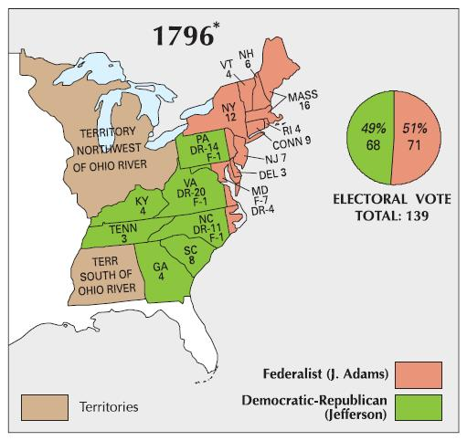

Chapter - Establishing the National Government
Section - The Alien and Sedition Acts

XYZ Affair
https://www.youtube.com/watch?v=uw0KcA59_8s
John Adams - XYZ and Alien and Sedition
http://www.youtube.com/watch?v=xqAt8A0W204
APUSH Review XYZ, A and S, VA and KY Resolutions
http://www.youtube.com/watch?v=TevQdggoEdE
John Adams Scene about Acts
https://www.youtube.com/watch?v=xUH-xtkovxg
Heading  Questions | Main Idea of Each paragraph  - Detail  - Detail | Additions  Improvements
The Alien and Sedition Acts | - War-fever deepened between Federalists and Democratic - Republicans  - Federalists fear of Revolutionary France (violence) causes  - mistrust immigrants  - suspect bring in dangerous ideas  - Immigrants back Democratic-Republicans  - To restore order - Federalists decide to attack opponents  - Acts to attack immigrants (Aliens)  - Acts to attack Republicans (Sedition)  - Alien Act  - Alien = immigrant  - Increase time to become a citizen from 5 to 14 years  - President can deport any alien he thinks is "dangerous"  - Sedition Acts - Harshest law ever passed against free speech!  - sedition - act that seeks to overthrow government  - Crime to write or say anything insulting or false about President, Congress, or government in general!  - 10 people convicted - Republican editors and printers | France and Britain at War  - America trading with both  - Both attack our merchant ships  - Negotiate with Britain to stop attacks  - But France asks for bribe instead  - Federalists call for war with France  Only citizens vote - can't vote for D-R  ADD - Democratic-Republicans can't stop these acts  - Federalists have majority in both house of Congress  - President (Adams) is Federalist  - Judges all appointed and approved by Federalists

Chapter - Establishing the National Government
Section - States Rights

Heading  Questions | Main Idea of Each paragraph  - Detail  - Detail | Additions  Improvements
States' Rights | Democratic Republicans denounced Alien and Sedition Acts  - Violated the Constitution  - Especially the 1st Amendment  Problem opposing law  - Not established that Supreme Court could strike down unconstitutional law  - So express opposition through state legislatures  Jefferson and Madison lead campaign by writing resolution attacking Alien and Sedition Acts  - Resolutions say  - Acts unconstitutional  - States have right to declare laws unconstitutional  - Passed by Virginia and Kentucky  Little impact because no other states supported but laws expired and changed  - Alien Acts after two years  - Sedition Act in 1801  - Time to become citizen back to 5 years in 1802  Long term impact - Resolutions had claimed states could nullify a law  - Gave rise to idea of states' rights - union is an agreement between states and that states can then refuse to enforce a federal law  - In future  - Number of states refuse to obey certain laws  - South will use idea to defend slavery | Federalist have the  - Presidency  - The majority in Congress  - Have appointed all federal judges  - Marbury v Madison – 1803  No court to declare unconstitutional or House to impeach  Resolution - def  a formal expression of opinion or intention voted on and passed by a legislature  Does not claim that states can violate the Constitution

Chapter - Establishing the National Government
Section - Election of 1800

Heading  Questions | Main Idea of Each paragraph  - Detail  - Detail | Additions  Improvements
A Bitter Campaign | Presidential election of 1800 viciously contested  - Federalists - civil war of Jefferson elected  - Democratic Republicans - Adams wants to create monarchy  Election decided by House of Representatives  - First place Wins Presidency  - Next highest Vice-President  - Adams defeated but  - But - No one receives majority  - Jefferson gets 73 electoral votes  - Burr, Jefferson's running mate, also gets 73  - Took 6 days and 36 votes for House to choose | Great story!!!!  House that votes is old House  - Newly elected House not yet started  - So the Federalist majority is choosing!!  - Know Jefferson is the desired choice  - But fear what he will do to their policies  - Could mess with Democratic Republicans  - In the end - Hamilton gets them to do the right thing

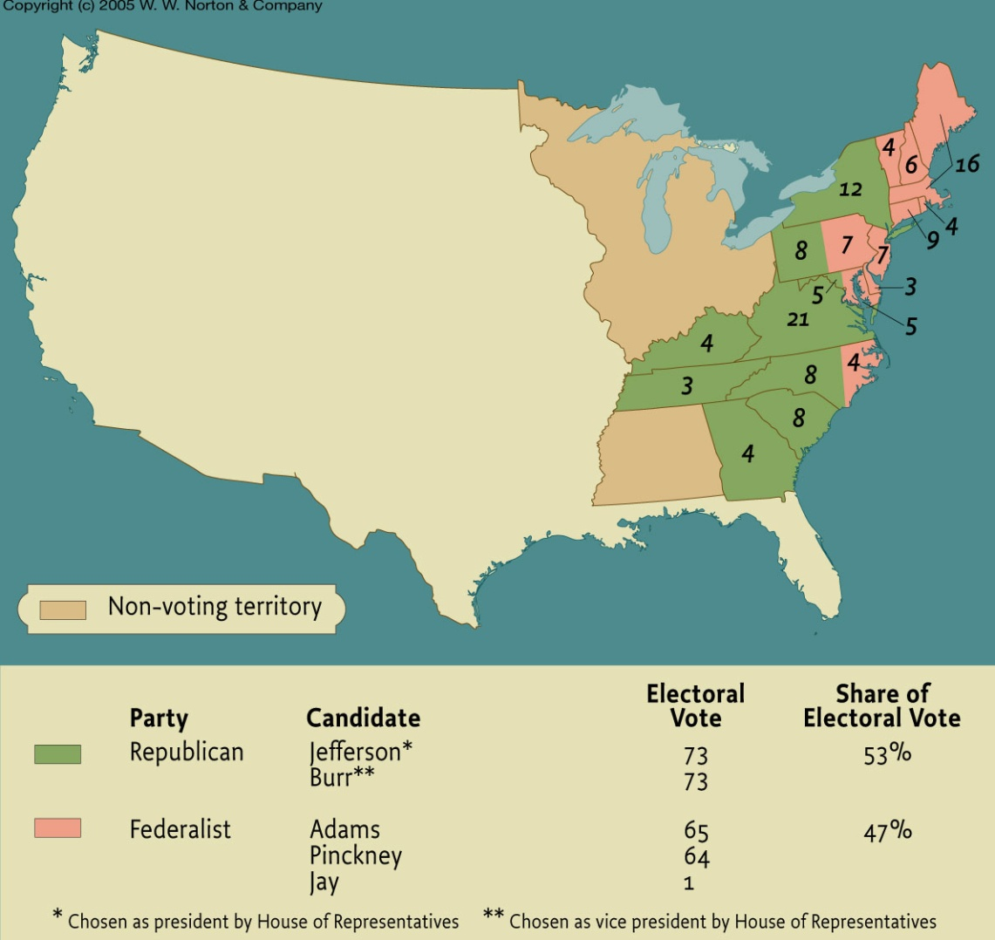

Chapter - Establishing the National Government
Section - Jefferson Overturns Federalist Policies

Thomas Jefferson & His Democracy: Crash Course US History #10

also reviews Election of 1800
https://www.youtube.com/watch?v=_3Ox6vGteek

Heading  Questions | Main Idea of Each paragraph  - Detail  - Detail | Additions  Improvements
Jefferson Charts a New Course | Jefferson thinks of election as "Revolution"  - First goal - limit federal power  - Thought federal gov't too involved in economic affairs  - Believed in Laissez faire - gov't should not interfere in economy  - "let alone" | Alter or abolish!
New Republican Policies | Laissez faire into practice  - Reduce number of people in gov't  - Fired al tax collectors  - Cut number of diplomats  Larger cuts in military  - Cuts army's budget in half  - Reduce size of army 4,000 to 2,500  - Eliminate all federal taxes in side country  - Tax revenue from tariffs only  Sedition Acts targeted  - All fines issued refunded  - All in prison released
Federalist Policies Remain | Can't reverse all policies  - Had to keep repaying debt  - Did not fire most Federalist officeholders  - Keep jobs if did them well and loyal citizens | Could not eliminate  the National Bank – It had a 20 year charter.

Chapter - Establishing the National Government
Section - Marbury v, Madison

Power of Judicial Review - Crash Course
https://www.youtube.com/watch?v=mWYFwl93uCM

Really fun review of Marbury
https://www.youtube.com/watch?v=YFFZYJzv8-I

Heading  Questions | Main Idea of Each paragraph  - Detail  - Detail | Additions  Improvements
The Supreme Court and judicial review | Republicans believe Federalist judges appointed at the last minute were just appointed to maintain Federalist power  - Adams had appointed Marbury in the last hours before he left office  - Did not get to keep this job  Jefferson told Madison to stop work on the appointments  - Marbury sues  - Says his case gets to go right to the Supreme Court because the Judiciary Act of 1789 said Supreme Court could review all cases brought against federal officials  Marbury Decision states - courts powers come from Constitution, not Congress  - Congress did not have the right to add jurisdictions like the power to hear all cases against federal officials  - So Act of 1789 was unconstitutional  Establishes the power of Judicial Review  - The power of the Supreme Court to strike down unconstitutional laws  - One of the most important powers of the Supreme Court | ADD - all unconstitutional federal government actions, too

Chapter - Establishing the National Government
Section - Three Important Court Cases Increase Federal Power, pp. 343-4

Hip History
Marbury
https://www.youtube.com/watch?v=TYxtCTIQNb4
Gibbons
https://www.youtube.com/watch?v=kKUpRFAi4vA

Heading  Questions | Main Idea of Each paragraph  - Detail  - Detail | Additions  Improvements
Three Important Supreme Court Rulings | Supreme Court promoted economic growth and strengthens national government (over states)  - Chief Justice a Federalist  - John Marshall  - 1819-1824  McCulloch v Maryland (1819) - states had no power to interfere with federal government institutions  - Maryland tried to tax the branch of the bank in Maryland  - Bank refused to pay  - Ruling -  - No taxing - Saying, "Power to tax is the power to destroy"  - Also ruled - State cannot pass a law that violates a federal law  Dartmouth v Woodward (1819) - Constitution (federal government) protects contracts  - New Hampshire is prevented from changing the charter of Dartmouth College  - Charter is a contract  - Contract - an agreement between two or more parties that can be enforced by law  - Contracts helped promote capitalism - the free market economy system  Gibbons v Ogden (1824) - Only Congress can regulate interstate commerce  - State of New York could not give a steam boat company a monopoly on carrying passengers across the Hudson River  - The other bank of the river is in New Jersey  - Thus it was interstate commerce - trade between two states | Court also clearly stated Bank was constitutional as an implied power  Change desired -  - the original charter had the trustees appointed and wanted to change it so trustees were elected by state elections - appointed trustees were all Federalists, state elections would have made them Democratic Republicans

