Settling the Western Lands  What was preventing the Articles from being ratified?  and  What had to be done to get them ratified? | - The Articles had to be approved by all 13 states  - Some states would not give their approval until other states had dropped their claims to land west of the Appalachians – see map p. 207 for claims  - This took years  - Virginia was the last to agree in 1781  - All western land was turned over to the national government  - it was valuable – in demand  - it was sold piece by piece to private companies | Ratified – voted for  Used money to pay back war debt
Land Ordinance of 1785  What is the purpose of the Land Ordinance?  Explain the process developed by the Land Ordinance. | - A system for land sales and settlement  - divide land into 6 mile sq. townships  - each township had 36 one mile square sections of land for sale  - couldn’t be sold for less than $1 a section  - One section in each township set aside for education  - “If a state expects to be ignorant and free,  it expects what never was and never will be.” Thomas Jefferson | Note – Did not have to buy a whole section –  Could buy ½ section, ¼ section, 1/8 section, 1/16 section  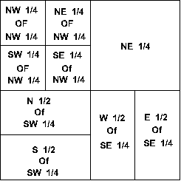
Northwest Ordinance  What is the purpose of the Northwest Ordinance?  Explain the process developed by the Northwest Ordinance.  What 5 states form from the NW Territores? | - Explained how new land to be governed  - new state constitutions would have to guarantee basic rights,  - like religion, speech, jury, habeas corpus  - and ban slavery!!!!  - Three stage process to become a new state  - Stage 1 – a territory  - president appoints a governor, a secretary, three judges  - Stage 2 - when have 5,000 free adult males  - get a legislature  - write a state constitution  - Stage 3 – when have 60,000 free people (male, female, children)  - could apply for statehood  - Five states created this way – Michigan, Ohio, Indiana, Illinois, Wisconsin | - Divide land into 5 territories
- The Articles had to be approved by all 13 states
  - Some states would not give their approval until other states had dropped their claims to land west of the Appalachians – see map p. 207 for claims

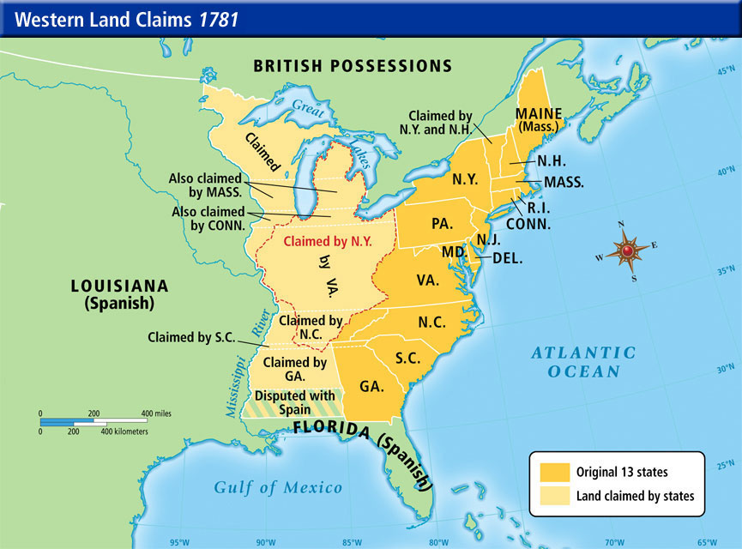

All western land was turned over to the national government
  - it was valuable – in demand
  - needed to be organized to be sold

Land Ordinance of 1785 - Organizes the Land to Sell
  - divide land into 6 mile sq. townships
  - each township a grid of 36 one mile squares called sections

Northwest Ordinance - Process for territory to become a state
  - Divide land into 5 territories - each has an appointed governor
  - at 5,000 free men - get a legislature, write a constitution
  - at 60, 000 free people - apply to become state
    - no slavery allowed
    - must have basic rights - freedom of religion, habeas corpus, jury trial

