Fitzgerald
Topic – Convincing Arguments
- The Enlightenment and Theories of John Locke – Natural Rights of Man, Social Compact Theory, Right of Revolution, Ch 4 Sec 4, p. 122-123
- Common Sense - Ch 6 Sec 1 - pp. 170-71
- Declaration of Independence - Ch 6 Sec 4, p. 172
The Enlightenment and  Theories of John Locke  - Natural Rights of Man  - Social Contract Theory  - Right of Revolution | - The Enlightenment - scientific movement of 1700s  - use human observation and reason  - identify "natural laws"  - Locke studies how governments are formed  - Parts to Locke's Theory  - Natural Rights  - People have certain natural rights  - life, liberty, and property - don't kill me, lock me up, take my stuff  - Social Contract Theory  - People formed governments to protect their rights  - Challenged idea that kings got their right to rule from God  - Right of Revolution  - If king violates natural rights,  - people have the right to overthrow the king
Common Sense | - 50 page pamphlet written by Thomas Paine  - Goal - convince colonists that it is "common sense" to rebel  - Key Points  - Makes fun of idea of having king at all -  - calls King "a royal brute"  - Attacks mercantilism -  - "Our corn will fetch its price in any market in Europe"  Very Emotional -  "the blood of the slain,  the weeping voice of nature cries,  'TIS TIME TO PART"  - Inspired the colonists  - Washington says it works a change on men's minds  - 500,000 copies sold from January till July 1776
Declaration of Independence | - Explains why colonists want to break away - to show respect for government  - First section - Locke's ideas about government - We hold these truths to be self-evident  - Natural Rights -  - All men are created equal  - have rights given to them by God  - Social Compact Theory -  - Governments are created to protect these rights  - Right of Revolution -  - If government violates these rights,  - people have a right to abolish the government  - and create a new one  - Next section - list of grievances (complaints against British)  - Ignoring rights English citizens had enjoyed since Magna Carta  - Depriving us in many cases of trial by jury  - Imposing taxes on us without our consent  - King ignored petitions for peace  - so unfit to be ruler of a free people  - Logical conclusion - All political connection with Great Britain totally dissolved

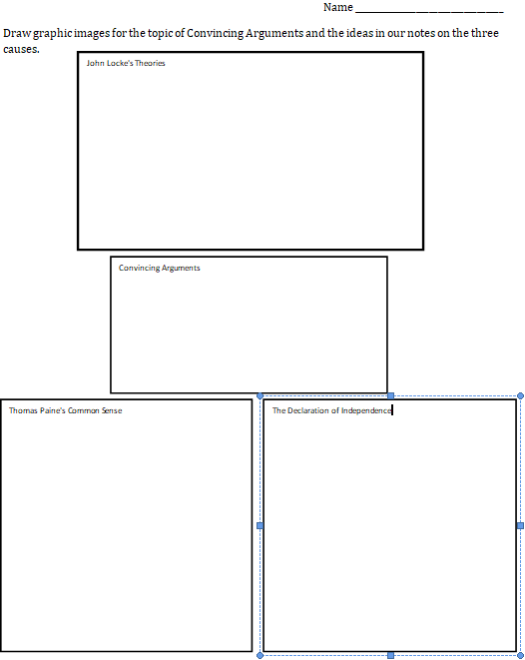

Name ___________________________________
Draw graphic images for the topic of Convincing Arguments and the ideas in our notes on the three causes.
John Locke's Theories

Convincing Arguments

The Declaration of Independence
Thomas Paine's Common Sense

