Fitzgerald

Topic - British Retaliation
- Closing of the New York Legislature, Ch 5 Sec 2, p. 148
- The Intolerable Acts - Ch 5 Sec 3, p. 151

Closing of the New York Legislature | - New York has 13,000 of the 20,000 troops because there can  - get to Ohio - if Natives attack again  - get to Canada - if French fight again  - stop most settlers trying to get to Ohio  - New York refuses to quarter troops  - Parliament passes an act - closes down New York's legislature  - All colonies organize boycott - violates right to representation  - if done to New York, can be done to any colony
The Intolerable Acts | - Goal - to punish Boston and Massachusetts for Boston Tea Party  - 4 laws  - Close the port of Boston - until cost repaid  - Weaken colonial self-government  - Increase power of royal governor  - Limit town meetings  - Anyone accused of murdering a British official, tried in London  - NOW put soldiers in homes  - Quebec Act also passed  - take away land west of Appalachians  - give land to Canada

Fitzgerald

Topic – Colonies Unite
- First Continental Congress, Ch 5 Sec 3, p. 152
- Lexington and Concorde, Ch 5 Sec 3, pp. 152-3
- Second Continental Congress. Ch 5 Sec 4, p. 156
- Olive Branch Petition, Ch 5, Sec 4, p. 158

First Continental Congress | - held after Intolerable Acts passed  - 12 of 13 meet in middle - in Philadelphia  - Actions -  - Declare - right to govern and tax self  - Demand - repeal of Intolerable Acts  - Call for  - all to boycott British goods  - training of militias to defend self against British army  - Plan to meet again in 1 year
Lexington and Concorde | - Militia storing arms in Concorde, a town just west of Boston  - British send 700 soldiers to capture arms  - Sons of Liberty watch for troops leaving fort from a church tower -  - put out signal lights to alert network of riders  - spread message to gather in Lexington to block the path  - Results  - Lexington - 77 minutemen  - first shot fired (THE SHOT HEARD ROUND THE WORLD)  - Concorde - 400 minutemen  - arms already been moved  - Road back to Boston - lined by 4,000 militia men  - Casualties  - British - 73 killed, 174 wounded, 26 missing  - Americans - 49 killed, 39 wounded, 5 missing
Second Continental Congress | - Held after Lexington and Concorde  - May 1775 - Form an army - choose George Washington as commanding general  - Fighting begins in upstate New York, Boston, Quebec  - May 1776 - Issue Declaration of Independence
Olive Branch Petition | - from - 2nd Continental Congress, to - King George  - states loyalty to King  - asks him to end fighting  - seeks peaceful end to dispute - olive branch symbolizes peace  - King - declared colonies "in open rebellion"
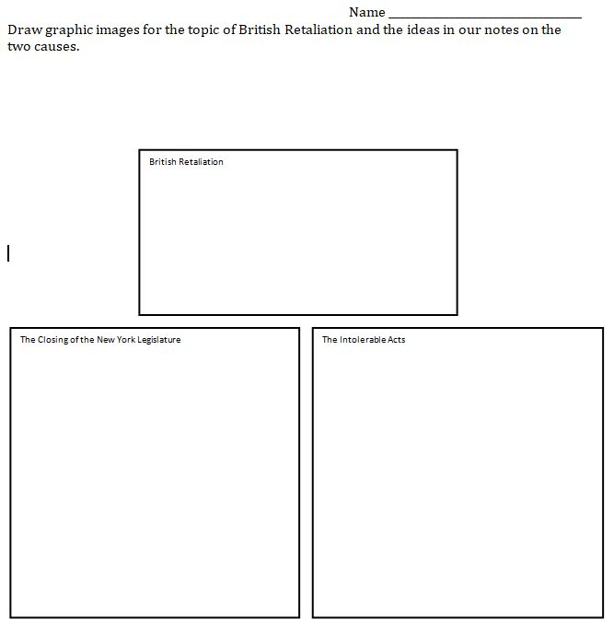

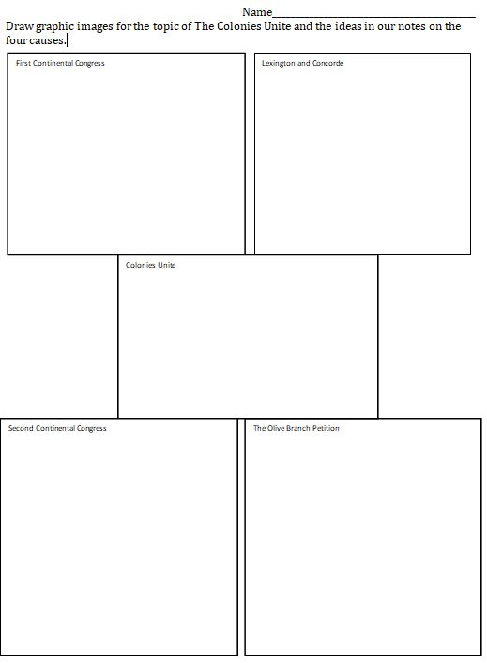

Name ___________________________________
Draw graphic images for the topic of British Retaliation and the ideas in our notes on the two causes.

British Retaliation

The Intolerable Acts
The Closing of the New York Legislature

Name_____________________________________________
Draw graphic images for the topic of The Colonies Unite and the ideas in our notes on the four causes.
Lexington and Concorde
First Continental Congress
Colonies Unite
Second Continental Congress
The Olive Branch Petition

