Fitzgerald
Northern Workers Primary Source 3-2-1
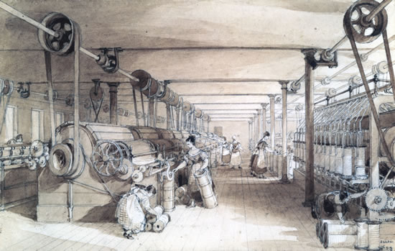
Instructions
- Read the excerpts from the "Voice of Industry."

- Find
  - 3 words,
  - 2 phrases (a group of words that does not have a subject or verb), and
  - 1 complete sentence
that capture big, important concepts about working in a factory.

- Arrange your chosen ideas creatively on the white paper you have been given.
  - You may use colored pencils or any other materials.
  - Do not title the page, it should speak for itself.

- These will be displayed, so create something you will be proud of when others see it.

- Have one group member write the names of the members of your group at the bottom of the page in pencil in small, neat writing.

You can record ideas here before doing your poster.

Mr. Editor:
Those who write so effusively about the "Beauties of Factory Life,"" tell us that we are indeed happy creatures, and how truly grateful and humbly submissive we should be. Can it be that any of us are so stupefied as not to realize the exalted station and truly delightful influences which we enjoy? . . . . Pianos, teachers of music, evening schools, lectures, libraries and all these sorts of advantages are, says he, enjoyed by the operatives. (Query—when do they find time for all or any of these? When exhausted nature demands repose?) Very pretty picture that to write about; but we who work in the factory know the sober reality to be quite another thing altogether . . . .
—Juliana
Voice of Industry, June 12, 1846

Aristocratic strangers, in broad cloths and silks, with their imaginations excited by the wonderful stories—romances of Factory Life— which they have heard, have paid hasty visits to Lowell, or Manchester, and have gone away to praise, in prose and verse, the beauty of our "Factory Queens," and the comfort, elegance and almost perfection, of the arrangements by which the very fatherly care of Agents, Superintendents, and Overseers, has surrounded them. To these nice visitors everything in and around a Lowell Cotton Mill is bathed in an atmosphere of rose-colored light. They see the bright side of the picture, and that alone. . . .
These lovers of the Romance of Labor—they don't like the reality very well—see not the pale and emaciated ones. . . . They think little of the weariness and pain of those, fair forms, as they stand there, at the loom and spindle, thirteen long hours, each day! They know not how long these hours of toil seem to them, as they look out upon the fields, and hills, and woods, which lie beyond the Merrimack, steeped in golden sunlight and radiant with beauty. . . .
These lovers of the Romance of Labor—here, have much to say of the moral and intellectual advantages by which the operatives are surrounded. These may be over-rated or they may not be, it matters not. It is true there are Churches and ministers "in any quantity," with many good influences, and with some that are at least questionable.
There are lectures of various kinds, some of them free, and others requiring only a trifling fee to secure admission, to all who wish it. Then there are also libraries of well selected books, to which all can have access. . . . Do you ask why they cannot partake? Simply from physical and mental exhaustion. The unremitted toil of thirteen long hours, drains off the vital energy and unfits for study or reflection. They need amusement, relaxation, rest, and not mental exertion of any kind. A really sound and instructive lecture cannot, under such circumstances, be appreciated . . . .
If each factory girl could suspend her labors in the Mill for a few be months each year, for the purpose of availing herself of the advantages for intellectual culture by which she is surrounded, much good might be derived. A few can and do thus avail themselves of these advantages; but the great mass are there to toil and toil only. Among these are some of earth's noblest spirits. Theirs is Love's willing toil. The old home-stead must be redeemed,—a poor sick mother or infirm father needs their little savings to keep them from the "Poor House,"—or a loved brother at Dartmouth or Harvard, is to be assisted in his manful efforts to secure an education; so they must not think of schools and books for themselves. They must toil on, and they do toil on.
But day by day they feel their over-tasked systems give way.—A dizziness in the head or a pain in the side, or the shoulders or the back, admonishes them to return to their country homes before it is too late. But too often these friendly monitions are unheeded. They resolve to toil a little longer. . . . This is no fancy of mine—no studied fiction—(would to God it were) but sober truth. . . .

Voice of Industry, December 3, 1847

