Natives of the Northeast

This region is cold in winter, with deep snows, and often hot in summer. The region contains deciduous and coniferous trees. From these trees, the native people made an enormous variety of tools: houses, containers, canoes, bows and arrows, ritual and subsistence equipment. From some of the trees came foods: nuts and fruits. The forests also were the habitat of much of the game hunted by the native peoples: bear, wolf, fox, moose, deer, along with numerous smaller game animals and birds. From the lakes natives took fish of several kinds while along the ocean shores shellfish in uncountable numbers were regularly harvested. Numerous wild foods were harvested in a seasonal cycle: rice, maple sap, berries, nuts, onions, yellow waterlily roots. Many nations, in addition to acquiring food by hunting, fishing, trapping, and collecting, some also farmed maize (corn), several types of beans and squash, and, in some areas, tobacco.
All natives in this region had a subsistence lifestyle, with three basic subsistence patterns: gathering-hunting, a mixed hunting/farming pattern, and all farming. The balance of the diet came from game, fish, and wild plants, and a highly nutritious combination of three basic crops: maize, beans, and squash. 50% farmed corn. Women were the primary cultivators, but men helped to prepare the fields. Corn, beans and squash were planted together, with the corn was planted along a central mound along with beans that could climb the corn stalk and squash was planted between mound rows. Such planting methods conserved moisture, prevented weed growth, and resulted in a high yield per acre. Gathering was primarily carried out by women and children. Hunting, on the other hand, was always a man's job, and deer were the primary game animals. Several groups used dogs for hunting. People in coastal areas caught eel and other fish, and collected shellfish. Men stalked seals sunning or rocks near shore, and larger fish were speared and netted from boats.
Settlements ranged from small villages of one or two houses to large towns encompassing several acres. Common dwellings were wigwams, oval- circular- or pyramidal-shaped wigwams framed with saplings and covered with overlapping strips of bark, woven mats, or skins. These houses were relatively easy to construct and take down, and could be adapted to all weather conditions. The Iroquois built longhouses (Iroquois). Gathering-hunting groups tended to come together in the winter in one base camp, living in single- or extended-family dwellings, hunting large game and trapping smaller animals.
Some groups built large wooden structures for rituals and council meetings in the center of villages.
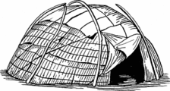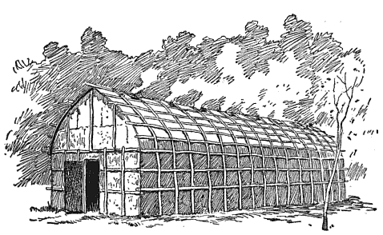
Political Organization varied from the highly structured League of the Iroquois to the much simpler forms of semi-nomadic gatherer-hunters: nuclear families and bands or group of bands led by a leader chosen by the community. In some nations there were councils headed by chiefs. Occasionally, nations also formed alliances, the most famous being the Iroquois Confederacy of 5 and later 6 tribes. This confederacy lasted 100s of years and played a major role in European conflicts including the American Revolution.
Social Organization varied widely. Many of the gathering-hunting groups recognized clans, a group of people all of whom claim descent from a common ancestor. Some groups based clans on descent from a common mother, others from a common father, and still others from both. Clans in northeastern groups were often associated with specific animal totems and membership in a clan was the basis for all social interaction. In many areas hereditary leadership was the norm. Among some groups, there were two such leaders: a civil leader and a war leader. Land was owned in common by the group with members having use rights but not ownership rights.
Two religious practices are commonly associated with this region. Warriors sought guardian spirits and supernatural help, either in dreams or during vision quests. Shamans, or medicine men, were the primary curers, although there also existed among some nations medicine societies.

Natives of the Southeast
The vegetation of the Southeast was dominated by pines, which were maintained by regular burning of the underbrush to provide good browse for the prime game, deer. Oak and other deciduous trees, many bearing edible nuts, cover the uplands. Cypress trees flourish in the many swamps. Tidal marshes are found along the coast. There are three environmental zones: the coastal plains, the foothills (known as the piedmont), and the Appalachian Mountains.
Native were subsistence farmers, growing corn, beans, and squash together. Most of the agricultural labor was provided by women, although men helped clear the fields. Women also were generally responsible for gathering wild plant foods, honey, and other materials. Hunting was a critical source of food and materials with deer being the primary game animal and providing meat, skins, hooves, and bone for many uses. Although a man might hunt deer by himself, deer were also hunted by groups of men using both fire and dogs. Bears were also hunted (both for their meat and for their fat, which was rendered into oil), as were opossums, squirrels, rabbits, turkeys, and waterfowl. Crabs, crawfish, shellfish, and fish were also caught.
Settlement tended to be larger than many in the Northeast. Many groups had at least one permanent town, where the bulk of the people lived. Some of these towns were quite large (covering hundreds of acres and containing thousands of people), laid out with planned streets, residential and public areas, surrounded by a palisade (stockades of upright posts), with moats or earthworks for protection. Sturdy thatched-roofed houses had mud-plastered walls over poles interwoven with reeds or branches. Families of a common mother usually lived next to each other. Following their wedding, a couple generally moved to the wife's village, building a house near the wife's mother and her female relatives.
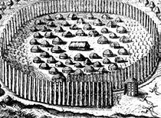
The common form of political organization was a chiefdom with a high levels of military organization. The people were ruled by an elite, some of whom seemed to have been given a god-like status, and the peoples' lives were governed by complex religious beliefs and elaborate rituals. Towns were usually independent, but almost always allied with other nearby towns into confederations. Each town had a council comprised of the most influential household leaders.
Social Organization was based on clans descended from a common female ancestor. Land was owned by the clan. Clans were associated with particular types of leaders, one clan being the one political leader came from, another, war leaders, another religious leaders.
Religious beliefs and practices had the primary goal maintaining harmony. Most towns had an eternal sacred fire burning in a temple, symbolizing continuity and harmony. The major religious observances in the Southeast were for planting and harvest. The Green Corn Ceremony was the major ceremony. This ceremony was held over a 3-day period. On the first day, the men refurbished public buildings and the women cleaned the town. On the second day, outstanding issues, such as disputes, divorces, crimes, and arguments, were settled. On the third day, a feast was held in the morning, and in the afternoon, the sacred fire was renewed.

Natives of the Great Plains
This region is a grassland, broken by ranges of hills and wooded river valleys. In the east are and tall-grass prairies, and in the drier west, short-grass prairies dominate. The valleys and hills were home to deer, elk, bear, antelope, and beaver, while in the mountains at the western edge lived mountain sheep. In the rivers, fish and waterfowl were abundant during their annual migrations. Bison were the principal inhabitants of the grasslands. Until the mid 1800s, more than 60 million of them lived in the region and provided the plains people with meat for eating, fat for cooking, hides for house-covers and winter coats, bones and horns for tools, stomachs were made into carrying and cooking devices, and even the tails were used as fly swatters.
The natives of this region lived subsistence life styles. Few lived year-round on the open grasslands. The tough, thick root masses of the grasses were impossible to penetrate with digging sticks, and the winter winds and driving snow storms and often intense summer heat made life extremely difficult for most of the year. Also, until the arrival of the Spanish-introduced horse in the middle of the 1600s, hunting bison on the open grassland was difficult for people on foot with only their dogs to help carry meat, hides, tools, and shelter. Instead, natives lived in the lush river bottoms of the major rivers that crossed the Plains where farming was possible. Men also seasonally left their villages to hunt bison, deer, elk, turkey, and prairie chicken, and women to gather wild plants. Some groups exclusively hunted and gathered, some exclusively farmed, and other were a mixture of both.
Nomadic hunting groups once they acquired horses had many common characteristics. They all lived primarily on bison, lived in portable skin tipis, produced light and durable articles of skin, emphasized war and military societies, were organized into clans that could be descended either from a common male or female relative, emphasized the Sun Dance as the major ceremony, and were politically organized into a single cohesive tribe. Tribal groups came together to hunt in the summer and dispersed in the winter.

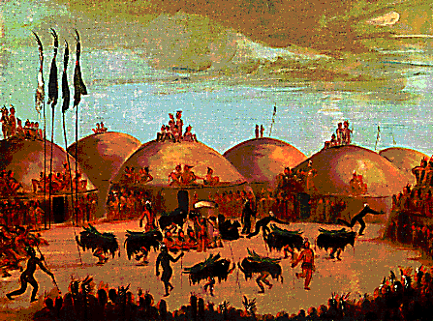
Farming groups lived in rather large, substantial earth-covered lodges built into bluffs overlooking the river bottoms, usually at a point where two rivers joined. Mandan towns were formally laid out with streets and a central plaza, where ceremonies were held and competitive games played. The Mandan earth lodge was circular and ranged in size from 40 to 80 feet in circumference. Four center posts held up a continuous series of horizontal cross beams over which were laid thick mats of willow branches followed by layers of firmly packed earth. Frequently the tops of the earth lodges were flattened to provide a platform for drying crops as well as serving as a porch on hot evenings.
Politically, the nomadic groups differed from those that were not nomadic. The nomadic hunting bands were led by a man who had earned his "authority" through a strong personality, demonstration of superior hunting and leadership skills, his ability to organize people and make decisions his followers regarded favorably. However, the final say in decision making was often that of an older woman whose strength of character and wisdom the families depended on. Because men were often away hunting and trading or at war, women were the main leaders of daily life and judges of all that concerned the family. The nations that were not nomadic had more formal political organizations than the nomadic bands. Towns were structured around clans were the primary unit of cooperation. Towns were managed by councils formed of representatives from the clans, chaired by men from clans that traditionally produced leaders.
Religious practices common known are guardian spirits and shamans. Guardian spirits were supernatural power beings who gave an individual special songs, prayers, and symbols which could be used for protection from evil or death. A guardian spirit usually appeared to an individual during a solitary vision quest, when he or she ventured out alone, far from home, and fasted and prayed until receiving supernatural instructions from a guardian spirit. Shamans, or medicine men, connected humans and the supernatural world, and since Plains people believed that illness was due to malevolent , shamans could cure disease.

Natives of the Northwest

The region is warmed by sea currents, and the mountains block off most cold air coming from the interior. The mountains are covered with temperate rain forests of giant Douglas fir, cedar, spruce, and hemlock. The forest were home to many game animals (deer, moose, elk, bear, mountain goats and sheep) and fur-bearing species (fox, mink, beaver). But it was to the sea that the native peoples looked for the bulk of their subsistence resources: whale, seal, sea lion, porpoise, sea otter, many species of fish (quarter ton halibut; half ton sturgeon; shoals of herring, smelt, cod, candlefish, salmon). The tidal flats yield huge quantities of shellfish. In the spring and fall, waterfowl darken the skies on their semiannual migrations. This wealth of food supported an estimated native population of 250,000.
The natives of the northwest lived a subsistence life-style. Of all the resources available to the Northwest Coast peoples, the two most important were cedar and salmon. Cedar provided the raw material from which houses, boats, baskets, boxes, clothing, and carvings of every imaginable kind were made. Salmon were taken using a variety of techniques, ranging from spears to nets. Although salmon were eaten fresh, huge amounts were dried and stored for later use. Other fish and shellfish resources were also important, and most groups hunted sea mammals, especially seal, but also whales and porpoise. Land mammals also were hunted, but their use was greatly overshadowed by the people's heavy reliance on marine resources.
Most of the people moved from winter villages to spring, summer, and fall location where they obtained resources. Winter villages were located at scattered areas adjacent to the shores of large rivers, the mainland coast, and along island shores. Some winter villages had as many as 35-40 rectangular cedar-plank houses arranged in street-like rows. Each house had a substantial false-front facade portraying mythical beings and peaked roofs. Frameworks were permanent structures, but the roofing and siding were not. Families had a house frame at each seasonal location, and moved the siding and roof planks between these locations. Houses were often built over an excavation, not on the ground itself. Some houses held as many as ten or twelve nuclear families (husband, wife, small children). Although some villages had as many as 40 houses, most held about a dozen such communal houses or fewer. Ideally, a village consisted of several separate houses, carved poles, fish-drying racks, caches of food and raw materials, and sweathouses.
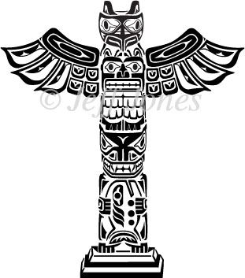
Political organization was simple but social organization complex. Political unity came from the extended families and particularly the geographic location of one's winter village. Local leadership was hereditary in the north, but in the south, wealth generally determined political position. Socially, there were four social classes. The highest class got their status from heredity and the accumulation and distribution of food, goods, and wealth items. Below this group were families with members of some standing in the community but who had not inherited wealth. The lowest group was formed by families of individuals who had previous been slaves or had lost the social status or wealth. Slaves and war captives had no status. One's rank could rise or fall. When one moved up in rank, it was necessary to secure formally one's new position at a potlach, a public feast at which events of social importance were proclaimed and validated. The hosts invited entire villages and spent months, sometimes years, preparing. Totem poles are monumental poles carved from large trees, mostly western red cedar, and elaborately painted and represent clans lines but also familiar legends and notable events.
As with the people of the people of the Great Plains, the guardian spirit and shamans were common religious traditions. The guardian spirit was common to the belief systems of all Northwest Coast people. The guardian spirit was obtained during a period of self-sacrifice, fasting and praying. Additionally, some guardian spirits were associated with a person's clan. A guardian spirit gave a person some basic skill or special knowledge (healing). Shamans among the Northwest Coast people, like shamans everywhere, had the ability to both heal and harm people. If a person had lost their soul, a shaman would travel to the world of the dead to retrieve it; if someone had placed a foreign object in a person's body, the shaman used both physical and non-physical means to extract it.

Native Americans of the Southwest

This region contains dry, rocky land with cactus. The temperatures are high and there it is very dry. Crops required irrigation. Desert animals include snakes and other reptiles. Wild turkey supplemented their diet.
The people led a subsistence lifestyle. Farmers kept sheep and goats, obtained from Spanish settlers, as livestock, and farmed corn, beans, squash, and sunflower seeds. The tribes actually grew 24 different types of corn. Some were settled farmers, some nomadic hunters, and some did both. The Zuni, Pueblo and Hopi are well known farm groups. The Apache and Navajo are well known nomadic hunting groups.
The houses of the farming groups and the hunting groups differed. Farmers lived in villages of adobe clay houses called pueblos. Pueblos were apartment-like structures built of stone, mud, and other local material. These structures were usually multi-storied buildings surrounding an open plaza. The rooms were accessible only through ladders lowered by the inhabitants, thus providing protection. Pueblos could be so large as to be occupied by hundreds to thousands. A hogan was a traditional Navajo dwelling made of mud and logs with a door facing east. Hunters lived in brush shelters or wickiups. A wikiup was constructed of tall saplings driven into the ground, bent over, and tied together near the top. This dome-shaped framework was covered with large overlapping mats of woven rushes or of bark that were tied to the saplings. A typical wickiup was some 15–20 feet in diameter. The different types of houses depended on the materials available and whether the home was permanent or temporary.

.
As with all Native American groups, the natives of the Southwest believed in animism, but particular religious practice associated with natives of the Southwest are the use of kachina figure, prayer sticks, and talking sticks. Animism is based on the religious idea that the universe and all natural objects have souls or spirits, that souls or spirits exist not only in humans but also in animals, plants, trees, rocks, etc., and natural phenomena such as thunder storms and rain and geographic features such as mountains, caves or rivers. Kachina figures may be represented by men in costume in religious dances or made into doll and represent sacred spirits of dead ancestors who bring the rain. The shaman or medicine men of the tribes also use objects called prayer sticks. A prayer stick can vary in shape but usually long and narrow, brightly colored and decorated with feathers that are selected according to the nature of the petition, and the person praying. Prayer Sticks, Spirit Sticks or Medicine Sticks are most commonly made from cedar, willow and cottonwood and decorated with paint, carvings and occasionally wrapped in buckskin or other leather materials. The stick is decorated with colorful symbols that represent the prayer or message. For instance, a feather is often attached to prayer stick to call to the spirit bird or totem to carry the prayer, supplication or message to the heavens. A different form of ritual and ceremony related to Talking Sticks. Talking Sticks were passed among members of a tribal council, and only the member holding the stick was free to express himself.

Smith, Charles, "Native Peoples of North America: History and Culture," Anthropology Department, Cabrillo College, 22 January 2011, <http://www.cabrillo.edu/~crsmith/noamer.html>.

Map
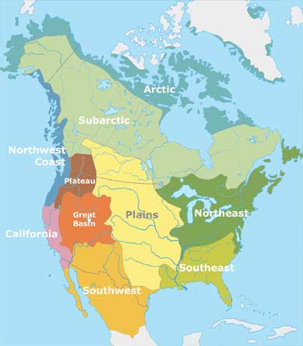

Video
Discovery Streaming "Native Americans: The First Peoples" 21:00

