Impact of European Settlement - Disease

Massive Population Drop Found for Native Americans, DNA Shows: Genetic data supports accounts of decline following European contact.
By Ker Than National Geographic News, Published December 5, 2011

The number of Native Americans quickly shrank by roughly half following European contact about 500 years ago, according to a new genetic study. The finding supports historical accounts that Europeans triggered a wave of disease, warfare, and enslavement in the New World that had devastating effects for native populations across the Americas.
Using samples of ancient and modern DNA the researchers calculated a demographic history for American Indians. Based on the data, the team estimates that the Native American population was at an all-time high about 5,000 years ago. The population then reached a low point about 500 years ago—only a few years after Christopher Columbus arrived in the New World and before extensive European colonization began.
Study co-author Brendan O'Fallon, a population geneticist who conducted the research, speculates that many of the early casualties may have been due to disease, which "would likely have traveled much faster than the European settlers themselves."
For instance, the Franciscan friar Toribio de Benavente—one of the first Spanish missionaries to arrive in the New World in the early 1500s—wrote that Mexico was initially "extremely full of people, and when the smallpox began to attack the Indians, it became so great a pestilence among them ... that in most provinces more than half the population died."
Some historians have questioned whether such effects were restricted to particular cities or regions, but the new study suggests mortality was widespread.

Use what you know to interpret the pictoragphs on the next page.

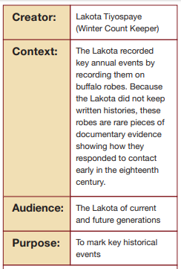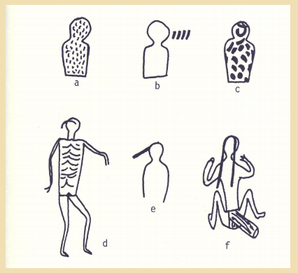
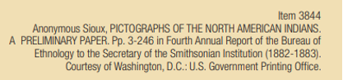
Source - Annenberg Learner - American History
https://www.learner.org/courses/amerhistory/pdf/text/AmHst02_Mapping.pdf
What was the purpose of the pictograph?

What event do you believe it represents?

Provide evidence from the document. State what you see snd explsin how what you describe is evidence thst your stated event is being represented.

Impact of European Settlement - Loss of Land

Instructions - Set the map in motion by clicking on the link. You may watch it play repeatedly as it loops. then answer the question that follow.
https://newsmaven.io/indiancountrytoday/archive/animated-map-shows-loss-of-western-tribal-lands-from-1784-Bg7yIq-gQUuC1UPZ9w-H6A/

What is the date of the first map?

What is the date of the last map?

What do you believe is the main idea this set of maps is trying to convey?

Read the article and answer the questions that follow.

A Short History of the U.S. Government’s

Relationship with Native Americans

Relations between Native Americans and the U.S. government have been full of tension. The history began when Native Americans extended an uneasy welcome to the first European settlers. They worried that the newcomers would take their land, and many did.
Many tribes sided with the British during the Revolutionary War. After the United States won its independence, the government was free to take Native American lands. It signed treaties with the tribes. These agreements defined the boundaries of tribal lands. They also stated how much the government would pay the tribes for taking their land.

Unauthorized Treaties
Sometimes, the representatives of Native American tribes who signed the treaties were not authorized to do so. William McIntosh was the chief of the Muskogee-Creek Nation. He signed the Treaty of Indian Springs in 1825. The agreement gave away nearly all of the tribe's land in the state of Georgia. The tribe's members said they had not authorized McIntosh to sign it, and later killed him.
In 1903, the U.S. Supreme Court ruled that Congress could override the land treaties. Many treaties made before then, however, remain in force. One is the Treaty of Fort Laramie of 1868, which was signed by the U.S. government and the Sioux Nation. In it, the government pledged that the Great Sioux Reservation would be for the "undisturbed use" of the tribe. The land included the Black Hills, a small mountain range in western South Dakota that is holy to the Sioux.
Neither side ever fully obeyed the treaty, however. When gold was discovered in the Black Hills, the United States tried to buy back the land. The Sioux rejected the offer, resulting in the Black Hills War. One of the war's most famous battles happened along the Little Bighorn River. General George A. Custer led a group of soldiers against the Sioux. Custer and his men were killed, and later the battle became known as Custer's Last Stand.
The United States continued its battle against the Sioux until reclaiming the Black Hills in 1877. In 1923, the Sioux sued, saying that the land had been unlawfully taken. Sixty years later, the Supreme Court agreed. It ruled that the government had to pay the tribe for the land. As of 2018, the amount due is around $1 billion. The tribe has refused to accept the money, however, because it is still seeking return of the land.

Taking the Land
In 1830, Congress passed the Indian Removal Act, which allowed the government to remove Native Americans from their tribal land and settle them elsewhere. The main targets were tribes in the Southeast, such as the Cherokee. Resettlement was supposed to be voluntary. However, it turned out not to be. Thousands of Native Americans were forced from their homes and sent west of the Mississippi River. The forced relocation became known as the Trail of Tears.
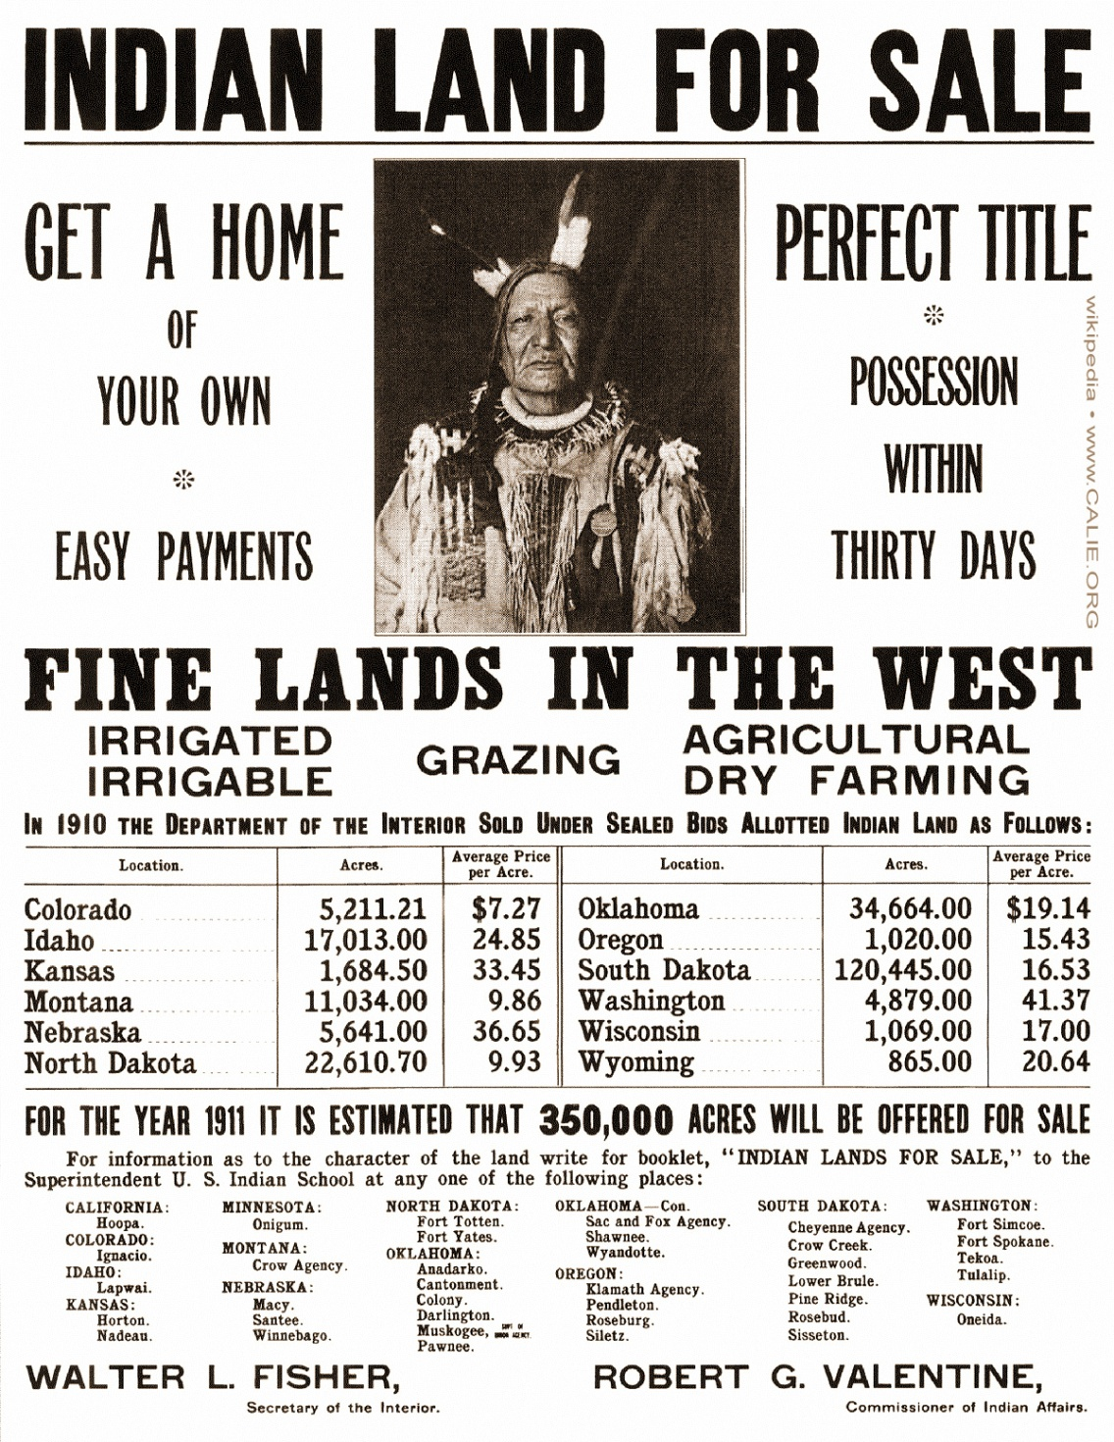
Image 2. This 1911 government poster shows how the government sold Native American land under allotment. It was signed by Secretary of the Interior Walter Lowrie Fisher and Robert G. Valentine, commissioner of Indian Affairs. Image courtesy of the Library of Congress
In 1887, the U.S. government passed another law called the General Allotment Act. It let the government divide tribal land into small lots for members. The goal was to pressure Native Americans into becoming farmers or ranchers. Lawmakers thought this would help tribal members fit in with society. The government bought back land that was not used and sold it to white settlers. Native Americans lost a lot of land.
A new approach was undertaken with the Indian Reorganization Act of 1934. The law stopped the dividing of tribal land into small lots. It also ended the sale of Native American land. After World War II, however, some lawmakers favored closing reservations. A number were closed, including one belonging to the Menominee tribe in Wisconsin.
The civil rights movement in the 1960s influenced government policy with Native Americans. In 1975, it passed the Indian Self-Determination Act. This law allowed tribes to self-govern and manage more of their affairs independently.
In 1987, the Supreme Court ruled on casinos operating on tribal land. It said that states cannot oversee them. This decision led to a new law, which governs casinos on reservations.
- Read the introduction [paragraphs 1-2].
Select the sentence that shows why Native Americans didn't trust the U.S government.
- Relations between Native Americans and the U.S. government have been full of tension.
- They worried that the newcomers would take their land, and many did.
- Many tribes sided with the British during the Revolutionary War.
- These agreements defined the boundaries of tribal lands

- Read the section "Unauthorized Treaties."
Which sentence explains why the Sioux tribe and the U.S. fought the Black Hills War?
- The Treaty of Fort Laramie of 1868, which was signed by the U.S. government and the Sioux Nation.
- When gold was discovered in the Black Hills, the United States wanted to get back the land.
- Custer and his men were killed, and later the battle became known as Custer's Last Stand.
- The United States continued its battle against the Sioux until reclaiming the Black Hills in 1877.

- Read the paragraph from the article.
In 1830, Congress passed the Indian Removal Act, which allowed the government to remove Native Americans from their tribal land and settle them elsewhere. The main targets were tribes in the Southeast, such as the Cherokee. Resettlement was supposed to be voluntary. However, it turned out not to be. Thousands of Native Americans were forced from their homes and sent west of the Mississippi River. The forced relocation became known as the Trail of Tears.
Which statement summarizes the paragraph?
- The Indian Removal Act allowed Congress to buy tribal land.
- The government forced all tribes in the east to leave their lands and move west.
- Congress wanted to take tribal land west of the Mississippi River.
- The Trail of Tears was a voluntary relocation of the Cherokee tribe.

- Which sentence from the article supports the main idea of the article?
- William McIntosh was the chief of the Muskogee-Creek Nation.
- Native Americans lost a lot of land.
- After World War II, however, some lawmakers favored closing reservations.
- In 1987, the Supreme Court ruled on casinos operating on tribal land.

Instructions - Read this article carefully. Choose what you believe are the five most important facts in the article and highlight them.

A Sociologist's Description of Native Americans Today

Native Americans
Native Americans, or “American Indians,” settled in North America long before any Europeans arrived. Yet they have now lived as foreigners and forgotten members of their own land for more than 200 years. In the 1800s, they were forced to leave their homelands and go to“reservations” where they had few opportunities for growing food, hunting animals, or obtaining work. The Native‐American population has only recently reached more than 2 million, while the overall population of the united States in approaching 330 million. Most live on reservations or in rural areas primarily located in the Western states, though recently more Natives are moving into urban areas.
American Indians are the poorest ethnic group in America. The vast majority live in substandard housing and about 30 percent live in utter poverty, meaning poverty so severe it leads to malnutrition and diseases. The average Native American attends school less than 10 years, and the drop‐out rate is double the national average. The rate of Indian unemployment is as high as 80 percent in some parts of the country. Further complicating these matters is the fact that the rate of alcoholism for Native Americans is more than five times that of other Americans.
Native Americans remain a tightly knit and culturally minded people who have maintained their original tribal identities. For instance, the Navajo—who have the most populated and largest reservation in this country—have held fast to their cultural patterns, even though many Navajo have worked in industrial cities.
Inspired in part by the civil rights movement, Native Americans have become politically active in recent years. The American Indian Movement (AIM) is one example of how Indians from various tribes have organized to preserve their authentic culture, prevent further violations of their territorial rights, and pursue other legal matters. Although some goals have been attained, the small number of Native Americans in the United States limits the attention paid to them by elected representatives and their legal pull.

"Sociology: Race and Culture - Native Americans." Cliff Notes. Houghton Mifflin Harcourt. https://www.cliffsnotes.com/study-guides/sociology/race-and-ethnicity/native-americans. Visited 18 September 2019.

Native American Teens Speak Out
https://www.youtube.com/watch?v=GHdW_LVfn28

List two things that they want you to know-

1.

2.

