Virginia Fitzgerald
1st hour
Putting-Out System, aka Domestic System

“The Domestic System”
Before factories as we would identify them, all manufacture of products like textiles was done at home and on a small scale. Work was confined to a cottage with everybody doing their bit. Work done at home – hence the “domestic” in the title – was slow and laborious. Daniel Defoe, of “Robinson Crusoe” fame -wrote about his journey through Yorkshire in about 1720 and described how he saw small cottages, small scale production and each family working for itself. However, not everything was done under one roof. Defoe noted that in Norfolk those employed in spinning worked elsewhere to those employed in weaving.
The process in the making of wool for clothes was as follows :
cleaning of the wool after it had been sheared from the sheep. carding of the wool – this was brushing it to separate the fibres. If a comb was used, this would be to get the fibres parallel. The cleaned and carded wool would then be spun by spinsters. This was frequently done by young girls. If these girls had not got married at a young age, it was believed that they would remain unmarried all their life – hence the term spinster today. The finished product of the spinsters was called yarn. the yarn would then be woven by a skilled weaver using a handloom. The finished product would then be sold to a clothier.
Each of these processes probably took place in separate cottages and spinning was seen as a job for women while weaving was seen as a man’s job.

The picture shows a typical domestic system home. The single room is dominated by a spinning wheel which is being worked by a young lady – the spinster. Food is being cooked in the same room. A ladder on the left of the picture will take the workers to their bedrooms once work for the day is finished and a window allows for light and ventilation. The amount of yarn produced in such a situation is clearly minimal.
If a worker did not work in his own home, he might work in a small workshop. Everything was done on a small scale. Even the coal mines – to fuel local cottages rather than send coal further afield – were small with shallow bell pits being the favoured type of mine as opposed to deep coal mining.
What was so good about the domestic system ?
the workers involved could work at their own speed while at home or near their own home. children working in the system were better treated in this system than they were to be in the factory system. As the women of a family usually worked at home, someone was always there to look after the children. conditions of work were better as windows could be open, people worked at their own speed and rested when they needed to. Meals could be taken when needed. as people worked for themselves they could take a pride in what they did. Tension in the workplace was minimal as the family worked as a unit. the best home produced goods were of a very good quality – though this probably was not true at a general level.
However, the domestic system did have a number of major weaknesses in the growing industrial power that was the United Kingdom :
the production was very slow and the finished product was simply not enough to, in the case of textiles, cloth the fast growing population of the United Kingdom . A better and faster system of production was needed.the complete process of production was usually done in several cottages and time was lost as materials were taken from cottage to cottage as one stage progressed to the next. the power of water was being developed and small cottages could not possibly take advantage of this source of power. the image of nice quaint country cottages giving workers a quality lifestyle (if not well paid) simply is not a correct one. Defoe witnessed children as young as four working in the domestic system and the waste that gathered around country cottages which did not improve the standard ad quality of life for those who had to live near such waste.

With a growing population that needed feeding, clothing etc. a new way was needed to meet the demands that a growing population would make on Britain. This would lead to the new factories, large and deep coal mines, huge ship building ports and the growth of our industrial cities with all the problems they were to bring.

URL: http://www.historylearningsite.co.uk/britain-1700-to-1900/industrial-revolution/the-domestic-system/
MLA Style Citation: C N Trueman. "The Domestic System." historylearningsite.co.uk. The History Learning Site, 31 Mar 2015. 3 Mar 2016.

Virginia Fitzgerald
1st hour
Putting-Out System, aka Domestic System

Summary
Before factories were built beginning around 1800, products were manufactured in homes on a small scale’ Work was done in the homes (cottages) of workers, with each step done in a different place. For example one home might spin thread, and another home might weave the thread into cloth.
There are several steps done in the process of making cloth, and each of these steps would be done in a separate cottage. First the wool is shorn from the sheep. Then it is cleaned by being carded, meaning it is drawn back and forth between two flat brushes to separate the fibers and get all fibers parallel. Then it is spun, usually by girls in their home. (The word “spinster” for unmarried woman comes from this.) Finally the yarn woven into cloth, usu. by men.
A merchant would buy the wool after it is shorn from the sheep and take it to a house to be carded with the tools necessary to do this. At the end of the week, he would pick up any cleaned wool, drop of more raw wool and pay the worker at that home for the amount she had cleaned. Then he would take the cleaned wool to a house where a spinner lived and drop of the cleaned wool and a spinning wheel. He would return on Friday to pick-up the thread the women had spun and drop of more clean wool and pay her for the thread she had produced. Then he would take the thread to the home of a weaver and drop it off with a loom. He would return on Friday to pick up any finished cloth and drop off more thread and pay the weaver for the cloth he had produced. Thus it was called the Putting out system because all the material was “put out” to different homes. It was also called the Domestic System because “domestic means “at home. Finally it was called the Cottage System because the work was done in the cottages of the workers.
The typical home within this system would have a single room with tools for work done there: carding brushes, spinning wheel, loom. Food was cooked in same room, and there was a ladder to bedrooms above in a loft.
There were both benefits and weaknesses of this system. One benefit to this system were that workers could work at their own speed, and so they could take breaks when they needed to and prepare and eat meals when they needed. Children are treated better than they were in factories, and someone was always home to look after the children. Windows could be opened. Tension was minimal, and products were often of high quality, so workers could take pride in their skill. A weaknesses of the system was that production was slow, so too little finished product was produced. Time was wasted in moving materials from cottage to cottage. Also, the homes could not take advantage of the new source of power - the water wheel. Finally, the workers were not well paid.
A growing population created a greater demand for products, so a faster system of production was needed. This led not only to factories but larger coal mines, huge shipping ports, and cities to bring together workers.

Images
Before
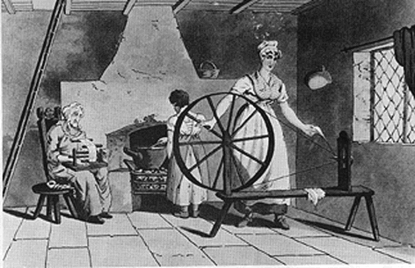
After
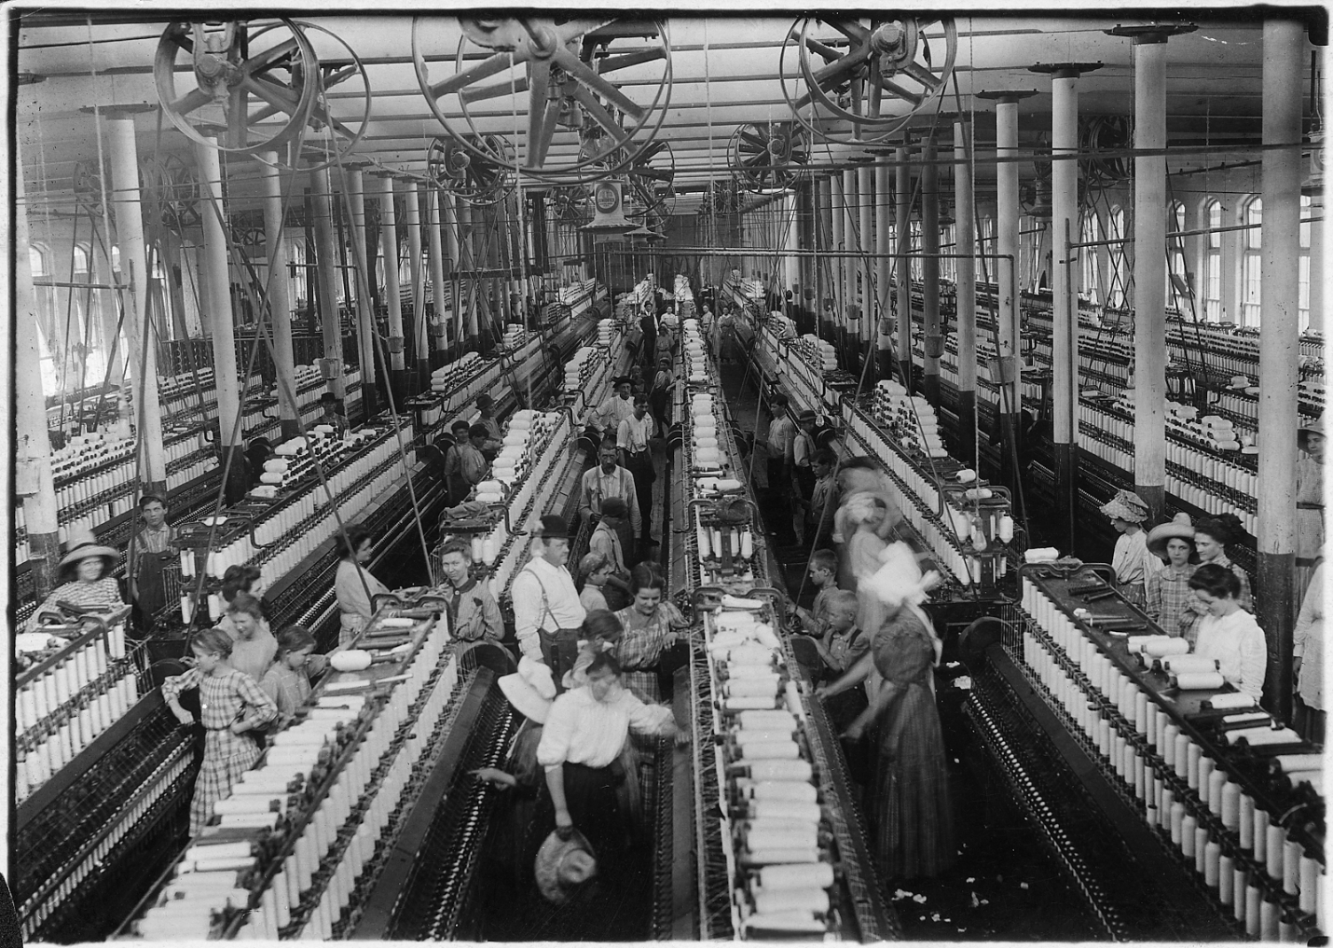

Video Clip

https://www.youtube.com/watch?v=1dSjcHS_UZA

Primary Source

Daniel Defoe wrote in A Tour Through the Whole Island of Great Britain (1724):
"The nearer we came to Halifax, we found the houses thicker, and the villages greater. The sides of hills, which were very steep, were spread with houses; for the land being divided into small enclosures, that is to say, from two acres to six or seven acres each, seldom more; every three or four pieces of land had a house belonging to it. Their business is the clothing trade. Each clothier must keep a horse, perhaps two, to fetch and carry for the use of his manufacture, to fetch home his wool and his provisions from the market, to carry his yarn to the spinners, his manufacture to the fulling mill, and, when finished, to the market to be sold. Among the manufacturers' houses are likewise scattered an infinite number of cottages or small dwellings, in which dwell the workmen which are employed, the women and children of whom, are always busy carding, spinning, etc. so that no hands being unemployed all can gain their bread, even from the youngest to the ancient; anyone above four years old works."

http://spartacus-educational.com/TEXdomestic.htm

Questions on Primary Source (See answers on next page.)
1. What must the cloth maker have and why?
2. Where is the work done and by whom?

Answers to Questions on Primary Source
1. What must the cloth maker have and why?

A cloth maker must have a horse or maybe two horses to carry everything from cottage to cottage. The passage says, "Each clothier must keep a horse, perhaps two, to fetch and carry for the use of his manufacture, to fetch home his wool and his provisions from the market, to carry his yarn to the spinners, his manufacture to the fulling mill, . . ." Etc.

2. Where is the work done and by whom?

The work is done by women and children in their cottages which surround the house of the manufacturer. The passage says, "Among the manufacturers' houses are likewise scattered an infinite number of cottages or small dwellings, in which dwell the workmen which are employed, the women and children of whom, are always busy carding, spinning, etc."

